

**HO CHI MINH UNIVERSITY OF TECHNOLOGY AND EDUCATION**

**FACULTY OF INFORMATION TECHNOLOGY**

**DEPARTMENT OF SOFTWARE ENGINEERING**

-----🙞🙜🕮🙞🙜-----

BỘ GIÁO DỤC VÀ ĐÀO TẠOBỘ GIÁO DỤC VÀ ĐÀO TẠO

TRƯỜNG ĐẠI HỌC SƯ PHẠM KỸ THUẬT TP. HỒ CHÍ MINH

KHOA CÔNG NGHỆ THÔNG TIN

-----🙞🙜🕮🙞🙜-----



**LĂNG TRỌNG NGÔN : 17110339**

**PHẠM TOÀN TRUNG : 17110395**

**Topic:**

**BUILDING A WEBSITE TO SELL CLOTHING ON MERN STACK**

**IT ENGINEER GRADUATION THESIS**

**MENTOR**

**LÊ VĨNH THỊNH Ph.D.**

**COURSE 2017 - 2021**



**HO CHI MINH UNIVERSITY OF TECHNOLOGY AND EDUCATION**

**FACULTY OF INFORMATION TECHNOLOGY**

**DEPARTMENT OF SOFTWARE ENGINEERING**

-----🙞🙜🕮🙞🙜-----

BỘ GIÁO DỤC VÀ ĐÀO TẠOBỘ GIÁO DỤC VÀ ĐÀO TẠO

TRƯỜNG ĐẠI HỌC SƯ PHẠM KỸ THUẬT TP. HỒ CHÍ MINH

KHOA CÔNG NGHỆ THÔNG TIN

-----🙞🙜🕮🙞🙜-----



**LĂNG TRỌNG NGÔN : 17110339**

**PHẠM TOÀN TRUNG : 17110395**

**Topic:**

**BUILDING A WEBSITE TO SELL CLOTHING ON MERN STACK**

**IT ENGINEER GRADUATION THESIS**

**MENTOR**

**LÊ VĨNH THỊNH Ph.D.**

**COURSE 2017 - 2021**

|  |  |
| --- | --- |
| **HCM UNIVERSITY OF TECHNOLOGY AND EDUCATION**  **FACULTY OF INFORMATION TECHNOLOGY**  ******* | **SOCIALIST REPUBLIC OF VIETNAM**  **Independence – Freedom - Happiness**  ******* |

# COMMENTARY OF INSTRUCTOR

Student name: Lăng Trọng Ngôn Student ID: 17110339

Student name: Phạm Toàn Trung Student ID: 17110395

Major: Information Technology.

Topic name: Build a sell clothing website on MERN Stack.

Name of instructor: Lê Vĩnh Thịnh Ph.D.

**COMMENTARY**

1. On content of topic & workload done:

1. Advantage:

1. Disadvantage:

1. Recommend for defense or not?
2. Rating type:
3. Mark: (By word: )

*Ho Chi Minh, ……………………………….* 2021

SUPERVISOR

(Name and signature)

|  |  |
| --- | --- |
| **HCM UNIVERSITY OF TECHNOLOGY AND EDUCATION**  **FACULTY OF INFORMATION TECHNOLOGY**  ******* | **SOCIALIST REPUBLIC OF VIETNAM**  **Independence – Freedom - Happiness**  ******* |

# COMMENTARY OF REVIEWER

Student name: Lăng Trọng Ngôn Student ID: 17110339

Student name: Phạm Toàn Trung Student ID: 17110395

Major: Information Technology.

Topic name: Build a sell clothing website on MERN Stack.

Name of reviewer: Huỳnh Xuân Phụng Ph.D.

**COMMENTARY**

1. On content of topic & workload done:

1. Advantage:

1. Disadvantage:

1. Recommend for defense or not?
2. Rating type:
3. Mark: (By word: )

*Ho Chi Minh, ……………………………….* 2021

REVIEWER

(Name and signature)

# MANY THANKS

In this fact, there are no successes that are not associated with support or assistance, whether more or less, directly or indirectly by others. Now we would like to send this sincere thanks to Lê Vĩnh Thịnh Ph.D., who has supported and transmitted motivation to us in the process of choosing topics, instructions and comments. Although we do not ask much, but when asking the teacher for help, it is the motivation for us to complete the project, without the instructions and practical experiences of the teacher, I think this project will be difficult to complete and completed on time. Once again, I would like to thank our supervisor.

We would like to send our thanks to our fellow students who provided useful information and knowledge to help us improve our topic. We would also like to thank Lê Vĩnh Thịnh Ph.D. who directly guided us to complete this project. We will not be able to complete without the guidance of the master. Due to lack of experience in designing and building software that applies this relatively new process, it is possible that during construction process, there are many errors and problems, so please understand.

Due to limited time, with limited knowledge and many other mistakes, so there will have inevitable problem, so I look forward to receiving your valuable suggestions from everyone for more complete later. We sincerely thank you.

Ho Chi Minh, July 2021

Lăng Trọng Ngôn Phạm Toàn Trung

# MISSION OF GRADUATE THESIS

Student name: Lăng Trọng Ngôn Student ID: 17110339

Student name: Phạm Toàn Trung Student ID: 17110395

Duration: from 22/02/2021 to 06/06/2021 (15 weeks)

Major: Information Technology.

Topic name: Build a sell clothing website on MERN Stack

Instructor: Lê Vĩnh Thịnh Ph.D.

Mission of graduate thesis:

1. *Theory:*

* Research about ReactJS, NodeJS, RESTful APIs, React Native.
* Research about Heroku, Google API, Facebook API.
* Research about e-commerce business analysis, sales management business.

1. *Practice:*

* Build an e-commerce system for clothing store base MERN Stack.

1. *Products:*

* Sell clothing website
* Sell clothing mobile application (Android).
* Website operation management.

1. *Essay outline:*

INTRODUCTION 1

1. URGENCY AND OBJECTIVES OF PROJECT 1

2. OBJECTS, SCOPE AND METHODS OF RESEARCH 2

3. EXPECTED RESULT 3

CONTENT 4

CHAPTER 1. THEORETICAL BASIS 4

1.1. OVERVIEW OF PROJECT 4

1.2. OVERVIEW OF MERN STACK 5

1.3. RESTFUL API 6

1.4. MONGODB 8

1.5. NODEJS 14

1.6. EXPRESSJS 16

1.7. PYTHON 19

1.8. FLASK 20

1.9. NLTK 20

1.10. REACTJS 21

1.11. JSON WEB TOKEN 27

CHAPTER 2. SURVEY OF STATUS AND DETERMINATION OF REQUIREMENTS 30

2.1. SURVEY OF CURRENT STATUS 30

2.2. DETERMINATION OF REQUIREMENTS 34

CHAPTER 3. REQUIREMENT MODELING 39

3.1. DEFINE USECASE 39

3.2. USE CASE DIAGRAM 45

3.3. USE CASE SPECIFICATION 45

CHAPTER 4. SOFTWARE DESIGN 68

4.1. SYSTEM DESIGN 68

4.2. DATABASE DESIGN 79

4.3. INTERFACE DESIGN 91

CHAPTER 5. INSTALLATION AND TESTING 123

5.1. INSTALL APPLICATION 123

5.2. SOFTWARE TESTING 126

CONCLUSIONS AND DEVELOPMENT STRATEGY 135

1. RESULT 135

2. ADVANTAGES 136

3. DISADVANTAGES 136

4. DEVELOPMENT STRATEGY 138

REFERENCES 139

1. *Implementation plan:*

|  |  |  |  |
| --- | --- | --- | --- |
| No | Time | Work | Note |
| 1 | 22/02/2021 to 28/02/2021 | Analyze requirements, identify agents and function in usecase diagrams. |  |
| 2 | 01/03/2021 to 06/03/2021 | Learn technology, tool to use |  |
| 3-4 | 08/03/2021 to 21/03/2021 | * Usecase specification * Sequence schema * database design. |  |
| 5 | 22/03/2021 to 28/03/2021 | * Make a list of screens * Describe the screens in detail |  |
| 6-10 | 29/03/2021 to 02/05/2021 | * Website interface design * Writing the API * Map API with corresponding interfaces |  |
| 11 | 03/05/2021 to 09/05/2021 | * Research, improve more features of the system. * Test system on website interface * Develop mobile interface |  |
| 12 | 10/05/2021 to 16/05/2021 | * Test system on website interface * Develop mobile interface |  |
| 13 | 17/05/2021 to 23/05/2021 | * Test system on website interface * Test system on mobile interface * Deploy the system to heroku |  |
| 14 | 24/05/2021 to 30/05/2021 | * Run the demo on the server * Test the functions of the system. * Write a report, make a powerpoint |  |
| 15 | 31/05/2021 to 06/06/2021 | * Fix errors arising during the demo process, testing. * Write a report, make a powerpoint * Prepare the final steps for the report. |  |

|  |  |
| --- | --- |
| Instructor  (Name and signature) | Ho Chi Minh, ………………………2021  Outline writer  (Name and signature) |

# TABLE OF CONTENT

COMMENTARY OF INSTRUCTOR i

COMMENTARY OF REVIEWER ii

MANY THANKS iii

MISSION OF GRADUATE THESIS iv

TABLE OF CONTENT viii

LIST OF TABLES xii

LIST OF IMAGES xvi

INTRODUCTION 1

1. URGENCY AND OBJECTIVES OF PROJECT 1

1.1. The urgency of project 1

1.2. Objective 1

2. OBJECTS, SCOPE AND METHODS OF RESEARCH 2

2.1. Research objects 2

2.2. Research scope 3

2.3. Research methods 3

3. EXPECTED RESULT 3

CONTENT 4

CHAPTER 1. THEORETICAL BASIS 4

1.1. OVERVIEW OF PROJECT 4

1.2. OVERVIEW OF MERN STACK 5

1.3. RESTFUL API 6

1.3.1. Overview of Restful API 6

1.3.2. Advantages 7

1.3.3. Disadvantages 8

1.4. MONGODB 8

1.4.1. NoSQL 8

1.4.2. Overview of Mongodb 10

1.4.3. Advantages 12

1.4.4. Disadvantges 13

1.4.5. Current version 13

1.4.6. Mongodb used in project 13

1.5. NODEJS 13

1.5.1. Overview of NodeJS 13

1.5.2. Node Package Manager (NPM) 14

1.5.3. Advantages 15

1.5.4. Disadvantages 16

1.5.5. Recent versions of NodeJS 16

1.5.6. NodeJS used in project 16

1.6. EXPRESSJS 16

1.6.1. Overview of Midleware 16

1.6.2. Overview of ExpressJS 17

1.6.3. ExpressJS used in project 19

1.7. PYTHON 19

1.7.1. Overview of Python 19

1.7.2. Python in project 19

1.8. FLASK 20

1.8.1. Overview of Flask 20

1.8.2. Flask in project 20

1.9. NLTK 20

1.9.1. Overview of NLTK 20

1.9.2. NLTK in project 21

1.10. REACTJS 21

1.10.1. Overview of ReactJS 21

1.10.2. The characteristic of ReactJS 21

1.10.3. Recent versions of ReactJS 24

1.10.4. Advantages 24

1.10.5. Disadvantages 25

1.10.6. Redux library 25

1.10.7. Redux-thunk library 26

1.10.8. Axios library 27

1.10.9. ReactJS in project 27

1.11. JSON WEB TOKEN 27

1.11.1. Overview of Json web token 27

1.11.2. Json web token in project 29

CHAPTER 2. SURVEY OF STATUS AND DETERMINATION OF REQUIREMENTS 30

2.1. SURVEY OF CURRENT STATUS 30

2.1.1. Shopee 30

2.1.1.1. Introduction 30

2.1.1.2. Advantages 31

2.1.1.3. Disadvantages 31

2.1.2. Tiki 31

2.1.2.1. Introduction 31

2.1.2.2. Advantages 32

2.1.2.3. Disadvantages 32

2.1.3. YaMe 32

2.1.3.1. Introduction 32

2.1.3.2. Advantages 33

2.1.3.3. Disadvantages 33

2.2. DETERMINATION OF REQUIREMENTS 34

2.2.1. Functional requirements 34

2.2.1.1. Professional function requirements 34

2.2.1.2. System function requirements 36

2.2.2. Non-functional requirements 37

CHAPTER 3. REQUIREMENT MODELING 39

3.1. DEFINE USECASE 39

3.1.1. Actor 39

3.1.2. Use case 40

3.2. USE CASE DIAGRAM 45

3.3. USE CASE SPECIFICATION 45

3.3.1. Recover password 45

3.3.2. Manage personal information 46

3.3.2.1. Add address 47

3.3.2.2. Edit address 47

3.3.3. Add product to cart 48

3.3.4. Manage cart 50

3.3.4.1. Edit product quantity from cart 50

3.3.4.2. Edit product option from cart 51

3.3.4.3. Remove product from cart 51

3.3.5. Order 52

3.3.5.1. Create order 52

3.3.5.2. Pay 53

3.3.6. Manage personal orders 54

3.3.6.1. View personal order detail 54

3.3.6.2. Cancel personal order 55

3.3.7. View system notifications 55

3.3.8. Manage users 56

3.3.8.1. View user information 56

3.3.8.2. Authorize account 57

3.3.8.3. Edit user account status 57

3.3.9. Manage products 58

3.3.9.1. Add new product 58

3.3.9.2. Edit product information 59

3.3.9.3. Manage product options 59

3.3.10. Manage orders 63

3.3.10.1. View order detail 64

3.3.10.2. Approve order 64

3.3.10.3. Confirm received order 65

3.3.10.4. Confirm failed order 65

3.3.10.5. Cancel order 66

3.3.11. Create in-store order 66

3.3.11.1. Create in-store order 67

CHAPTER 4. SOFTWARE DESIGN 68

4.1. SYSTEM DESIGN 68

4.1.1. Work flow 68

4.1.1.1. Online ordering 68

4.1.1.2. Create order in store 68

4.1.2. Sequence diagram 69

4.1.2.1. Login 69

4.1.2.2. Recovery password 70

4.1.2.3. Change password 72

4.1.2.6. Add product to cart 73

4.1.2.7. Create Order 74

4.1.2.8. Manage personal order 75

4.1.2.9. Manage orders 75

4.1.2.10. Create instore order 78

4.2. DATABASE DESIGN 79

4.2.1. users 79

4.2.2. brands 81

4.2.3. categoryGroups 81

4.2.4. categories 81

4.2.5. products 82

4.2.6. sizeOptions 83

4.2.7. colorOptions 83

4.2.8. quantityOption 84

4.2.9. comments 84

4.2.10. rates 85

4.2.11. carts 86

4.2.12. orders 86

4.2.13. orderDetail 88

4.2.14. notifications 88

4.2.15. Messenger 89

4.2.16. Messages 90

4.3. INTERFACE DESIGN 91

4.3.1. List of screens and screen flow on website 91

4.3.2. Screen details on website 93

4.3.2.1. Customer pages 93

4.3.2.2. Admin Pages 111

4.3.3. List of screens and screen flow on mobile application 122

CHAPTER 5. INSTALLATION AND TESTING 123

5.1. INSTALL APPLICATION 123

5.2. SOFTWARE TESTING 126

5.2.1. Registration function 126

5.2.2. Login function 128

5.2.3. Password change function 129

5.2.4. Product search function 129

5.2.5. Ordering functions 130

5.2.6. Product list filter by condition function 131

5.2.7. Image change function when changing product colors 132

5.2.8. Product rating function 133

5.2.9. Product comment function 133

CONCLUSIONS AND DEVELOPMENT STRATEGY 135

1. RESULT 135

1.1. Knowledge and skills 135

1.2. Product 135

2. ADVANTAGES 136

3. DISADVANTAGES 136

4. DEVELOPMENT STRATEGY 138

REFERENCES 139

# LIST OF TABLES

Table 1.1. The relationship of RDBMS terminology with MongoDB 12

Table 1.2. Recent versions of ReactJS 24

Table 3.1. Actor 39

Table 3.2. Use case 40

Table 3.3. Specific description Recovery password 45

Table 3.4. Specific description Add address 47

Table 3.5. Specific description Edit address 47

Table 3.6. Specific description Add product to cart 49

Table 3.7. Specific description Edit product quantity from cart 50

Table 3.8. Specific description Edit product option from cart 51

Table 3.9. Specific description Remove product from cart 51

Table 3.10. Specific description Create order 52

Table 3.11. Specific description Pay 53

Table 3.12. Specific description View personal order detail 54

Table 3.13. Specific description Cancel personal order 55

Table 3.14. Specific description View system notifications 55

Table 3.15. Specific description View user information 56

Table 3.16. Specific description Authorize account 57

Table 3.17. Specific description Edit usser account status 57

Table 3.18. Specific description Add new product 58

Table 3.19. Specific description Edit product information 59

Table 3.20. Specific description Add color option 60

Table 3.21. Specific description Edit color option 60

Table 3.22. Specific description Add size option 61

Table 3.23. Specific description Edit size option 61

Table 3.24. Specific description Add quantity option 62

Table 3.25. Specific description Edit quantity option 62

Table 3.26. Specific description View order detail 64

Table 3.27. Specific description Approve order 64

Table 3.28. Specific description Confirm received order 65

Table 3.29. Specific description Confirm failed order 65

Table 3.30. Specific description Cancel order 66

Table 3.31. Specific description Create in-store order 67

Table 4.1. users table 79

Table 4.2. addresses table 80

Table 4.3. brands table 81

Table 4.4. categoryGroups table 81

Table 4.5. categories table 82

Table 4.6. products table 82

Table 4.7. sizeOptions table 83

Table 4.8. colorOptions table 83

Table 4.9. quantityOptions table 84

Table 4.10. comments table 84

Table 4.11. replies table 85

Table 4.12. rates table 85

Table 4.13. replies table 85

Table 4.14. carts table 86

Table 4.15. orders table 86

Table 4.16. customerInfo table 87

Table 4.17. actionLog table 88

Table 4.18. orderDetail tables 88

Table 4.19. notifications table 89

Table 4.20. target table 89

Table 4.21. messenger table 90

Table 4.22. messenger table 90

Table 4.23. messenger table 91

Table 4.24. Describe Home page 94

Table 4.25. Describe Home page 95

Table 4.26. Describe Detail product page 96

Table 4.27. Describe Header of customer page when not logged in 97

Table 4.28. Describe Header of customer page when logged in 97

Table 4.29. Describe Login page 98

Table 4.30. Describe forgot password page 99

Table 4.31. Describe Registration page 99

Table 4.32. Describe Account navigation bar 100

Table 4.33. Describe Account’s profile page 101

Table 4.34. Describe List addresses 101

Table 4.35. Describe Add new address dialog 102

Table 4.36. Describe Edit address dialog 103

Table 4.37. Describe Delete address dialog 103

Table 4.38. Describe Account’s update password page 104

Table 4.39. Describe Account’s update phone number page 104

Table 4.40. Describe Personal order page 105

Table 4.41. Describe Personal order page with online payment method of order 106

Table 4.42. Describe Personal order detail page with pending approve status of order 107

Table 4.43. Describe Cart page 108

Table 4.44. Describe Notification dialog 108

Table 4.45. Describe messenger dialog 109

Table 4.46. Describe create message dialog 110

Table 4.47. Detail messages dialog 111

Table 4.48. Describe Admin navigation bar 111

Table 4.49. Describe Manage order page 112

Table 4.50. Describe Order page with pending pay status or order 113

Table 4.51. Describe Order page with pending approve status of order 114

Table 4.52. Describe Order page with delivering status of order 114

Table 4.53. Describe User management page 115

Table 4.54. Describe User detail page 116

Table 4.55. Describe Brand management page 117

Table 4.56. Describe Brand management page on edit status 117

Table 4.57. Describe Brand management page on edit status 118

Table 4.58. Describe Product management page 119

Table 4.59. Describe Product option page 119

Table 4.60. Describe Add product page 121

Table 5.1. Software testing registry functions 126

Table 5.2. Software testing login functionality 128

Table 5.3. Test the password change functionality 129

Table 5.4. Test product search functionality 129

Table 5.5. Test order functionality 130

Table 5.6. Test product filter by condition function 131

Table 5.7. Test image change function 132

Table 5.8. Test product rating function 133

Table 5.9. Test product comment function 133

# LIST OF IMAGES

Image 1.1. Overview of project structure 4

Image 1.2.Website data flow diagram using MERN Stack 5

Image 1.3.Data flow of restful API 6

Image 1.4.Multi-platform on Restful API 7

Image 1.5.Photos of companies using NodeJS 14

Image 1.6. Photo of how middleware work 17

Image 1.7. Middleware in ExpressJS 18

Image 1.8. Popular front end language chart - 2019 21

Image 1.9. Difference between virtual DOM and real DOM 22

Image 1.10. Data flow and Events flow in ReactJS 23

Image 1.11. Components of JWT 28

Image 2.1.Size of photo on Tiki 32

Image 3.1. Use case diagram 45

Image 3.2. Use case Recover password 45

Image 3.3. Use case Manage personal information 46

Image 3.4. Use case Add product to cart 48

Image 3.5. Use case Manage cart 50

Image 3.6. Use cart order 52

Image 3.7. Use case Manage personal orders 54

Image 3.8. Use case View system notifications 55

Image 3.9. Use case Manage users 56

Image 3.10. Use case Manage products 58

Image 3.11. Use case Manage product options 60

Image 3.12. Use case Manage orders 63

Image 3.13. Use case Create in-store order 66

Image 4.1. Work flow about online order 68

Image 4.2. Work flow about create order in store 68

Image 4.3. Sequence diagram for Login 69

Image 4.4. Send mail 70

Image 4.5. Recovery password 71

Image 4.6. Sequence diagram for Change password 72

Image 4.7. Sequence diagram for Add product to cart 73

Image 4.8. Sequence diagram for Create order 74

Image 4.9. Sequence diagram for Cancel personal order 75

Image 4.10. Sequence diagram for Approve order 75

Image 4.11. Sequence diagram for Confirm received order 76

Image 4.12. Sequence diagram for Confirm failed order 77

Image 4.13. Sequence diagram for Create in-store order 78

Image 4.14. Database diagram 79

Image 4.15. Screen flow of Customer on website 91

Image 4.16. Screen flow of Admin on website 92

Image 4.17 Home screen 93

Image 4.18. Home page 93

Image 4.19. Home page 94

Image 4.20. Home page 94

Image 4.21. Product page 95

Image 4.22. Detail product page 96

Image 4.23. More information of product detail page 96

Image 4.24. Comment and race 96

Image 4.25. Header of customer page when not logged in 97

Image 4.26. Header of customer page when logged in 97

Image 4.27. Login page 98

Image 4.28. Forgot password page 98

Image 4.29. Registration page 99

Image 4.30. Account navigation bar 100

Image 4.31. Account’s profile page 101

Image 4.32. List addresses 101

Image 4.33. Add new address dialog 102

Image 4.34. Edit address dialog 103

Image 4.35. Delete address dialog 103

Image 4.36. Account’s update password page 104

Image 4.37. Account’s update phone number page 104

Image 4.38. Personal order page 105

Image 4.39. Personal order detail page with online payment method of order 106

Image 4.40. Personal order detail page with online payment method of order 106

Image 4.41. Personal order detail page with pending approve status of order 107

Image 4.42. Cart page 107

Image 4.43. Notification dialog 108

Image 4.44. Messenger dialog 109

Image 4.45. Create new message dialog 110

Image 4.46. Detail messages dialog 111

Image 4.47. Admin navigation bar 111

Image 4.48. Manage order page 112

Image 4.49. Order page with pending pay status or order 113

Image 4.50. Order page with complete status of order 113

Image 4.51. Order page with pending approve status of order 114

Image 4.52. Order page with delivering status of order 114

Image 4.53. User management page 115

Image 4.54. User detail page 116

Image 4.55. Brand management page 117

Image 4.56.Brand management page on add status 117

Image 4.57. Brand management page on edit status 118

Image 4.58. Product management page 118

Image 4.59. Product option page 119

Image 4.60. Add product page 121

Image 4.61. Screen flow on mobile application 122

Image 5.1. Open the project backend with visual code 123

Image 5.2. Visual studio code interface 124

Image 5.3. Terminal window 124

Image 5.4. The Terminal window informs that the project has been run successfully 124

Image 5.5. Open project frontend with visual code 125

Image 5.6. The terminal is in the process of installing the missing package 126

Image 5.7. Terminal window informs that the project has been run successfully 126

Image 5.8. The results run successfully 126

# INTRODUCTION

## URGENCY AND OBJECTIVES OF PROJECT

### The urgency of project

In the current technological ega, traditional commerce is gradually becoming obsolete, instead, E-commerce is developing strongly and becoming a trend. One of the very popular categories on the e-commerce channel is the fashion industry. This is because fashion has always been a very active commercial sector, plus e-commerce makes buying and selling easier than ever, especially in busy times. An e-commerce website makes it easy for customers to choose an item they love without going to the store. Sellers can also easily manage their business. Not only that, e-commerce website also allows you to suggest and advertise your products and services more effectively than traditional commerce. This is also a channel of interaction between customers and sellers and between customers and customers.

E-commerce websites are no longer unfamiliar, moreover, websites are increasingly expanding their functions. In the industrial revolution 4.0, new technologies increasingly appear with outstanding advantages over their predecessors. For example, cloud platforms, MERN stack or Mern stack technologies, ... allow the development of a website that ensures the best user experience, with fast, accurate response, and intuitive interface but still ensuring maximum hardware resource savings. Infact, previous websites do not meet these requirements.

From the increasing requirement of information technology development in parallel with the development of e-commerce, the demand for product development is increasingly high.

### Objective

The topic "BUILDING A WEBSITE TO SELL CLOTHING ON MERN STACK" raises two central issues about the goals that students need to study and implement, including:

* The first issue about the theoretical factor, students need to have professional research results and understand the overview and applicability of each component in the MERN model in general. For each component of the MERN Stack understands and identifies its operating principle, component or model characteristics. The library is built on the basis of the Javascript programming language to gain popularity among programmers such as: NodeJS - build Server, ReactJS - build user-side application, MongoDB - database, ExpressJS - middleware support Server building support. Along with understanding about 4 typical components of the MERN Stack, students need to learn more about the libraries and module source code that help in the process of building actual Web applications.
* The second problem of the topic poses about the application of the MERN Stack model to building a specific product, here is the "Website selling clothing". The finished product must be a Web application built with all the components of the MERN Stack model and meet application requirements including: customer side: purchase, clothing selection, product tracking during transport; administrator side: manage products and users; and some other features may apply in practice as well as upgrade or continue to develop in the future. In addition, the website also needs to ensure security factors such as the form of authentication between the user and the server, the corresponding decentralization mechanism of the system, database security, ...

## OBJECTS, SCOPE AND METHODS OF RESEARCH

### Research objects

The project is implemented around two focus objects, including: technology and practical knowledge about an e-commerce website specializing in clothing business.

In which the technology object includes compulsory research objects: MERN stack technology includes 4 lice objects: Mongodb - database using cloud storage, ExpressJS - middleware for server building, ReactJS - library for building user interfaces, NodeJS - building Server. Technologies used to deploy and operate the system include Amazon Elastic Compute Cloud (EC2), Docker Engine, Heroku. In addition to combining technology research objects, some valuable libraries such as JWT (Json Web Token), socket.io, ngx-chart also need to be studied for application. Use of product functionality.

Subjects of research on practical knowledge of e-commerce websites specializing in clothing business include: specifications of a website, searching and placing orders, order processing methods, payment methods and shipping, invoicing and retrieval, product and user management.

### Research scope

The scope of the research is set at the general level, understands the general knowledge of the research content and applying each knowledge content to the actual product, without putting heavy theories and non-application.

### Research methods

Researching and understanding the materials and websites related to the applied technologies.

Consult with your instructor and friend who have experience relating to issues related to essay topic to create the accuracy of the topic.

Refer to existing e-commerce websites such as Tiki, Shopee, Lazada as well as some websites specializing in clothing business such as YaMe (yame.vn), Owen (owen.vn).

## EXPECTED RESULT

Understand basic to advanced knowledge of the MEAN Stack model and apply that knowledge to complete the topic.

With reference results from an existing e-commerce website, this new e-commerce website will, overcome existing weaknesses and add the necessary features to become a complete and responsive system. be the best user needs. The system will then include the following components:

* An API Server system ensures website functions.
* A system stores the data and essential resources of the system.
* A website with an intuitive and friendly interface, ensuring full functions for customers and administrators.

# CONTENT

# THEORETICAL BASIS

## OVERVIEW OF PROJECT

Building an e-commerce website combined with mobile application for store with specialized products is clothing.

Provide the administrator a website to manage this e-commerce channel.

Website is the place to synthesize all the products of the store, also manage the sale on the e-commerce channel of this store.

Users who buy goods on this e-commerce channel can enjoy offline after-sales services at local store.

The system is built on the MERN Stack platform with the following structure:

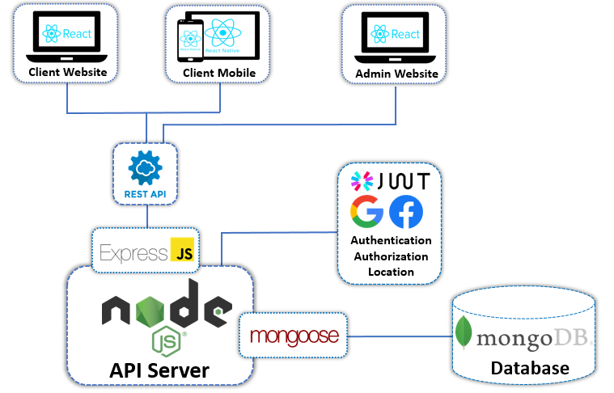

Image .. Overview of project structure

## OVERVIEW OF MERN STACK

The MERN stack is an open source combo of Javascript-related technologies that are also the hottest today: MongoDB, ExpressJS, React / React Native, NodeJS. People use the MERN stack to build the React Universal App. Inside:

* MongoDB is the hottest noSQL database today. MongoDB often comes with Mongoose - a library to make communication with MongoDB easier.[4]
* Node.js is a Javascript runtime.
* Express is a web framework built with Javascript that runs on Node.js. It supports many of the required features of a web framework such as routing, middlewares, template engines.
* React is a frontend library written in Javascript. React Native is the successor to React, and it is used for cross-platform mobile app development.

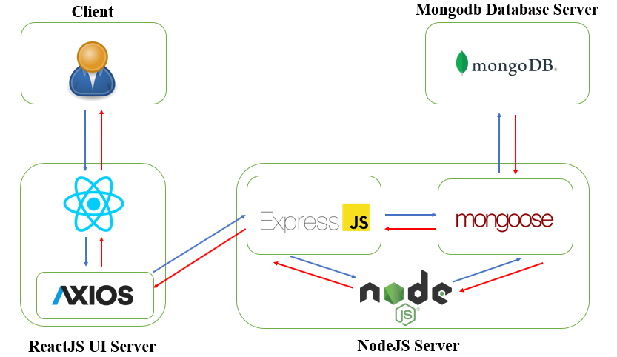

Image 1.2.Website data flow diagram using MERN Stack

[6 – References 6]

## RESTFUL API

### Overview of Restful API

RESTful API is a standard used in designing API for web applications (designing Web services) to facilitate the management of resources. It focuses on system resources (text files, images, audio, video, or dynamic data ...), including resource states that are formatted and transmitted over HTTP.



Image 1.3.Data flow of restful API

The components:

API (Application Programming Interface) is a set of rules and mechanisms by which an application or a component will interact with another application or component. The API can return the data that you need for your application in common data types like JSON or XML.

REST (REpresentational State Transfer) is a data structure transformation, an architectural style for writing APIs. It uses a simple HTTP method to facilitate communication between machines. So instead of using a URL for handling some user information, REST sends an HTTP request like GET, POST, and DELETE, to a URL to process the data.

RESTful API is a standard used in designing APIs for web applications to manage resources. RESTful is one of the most commonly used API designs today for different applications (web, mobile, etc.) to communicate with each other.

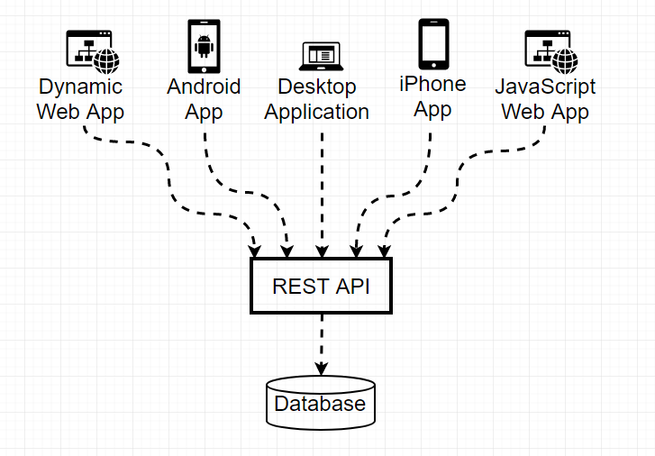

Image 1.4.Multi-platform on Restful API

The most important REST function is to specify how to use HTTP methods (like GET, POST, PUT, DELETE ...) and how to format URLs for web application to manage resources. RESTful does not specify application code logic and is not limited to an application programming language, any language or framework can be used to design a RESTful API.

[8 – References 8]

### Advantages

* Performance: components ensure that the communication follows a convention for better system performance.
* Variability: for systems that need constantly changing resources, using REST with simple request creation makes things simpler.
* Extensibility: REST systems are highly scalable thanks to the separation of components and pre-defined communication conventions.
* Flexibility: The standardized interface makes the system more flexible, can be used for many different platforms, mobile, web, ...
* Transparency: in the communication between components, requests become very clear and easy to understand.
* Simplicity: construction is very simple, for example resource declaration in rails helps to build uri for resources.
* Reliability: It is difficult to fail in communication between the components that crashes the system.

### Disadvantages

* Only works on HTTP protocols.
* Security and authentication may not be guaranteed by SOAP (stateless).

## MONGODB

### NoSQL

The term NoSQL was first introduced in 1998 as a generic name for lightweight open source relational databases but does not use SQL for queries. In 2009, Eric Evans, a Rackspace employee, reintroduced the term NoSQL in a seminar on distributed open source databases. The term NoSQL marks the development of a new generation of database: distributed and non-relational (not tied).

Today, we can understand that NoSQL is an open source database without using Transact-SQL to query information. NoSQL is abbreviated by: None-Relational SQL, or is often called Not-Only SQL. This database is developed on Javascript Framework with JSON data type (JSON's syntax is "key: value"). NoSQL was born as a patch for the shortcomings of the RDBMS relational data model in terms of speed, features, scalability, memory cache, ...

**Some general features:**

* NoSQL stores its data in the form of "key - value" value pairs. Uses a large number of nodes to store information.
* Distributed model under software control.
* Accept duplicate data because several nodes will store the same information.
* A query will be sent to many machines at the same time, so when a certain machine cannot serve, it will not affect the quality of returning the results.
* Non-relational, there are no constraints for data consistency.
* Consistency not in real time: After each database change, there is no need to immediately impact all related databases but is spread over time.

**Why use NoSQL database?**

* Flexible: NoSQL databases often provide flexible diagrams that help the development process faster and more repetitive. The flexible data model makes NoSQL database an ideal choice for data that is not structured or has an incomplete structure.
* Ability to scale: NoSQL databases are often designed to scale using distributed hardware clusters instead of scaling up by adding costly and powerful servers.
* High performance: NoSQL database is optimized for specific data models and access patterns for higher performance than trying to achieve a similar level of functionality with relational database.
* Extremely practical: NoSQL database provides extremely practical APIs and data types, built specifically for each respective data model.

**Popular NoSQL systems**

***Document database (e.g. CouchDB, MongoDB):*** Data is added and stored as a free JSON structure or "document", in which the data can be of any type, from integer to string or to free texts.

* Advantages: Used when the source data is not fully described.
* Disadvantage: Query performance, there is no standard syntax for data queries.

***Key-value stores (e.g. Redis, Riak):*** Freeform values, from simple integers or strings to complex JSON documents, accessed in the database by keys.

* Advantages: Search is very fast.
* Disadvantage: Save data not according to certain schema.

***Wide column stores (e.g. HBase, Cassandra):*** Data is stored in columns instead of rows like in a conventional SQL system. Any number of columns (and therefore a variety of data types) can be grouped or aggregated as needed for data queries or views.

* Advantages: Quick search, Good data distribution.
* Disadvantage: Support with very little software.

***Graph database (example: Neo4j):*** Data is represented as a network or graph of entities and relationships of that entity, with each node in the graph being a block of data in freeform.

* Advantages: Applying algorithms on graph such as shortest path, interconnection, ...
* Disadvantage: Have to browse the graph internally, to answer queries. Not easy to disperse.

### Overview of Mongodb

MongoDB was born by MongoDB Inc., at that time 10th generation, in October 2007 it was part of a PaaS (Platform as a Service) product, similar to Windows Azure and Google App Engine. Then it was turned open source in 2009. Today, MongoDB is the leading NoSQL database, used by millions of people.

MongoDB is an object-oriented, open source database program in which tables are flexibly structured allowing data to be stored on the table without having to follow a certain type of structure. Because of this flexible structure, MongoDB can be used to store data with complex and variable structure and is not fixed (also known as Big Data).

MongoDB is a document database. Written in C ++ language. Because it is written in C ++, it is capable of high speed computation, unlike the current database management systems.

In addition, MongoDB is a cross-platform database, working on Collection and Document concepts, it provides high performance, high availability, and easy scalability

Common terms used in MongoDB:

* _id: is a required field in each document. The _id field represents a unique value in the MongoDB document. The _id field can also be interpreted as the primary key in the document. If you add a new document, MongoDB will automatically generate a _id representing that document and is unique in the MongoDB database.
* Collection: A group of documents in MongoDB. Collection can be understood as a corresponding table in the RDBMS (Relational Database Management System). Collection resides in a single database. Collections do not have to define columns, rows or data types first.
* Cursor: This is a pointer to the result set of a query. The client can iterate over a pointer to get the results.
* Database: The place containing the Collection, like the RDMS database they contain tables. Each Database has its own file stored in physical memory. A MongoDB server can contain many Database.
* Document: A record belonging to a Collection is called a Document. Documents include name and value fields, respectively.
* -Field: is a name - value pair in a document. A document can have zero or more fields. The fields are like columns in a relational database.
* JSON: Short for JavaScript Object Notation. Human readable in simple textual representation for structured data. JSON currently supports a lot of programming languages.
* Index: are special data structures, used to hold a small portion of the data sets to easily scan. An index stores the value of a particular field or set of fields, sorted by the value of these fields. Index effectively supports the analysis of queries. Without an index, MongoDB would have to scan all documents of the collection to select which documents match the query. This scan is inefficient and requires MongoDB to process large volumes of data.

Below given table shows the relationship of RDBMS terminology with MongoDB

Table .. The relationship of RDBMS terminology with MongoDB

|  |  |
| --- | --- |
| **MongoDB** | **RDBMS** |
| Document orientation and non-relational databases | Relational databases |
| Document-based | Item based |
| Based on Field | Column-based |
| Based on Collection and key-value pairs | Table based |
| Provide Javascript client for the query | Does not provide Javascript for queries |
| Relatively easy to set up | Relatively not easy to set up |
| It is unaffected by SQL injection | It is quite vulnerable to SQL injection |
| Ideal for decentralized data storage | Not good for hierarchical data storage |
| There is dynamic schema | Contains predefined schema |
| 100 times faster | Vertical scale of RAM |
| It can extend horizontally through sharding | Vertical scale of RAM |

|  |  |
| --- | --- |
| **Database Server and Client** | |
| Mysqld/Oracle | mongod |
| mysql/sqlplus | mongo |

### Advantages

* Unstructured, non-constrained, intact data storage results in high availability, great efficiency, and easy storage expansion.
* Data is caching (buffered) to RAM, restricting access to the hard drive so the read and write speed is high.

### Disadvantges

* Not applicable to any transaction models that require high precision due to no constraints.
* There is no transaction mechanism to service banking applications.
* Data uses RAM as the focus of activity so when the operation requires a large RAM memory.
* Any changes to the default data are not written to the hard drive immediately, so the chance of losing data from the unexpected power failure is very high.

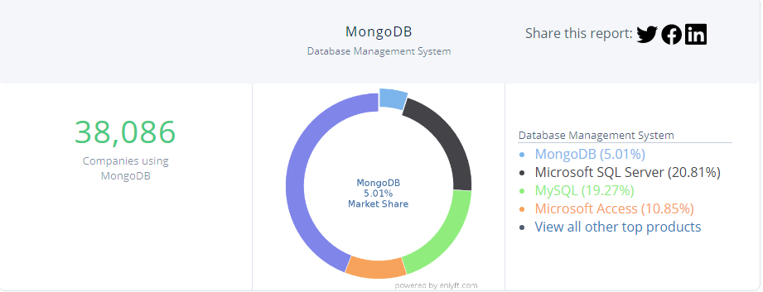

Image 1.5. MongoDB Market Share and Competitors in Database Management System

### Current version

The current latest vserion is version 4.4

### Mongodb used in project

In the project, mongodb is used as the database of the website

## NODEJS

### Overview of NodeJS

NodeJS is a platform built on the "V8 Javascript engine" written in C ++ and Javascript. This platform was developed by Ryan Lienhart Dahl, sponsored by the California-based company Joyent, USA in 2009.

NodeJS was born when the early developers of JavaScript extended it from something you could only run in the browser to something you could run on your machine as a standalone application. NodeJS creates real-time, fast-processing applications.

NodeJS apply to applications with massive traffic, need to scale fast, need to innovate in technology, or create Startup projects as quickly as possible.

NodeJS is suitable for applications:

* Websocket servers: Web socket servers such as Online Chat, Game Server ...
* Fast File Upload Client: programs that upload files with high speed.
* Ad Server: The ad servers.
* Cloud Services: Cloud services.
* RESTful APIs: these are the applications that are used for other applications through the API.
* Any Real-time Data Application: Any real-time speed requirement. Micro Services: The idea of micro services is to break a large application into small services and connect them together. NodeJS can do this well.



Image 1.5.Photos of companies using NodeJS

[5 – References 5]

### Node Package Manager (NPM)

Node package manager is a tool to create and manage Javascript programming libraries for NodeJS.

In the Javascript community, programmers share thousands of libraries with code that already performs a certain function. It helps new projects avoid rewriting basic components, programming libraries, or even frameworks.

With NPM, managing libraries is much simpler. The libraries are all available on NPM, you run a command line to download them and easily include them.

### Advantages

* NodeJS is very fast and consumes less resources because NodeJS is built on V8 Javascript platform, moreover, NodeJS receives and processes many connections with just a single-thread. This helps the system to consume the least RAM and run fastest without having to create new threads for each query like PHP. In addition, taking advantage of the non-blocking I/O advantage of Javascript that NodeJS makes the most of the server's resources without creating latency like PHP.
* Highly scalable, this is an important requirement when you are trying to create a large product and want to ensure fast scalability, meeting a large number of users as your site evolved.
* NodeJS is very suitable for building RESTful API (json). Almost no language handles JSON more easily than Javascript, not to mention that API servers often don't have to processor heavy tasks but the amount of concurrent requests is very high. But NodeJS will handle non-blocking. There is nothing more appropriate than NodeJS in this case.
* Suitable for developing applications on 1 page (Single page Application). NodeJS with fast processing speed, capable of handling multiple requests concurrently and fast response time.
* Built based on Javascript language, NodeJS has similar syntax. Suitable for Javascript programmers.
* NodeJS is very developed, with strong community. There are libraries and tools to assist in the software development process.
* Suitable for building real-time application: With the advent of mobile applications & HTML 5, NodeJS is very effective when building real-time applications such as chat applications. , social networking services such as Facebook, Twitter, ...

### Disadvantages

* Like most new technologies, implementing NodeJS on a host is not easy. NodeJS is that it's still in the early stages of development, which means that some of the features will change as it progresses.
* Resource intensive application.
* If you need to deal with applications that consume CPU resources such as encoding video, converting files, decoding encryption… or similar applications, do not use NodeJS. Because NodeJS is written in C ++ & Javascript, it takes a long time to go through a NodeJS compiler. In this case, write a C ++ Addon to integrate with NodeJS for maximum performance increase.

### Recent versions of NodeJS

The latest version as of 10/10/2020 is 14.13.1. Versions are released very quickly, almost only a month to have a new version.

### NodeJS used in project

In the project, NodeJS is used to build Restful API

## EXPRESSJS

### Overview of Midleware

Middleware is between the request and the response. It receives requests, executes the corresponding commands on that request. Once completed, it responds or passes the delegate result to another Middleware in the queue.

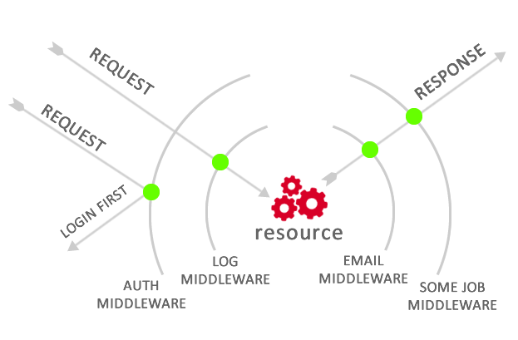

Image 1.6. Photo of how middleware work

Modern Web Frameworks are now using it as part of an application to connect other parts together. For web applications, using Middleware effectively makes it possible to minimize the number of lines of code to write in the application.

With the general idea is the bridge between user interaction and system in Web programming. Middleware acts as an intermediary between the request/response and the logic processing inside the web server.

Therefore, Middleware in the Framework for Web applications (Laravel, Django, Rails, ExpressJS ...), will be the functions used to preprocess, filter requests before being put into processing logic or adjust responses before sent to the user.

### Overview of ExpressJS

ExpressJS is a framework built on top of NodeJS. It offers powerful features for web or mobile development. ExpressJS supports HTTP and midleware methods which makes API extremely powerful and easy to use.

ExpressJS is released under an open source license, has a large support community, is allowed to use for commercial purposes. So you can completely rest assured to use this framework for your projects, from small to large projects.

Some of the main functions of ExpressJS:

* Middleware support to return HTTP requests
* Defines the route based on HTTP (CRUD) actions
* Allows rendering of html pages using template engines (jade, pug ...)

Middleware in ExpressJS:

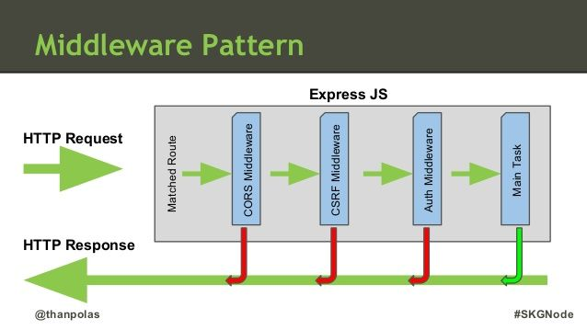

Image 1.7. Middleware in ExpressJS

The figure above shows three middleware included in ExpressJS. A request when sent to Express will be handled through 5 steps as follows:

* Find the Route corresponding to the request
* Use CORS Middleware to check the cross-origin Resource sharing of the request
* Use CRSF Middleware to authenticate the CSRF of the request and prevent fake requests
* Use Auth Middleware to verify whether the request is accessed or not
* Handle the work requested by request (Main Task)
* Any step in step 2,3,4, if an error occurs, will return a response to the user, which can be CORS error, CSRF error or auth error depending on which step the request is stopped at.

### ExpressJS used in project

Used to build Restful API

## PYTHON

### Overview of Python

Python is an interpreted high-level general-purpose programming language. Python's design philosophy emphasizes code readability with its notable use of significant indentation. Its language constructs as well as its object-oriented approach aim to help programmers write clear, logical code for small and large-scale projects.

Python is dynamically-typed and garbage-collected. It supports multiple programming paradigms, including structured (particularly, procedural), object-oriented and functional programming. Python is often described as a "batteries included" language due to its comprehensive standard library.

Guido van Rossum began working on Python in the late 1980s, as a successor to the ABC programming language, and first released it in 1991 as Python 0.9.0. Python 2.0 was released in 2000 and introduced new features, such as list comprehensions and a garbage collection system using reference counting. Python 3.0 was released in 2008 and was a major revision of the language that is not completely backward-compatible and much Python 2 code does not run unmodified on Python 3. Python 2 was discontinued with version 2.7.18 in 2020.

Python consistently ranks as one of the most popular programming languages.

### Python in project

Used to build virtual assistants

## FLASK

### Overview of Flask

Flask is a web framework, it belongs to the type of micro-framework built in Python programming language. Flask allows you to build simple to complex web applications. It can build small APIs, web applications such as websites, blogs, wiki pages or a time-based website or even a commercial website. Flask provides you with the tools, libraries, and technologies to help you do the above.

Flask is a micro-framework. This means that Flask is a standalone environment, with little use of other external libraries. Therefore, Flask has the advantage of being lightweight, has very few errors due to few dependencies as well as easy to detect and handle security errors.

### Flask in project

Used to build an API to respond to messages when there is an incoming message that needs a bot to respond

## NLTK

### Overview of NLTK

The Natural Language Toolkit, or more commonly NLTK, is a suite of libraries and programs for symbolic and statistical natural language processing (NLP) for English written in the Python programming language. It was developed by Steven Bird and Edward Loper in the Department of Computer and Information Science at the University of Pennsylvania. NLTK includes graphical demonstrations and sample data. It is accompanied by a book that explains the underlying concepts behind the language processing tasks supported by the toolkit, plus a cookbook.

NLTK is intended to support research and teaching in NLP or closely related areas, including empirical linguistics, cognitive science, artificial intelligence, information retrieval, and machine learning. NLTK has been used successfully as a teaching tool, as an individual study tool, and as a platform for prototyping and building research systems. There are 32 universities in the US and 25 countries using NLTK in their courses. NLTK supports classification, tokenization, stemming, tagging, parsing, and semantic reasoning functionalities.

### NLTK in project

Used to build predictive models from sample data and analyze incoming messages to make predictions about that type of message response.

## REACTJS

### Overview of ReactJS

React (Or ReactJS, React.js) is an open source Javascript library for building reusable interface components, building UI for the web in accordance with Single Page Applications trend. It was created by Jordan Walke, a software engineer at Facebook. React was first implemented for Facebook's Newsfeed app in 2011, then was implemented for Instagram.com in 2012. It was launched as an open source JavaScript engine in 2013.

Overall all of ReactJS's great power comes from its focus on components, which means that ReactJS allows developers to break the user interface from something big and complex into components that are many times smaller and simpler, these components are highly interactive and reusable, meaning that data rendering is not only done at the server location, but also at the Client location when using ReactJS.

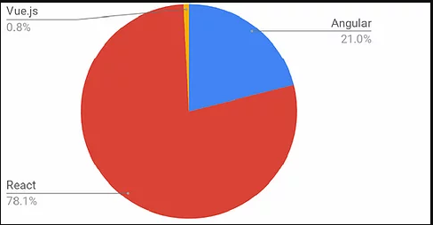

Image 1.8. Popular front end language chart – 2019

[2 – References 2]

### The characteristic of ReactJS

*Virtual DOM*

Virtual DOM technology enhances application performance. The fact that only the root node has a state and when it changes, will restructure whole, meaning that the DOM tree will also have to change a part, which affects the processing speed. React JS uses Virtual DOM (virtual DOM) to improve this problem. Virtual DOM is a Javascript object, each object contains all the information needed to create a DOM, when the data changes it will calculate the change between the object and the real tree, this optimizes re-rendering of the real DOM tree.



Image 1.9. Difference between virtual DOM and real DOM

React uses one-way data binding mechanism. Data is passed from parent to child via props. Simple data flow makes it easy to control and control and fix bugs. With the above features, React is used to build large applications whose data changes continuously over time. Most of the data changes with interface changes.



Image 1.10. Data flow and Events flow in ReactJS

*JSX*

JSX is a language that allows to write HTML code in Javascript. Characteristics of JSX

Faster: JSX performs optimization while compiling to Javacsript code. These codes give a much faster execution time than an equivalent code written directly in Javascript.

Safer: In contrast to Javascript, JSX is statically-typed, meaning it is compiled before running, just like Java, C ++. So errors are detected right away during compilation. In addition, it also provides very good compile-time debugging.

Easier: JSX inherits Javascript based, so it's very easy for Javascripts developers to use.

*Components*

React is built around components, not using templates like other frameworks. In React, we build web pages using small components. We can reuse a component in many places, with different states or properties, in a component can contain other components. Each component in React has its own state, which can be changed, and React will perform component updates based on state changes.

*Props and State*

Props: to help the components interact with each other, the component receives an input called props, and returns a property describing what the child component will render. Prop is immutable.

State: shows the state of the application, when the state changes, the component concurrently re-renders to update the UI.

### Recent versions of ReactJS

Table .. Recent versions of ReactJS

|  |  |  |
| --- | --- | --- |
| Version | Meeting day | Update |
| 16.10.1 | 28/9/2019 | Fix regression in Next.js apps |
| 16.10.2 | 3/10/2019 | Fix regression in react-native-web |
| 16.11.0 | 22/10/2019 | Fix mouseenter handlers from firing twice inside nested React containers. |
| 16.12.0 | 14/11/2019 | React DOM - Fix passive effects (useEffect) not being fired in a multi-root app. |
| 16.13.0 | 26/2/2019 | Fix regressions in React core library and React Dom. |
| 16.13.1 | 19/3/2020 | Fix bug in legacy mode Suspense where effect clean-up functions are not fired  Revert warning for cross-component updates that happen inside class render lifecycles. |

### Advantages

* Easy to learn, thanks to the simple design, using JSX allows programmers with knowledge of Javascript to be more accessible. Skills learned in React can be applied to React Native development.
* ReactJS is extremely efficient: ReactJS creates its own virtual DOM - where the components actually live on, which will greatly improve performance. ReactJS also calculates what changes need to be updated to the DOM and only does them, which helps ReactJS avoid expensive DOM manipulations.
* ReactJS makes writing Javascript code easier: It uses a special syntax JSX (Javascript extension) that allows us to mix HTML and Javascript code. We can add HTML snippets into the render function without having to concatenate. This is an interesting feature of ReactJS. It will convert the HTML snippets into HTML object constructors using the JSX converter.
* There are many development tools available: When you start ReactJS, don't forget to install the Chrome extension (or other browsers) for ReactJS. It makes debugging the code easier. After you install this application, you will have a direct view of the virtual DOM as if you were looking at a regular DOM tree.
* Server layer rendering: One of the problems with single page applications is SEO optimization and page load times. If all construction and rendering of the page is done on the client, then the user will have to wait for the page to be initialized and displayed. This is actually slow. Or what if the user has disabled Javascript? ReactJS is a component library, it can both render outside the browser using the DOM and also render with the HTML strings returned by the Server.
* Working with interface test: It is extremely easy to write interface test cases because the virtual DOM is completely installed in JS.
* High performance for applications with constantly changing data, easy for maintenance and fix bugs.

### Disadvantages

* ReactJS only serves the View layer. React is just a View Library, it's not a MVC framework like other frameworks. This is just a Facebook library that help render the view. So React will not have the Model and Controller, but must be combined with other libraries. React also won't have 2-way binding or Ajax
* Integrating ReactJS into traditional MVC frameworks requires reconfiguration.
* React is quite heavy compared to other frameworks.
* Hard to reach for Web beginners.

### Redux library

Redux is an open source JavaScript library for managing the state of JavaScript applications. Redux is often used in conjunction with some other JavaScript libraries like React or Angular to build the front-end for a Web application (Redux is not dependent on React or Angular). Redux was born inspired by the ideology of Elm language and architecture of Flux (Facebook), created by Dan Abramov and Andrew Clark.

The basic components of Redux:

* ***Actions:*** is simply events. They are how we send data from the app to the Redux store. These data can be from user interaction with app, API calls or it can be from form submission.
* ***Reducers*** are primitive functions that take the current state of the app, perform an action and return a new state, those states are stored as objects. They specify how an application's state changes in response to an action sent to the store.
* ***Store*** saves the application state and is unique in any Redux application. You can access stored states, update states, and register or unsubscribe from listeners via helper methods.

How it Works: When an action is sent to the Store, the Store uses the Reducer functions, based on the Action's type and payload information, merges with the current state, and produces a new state.

[3 – References 3]

### Redux-thunk library

Redux Thunk is a Middleware that allows you to write Actions that return a function instead of a plain javascript object by delaying the action to be passed to the reducer. Redux Thunk is used to handle complex asynchronous logic that requires access to the Store or simply retrieving data like an Ajax request.

Redux Thunk allows to return Actions as a function instead of just a PJO (action usually returns an object, it is called a plain Javascript object), it acts as a middleware that is set before the time reducer receives the request. to determine if the action returns a PJO or not, if it's a PJO, the Thunk will pass the action to the Reducer as usual, if the action returns a function, the Redux Thunk will "block" the action and wait for it. until some asynchronous command in the function completes and returns the result (like the response value above). At this point we have received a PJO and the Redux Thunk will send this action to the Reducer as usual. So we have the following diagram:



Redux Thunk is a Middleware that allows you to write Actions that return a function instead of a plain javascript object by delaying the action to be passed to the reducer.

Redux Thunk is used to handle complex asynchronous logic that requires access to the Store or simply retrieving data like an Ajax request.

### Axios library

Axios is an HTTP Client library based on Promise. It basically provides an API for handling XHR (XMLHttpRequests). Axios is suitable for front-end UI programming libraries such as React, Vue.js or Angular, ... Axios can work in almost all browsers.

Current browsers now have the Fetch API features built in. However, one of the biggest characteristics of Axios compared to Fetch is the handling of HTTP error codes by the two libraries. When using Fetch, if the server returns the status codes of 4xx or 5xx, the programmer has to manually check for those error codes. Meanwhile, Axios will reject all requests if one of the above error codes is returned.

[7 – References 7]

### ReactJS in project

In the project, ReactJS is used to build the website interface version 16.13.1.

## JSON WEB TOKEN

### Overview of Json web token

JWT is a means to represent the transfer request between two parties Client - Server, the information in JWT string is formatted with JSON. In which the Token chain must have 3 parts, the header, the payload part and the signature part, which must be separated by a "."

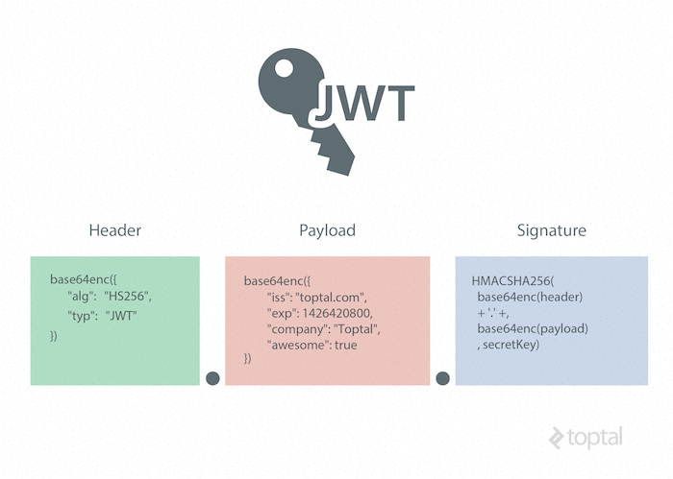

Image 1.11. Components of JWT

So according to the theory above, I will have a Token chain as follows: header.payload.signature

Header

The header will contain the data type, and the algorithm used to encode the JWT string

{

"typ": "JWT",

"alg": "HS256"

}

" typ " (type) indicates that the object is a JWT

“alg” (algorithm) defines the encryption algorithm for the string is HS256

Payload

The payload section will contain the information you want to put in the Token chain such as username, userId, author, ... for example:

{

"user_name": "admin",

"user_id": "1513717410",

"authorities": "ADMIN_USER",

"jti": "474cb37f-2c9c-44e4-8f5c-1ea5e4cc4d18"

}

Signature

This signature will be generated by encrypting the header, the payload is accompanied by a string secret, for example:

data = base64urlEncode( header ) + "." + base64urlEncode( payload )

signature = Hash( data, secret );

base64UrlEncoder: thuật toán mã hóa header và payload

When should I use JSON Web Token?

Authentication: This is the most common case using JWT. When the user is logged into the system, the next request from the user will contain additional JWT codes. This allows a user to be granted access to the urls, services, and resources that that token allows. This method is unaffected by Cross-Origin Resource Sharing (CORS) since it does not use cookies.

[1- References 1]

### Json web token in project

Used to login, verify identity, position.

# SURVEY OF STATUS AND DETERMINATION **OF REQUIREMENTS**



## SURVEY OF CURRENT STATUS

Fashion has always been an essential part of life. The business of fashion items has also become active since then, especially on the e-commerce platform - which is the current business trend. Beginners without capital or experience want to start with e-commerce. Or stores that want to open an e-commerce channel. Therefore, an e-commerce channel that is supported on both website and mobile platforms is essential.

Most people today are either busy, or lazy with the help of technology, or for other reasons that make them less likely to visit offline stores. Instead, they often shop online. Online shopping also has many benefits, such as more convenience, or sometimes the price will be cheaper. Therefore, online shopping has recently become a great demand of customers.

Here is the work of the e-commerce system for the store chain required to provide users:

- SuperAdmin: manage their stores in detail such as: view information, manage products of stores.

- Admin: process orders, reply comments.

- Customers: view, comment, rate and order easily via computer or phone.

### Shopee

#### Introduction

Shopee is the leading e-commerce platform in Southeast Asia, headquartered in Singapore and a subsidiary of Sea company, formerly Garena (owners of brands such as: Garena, Foody, Now, Airpay). from 2015 and at the present time has been present in a total of 7 Asian countries including: Singapore; Malaysia; Thailand; Taiwan; Indonesia; Vietnam, and the Philippines.

Shopee was born to create an e-commerce platform to provide customers with an easy, safe and convenient online shopping experience by fast payment and shipping process.

Besides, Shopee will create a business environment for individuals, organizations and businesses that want to promote, market and distribute their products to customers. Just a few simple steps to register and upload, describe products, everyone can open a store on Shopee and this is also an online business opportunity for any individual, any organization.

Present in Vietnam around August 2016. Up to the present time, Shopee can be seen as superior to its predecessors such as Lazada, Tiki, Adayroi, Lotte….

#### Advantages

* Provide almost all the professional functions that users need such as: preferential sale prices, regular discounts, policies to protect both buyers and sellers.
* Intuitive user interface, provide product information fully as well as search filters
* Offers many forms of delivery and payment, including payment by Shopee coin, a virtual currency of Shopee and through the e-wallet AirPay
* Provide many login methods

#### Disadvantages

Because there are too many functions, leading to a decrease in website performance, in particular the response speed and page load are quite slow.

### Tiki

#### Introduction

As one of the largest e-commerce sites in Vietnam, according to iPrice's statistics in the second quarter of 2019, Tiki ranks second among e-commerce exchanges in Vietnam, just behind Shopee (in terms of visits).

Tiki operates under the business model of B2C (Business to Customer), which means Tiki is the intermediary connecting consumers and businesses / sellers together. Creating a friendly, convenient and easy online shopping environment for both buyers and sellers.

Brands / businesses / traders / sellers will register to open booths on Tiki to sell their products. Besides, Tiki himself also directly sells and distributes many products of genuine brands through TikiTrading booth.

Front-end:

* Website using ReactJS.
* Phones using React Native.

#### Advantages

* Website has a scientific and reasonable layout
* Page loading speed is quite fast
* Take advantage of ReactJS human resources for React Native development
* Easy to maintain

#### Disadvantages

* The interface is confusing for the first-time visitor
* The size of the website is about 3MB (2018)
* Small photo but big size

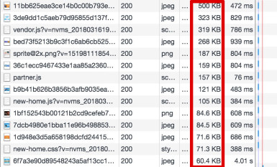

Image ..Size of photo on Tiki

* Css is quite heavy

### YaMe

#### Introduction

YaMe is a Vietnamese fashion brand for young people. YaMe means You are My everything.

YaMe has been launching more trendy collections to contribute to the fashion trend of contemporary youth! Quickly and promptly catch the latest trends of the world to bring to Vietnam...

Do not always follow the trend, lose yourself. YaMe has always kept the values it has built and developed for a long time, the highlights that have brought customers to YaMe during the past time. In addition to investment products and picky faces, YaMe still regularly launches casual designs at great prices for students.

#### Advantages

* Fast page loading speed
* Limit the maintenance of lead over time

#### Disadvantages

* Long application development time.
* Suitable for websites that require high speed, light. Not suitable for websites that ask for fast development time.
* Requires high knowledge as well as skills
* Difficulty in website maintenance.
* Complicated and difficult to use user interface



## DETERMINATION OF REQUIREMENTS

### Functional requirements

#### Professional function requirements

##### Guest

* **View homepage**
  + View poster
  + View Featured products
* **Search product**
* **View product detail and view reviews**
* **Register**
* **Login:**
  + Login with website account
  + Login with Google
  + Login with Facebook
  + Recover password

##### Customer

* **View homepage:**
  + View poster
  + View recommended products
  + View Featured products
* **Search product**
* **View product detail and reviews**
* **Comment and rate**
  + Comment and rate
  + Reply comment and rate
  + Edit and remove comment and rate
* **Manage personal information:**
  + Edit personal information
  + Add, edit, delete addresses
  + Add avatar
  + Edit avatar
  + Change password
* **Manage cart:**
* Add product to cart
* Remove product from cart
* Edit product quantity
* Edit product type
* **Order:**
* Order
* Pay
* **Manage orders:**
  + View personal order list
  + Search orders
  + View order detail
  + Cancel order
* **View notifications**
* **Chat**
* **Logout**

##### Admin

* **Including customer functions**
* **View system notifications**
* **Manage orders:**
  + View order list
  + Search orders
  + View order detail and order status
  + Approve order
  + Confirm received order
  + Confirm failed order
  + Cancel order

##### SuperAdmin

* **Including Admin functions**
* **Manage Users:**
  + View user list
  + Search users
  + View user information
  + Authorize account
  + Disable user account
* **Manage brands:**
  + Add new brand
  + View list brand
  + Edit brand information
  + Disable brand
* **Manage category groups:**
  + Add new category group
  + View list category group
  + Edit category group information
  + Disable category group
* **Manage categories:**
  + Add new category
  + View list category
  + Edit category group
  + Disable category
* **Manage products:**
  + Add new product
  + View list product
  + Search products
  + View product detail
  + Edit product information
  + Disable product
* **Manage product options:**
  + Add new product option
  + View list product option
  + Edit product option information

#### System function requirements

* **Authorization:**
* Guest: Only view homepage, search products, view product detail, view product reviews, signup and login
* Customer: View homepage, search products, view product detail, view reviews, comment and rate, chat, manage personal information, add product to card, manage cart, order and manager order.
* Admin: Manage orders and have same functions as Customer
* SuperAdmin: Manage users, manage brand, manage products, manage product options and have same functions as Admin
* **Notification:**
* Always be informed when the operation succeeds or fails
* **Security:**
* Always check the permissions before working with data
* Against basic attacks such as: xss, sql injection, CSRF, ...
* **Storage:**
* Users
* Admins
* Chats
* Images
* Brands
* Categories
* Category groups
* Products
* Orders

### Non-functional requirements

* **Usability:**
* Easy-to-see, user-friendly interface
* Fully functional
* Easy to manipulate
* **Effectiveness:**
* Fast and efficient search speeds
* Fast page loading speed
* **Compatibility:**
* To meet multiple platforms and devices
* **Development:**
* Easy to develop applications, and use in trading other products
  + **Maintainment:**
* Easy to operate
* Easy maintenance and repair

# REQUIREMENT MODELING



## DEFINE USECASE

### Actor

Table .. Actor

|  |  |  |  |  |  |
| --- | --- | --- | --- | --- | --- |
| **No** | **Use case** | **SuperAdmin Actor** | **Admin Actor** | **Customer Actor** | **Guest Actor** |
| 1 | Register |  |  |  | x |
| 2 | Login |  |  |  | x |
| 3 | Logout | x | x | x |  |
| 4 | Change password | x | x | x |  |
| 5 | Recover password | x | x | x |  |
| 6 | Manage personal information | x | x | x |  |
| 7 | View personal notifications | x | x | x | x |
| 8 | Chat | x | x | x |  |
| 9 | View homepage | x | x | x | x |
| 10 | Search product | x | x | x | x |
| 11 | View product detail | x | x | x | x |
| 12 | Comment and rate | x | x | x |  |
| 13 | Add product to cart | x | x | x |  |
| 14 | Manage cart | x | x | x |  |
| 15 | Order | x | x | x |  |
| 16 | Manage personal orders | x | x | x |  |
| 17 | View system notifications | x | x |  |  |
| 18 | Manage users | x |  |  |  |
| 19 | Manage brands | x |  |  |  |
| 20 | Manage category groups | x |  |  |  |
| 21 | Manage categories | x |  |  |  |
| 22 | Manage products | x |  |  |  |
| 23 | Manage orders | x | x |  |  |
| 24 | Create in-store order | x | x |  |  |
| 25 | View statistics | x |  |  |  |

### Use case

Table .. Use case

|  |  |  |  |  |  |
| --- | --- | --- | --- | --- | --- |
| **No** | **Use case name** | | | | **Use case ID** |
| 1 | Register | | | | UC_1 |
| 2 | Login | | | | UC_2 |
|  | 2.1 | Login with account | | | UC_2.1 |
|  | 2.2 | Login with Google | | | UC_2.2 |
|  | 2.3 | Login with Facebook | | | UC_2.3 |
| 3 | Logout | | | | UC_3 |
| 4 | Change password | | | | UC_4 |
| 5 | Recover password | | | | UC_5 |
| 6 | Manage personal information | | | | UC_6 |
|  | 6.1 | View personal information | | | UC_6.1 |
|  | 6.2 | Edit personal information | | | UC_6.2 |
|  | 6.3 | Add avatar | | | UC_6.3 |
|  | 6.4 | Edit avatar | | | UC_6.4 |
|  | 6.5 | Add address | | | UC_6.5 |
|  | 6.6 | Edit Address | | | UC_6.6 |
| 7 | View personal notifications | | | | UC_7 |
| 8 | Chat | | | | UC_ |
|  | 8.1 | Chat with other users | | | UC_8.1 |
|  | 8.2 | Chat with customer service | | | UC_8.2 |
|  | 8.3 | Chat with virtual assistant | | | UC_8.3 |
| 9 | View homepage | | | | UC_9 |
|  | 9.1 | View poster | | | UC_9.1 |
|  | 9.2 | View hot products | | | UC_9.2 |
|  | 9.3 | View recommended products | | | UC_9.3 |
| 10 | Search products | | | | UC_10 |
|  | 10.1 | View all products | | | UC_10.1 |
|  | 10.2 | Search products by name | | | UC_10.2 |
|  | 10.3 | Search products by category group | | | UC_10.3 |
|  | 10.4 | Search products by category | | | UC_10.4 |
|  | 10.5 | Sort products by option | | | UC_10.5 |
|  | 10.6 | Filter products by price | | | UC_10.6 |
| 11 | View product detail | | | | UC_11 |
| 12 | Comment and rate | | | | UC_12 |
|  | 12.1 | Comment | | | UC_12.1 |
|  | 12.2 | Reply comment | | | UC_12.2 |
|  | 12.3 | Edit comment | | | UC_12.3 |
|  | 12.4 | Remove comment | | | UC_12.4 |
|  | 12.5 | Rate | | | UC_12.5 |
|  | 12.6 | Replay rate | | | UC_12.6 |
|  | 12.7 | Edit rate | | | UC_12.7 |
|  | 12.8 | Remove rate | | | UC_12.8 |
| 13 | Add product to cart | | | | UC_13 |
| 14 | Manage cart | | | | UC_14 |
|  | 14.1 | Edit product quantity | | | UC_14.1 |
|  | 14.2 | Edit product option | | | UC_14.2 |
|  | 14.3 | Remove product | | | UC_14.3 |
| 15 | Order | | | | UC_15 |
|  | 15.1 | Create order | | | UC_15.1 |
|  |  | 15.1.1 | | Choose products from cart | UC_15.1.1 |
|  |  | 15.1.2 | | Choose payment method | UC_15.1.2 |
|  |  | 15.1.3 | | Choose receive method | UC_15.1.3 |
|  |  | 15.1.4 | | Choose receive address | UC_15.1.4 |
|  |  | 15.1.5 | | Choose shipping address | UC_15.1.5 |
|  |  | 15.1.6 | | View total price and shipping fee | UC_15.1.6 |
|  | 15.2 | Pay | | | UC_15.2 |
| 16 | Manage personal orders | | | | UC_16 |
|  | 16.1 | View personal order list | | | UC_16.1 |
|  | 16.2 | Search personal orders | | | UC_16.2 |
|  |  | 16.2.1 | | Search personal orders by order ID | UC_16.2.1 |
|  |  | 16.2.2 | | Search personal orders by product name | UC_16.2.2 |
|  |  | 16.2.3 | | Search personal orders by customer name | UC_16.2.3 |
|  |  | 16.2.4 | | Search personal orders by customer phone number | UC_16.2.4 |
|  | 16.3 | View personal order detail | | | UC_16.3 |
|  | 16.4 | Cancel order | | | UC_16.4 |
| 17 | View system notifications | | | | UC_17 |
| 18 | Manage users | | | | UC_18 |
|  | 18.1 | View user list | | | UC_18.1 |
|  | 18.2 | Search users | | | UC_18.2 |
|  |  | 18.2.1 | | Search user by name | UC_18.2.1 |
|  |  | 18.2.2 | | Search user by role | UC_18.2.2 |
|  | 18.3 | View user information | | | UC_18.3 |
|  | 18.4 | Authorize account | | | UC_18.4 |
|  | 18.5 | Disable user account | | | UC_18.5 |
| 19 | Manage brands | | | | UC_19 |
|  | 19.1 | Add new brand | | | UC_19.1 |
|  | 19.2 | View brand list | | | UC_19.2 |
|  | 19.3 | Search brands | | | UC_19.3 |
|  | 19.4 | Edit brand information | | | UC_19.4 |
|  | 19.5 | Disable brand | | | UC_19.5 |
| 20 | Manage category groups | | | | UC_20 |
|  | 20.1 | Add new category group | | | UC_20.1 |
|  | 20.2 | View category group list | | | UC_20.2 |
|  | 20.3 | Search category groups | | | UC_20.3 |
|  | 20.4 | Edit category group information | | | UC_20.4 |
|  | 20.5 | Disable category group | | | UC_20.5 |
| 21 | Manage categories | | | | UC_21 |
|  | 21.1 | Add new category | | | UC_21.1 |
|  | 21.2 | View category list | | | UC_21.2 |
|  | 21.3 | Search categories | | | UC_21.3 |
|  | 21.4 | Edit category information | | | UC_21.4 |
|  | 21.5 | Disable category | | | UC_21.5 |
| 22 | Manage products | | | | UC_22 |
|  | 22.1 | Add new product | | | UC_22.1 |
|  | 22.2 | View product list | | | UC_22.2 |
|  | 22.3 | Search products | | | UC_22.3 |
|  |  | 22.3.1 | | Search product by product name | UC_22.3.1 |
|  |  | 22.3.2 | | Search product by product category | UC_22.3.2 |
|  | 22.4 | View product information | | | UC_22.4 |
|  | 22.5 | Edit product information | | | UC_22.5 |
|  | 22.6 | Manage product options | | | UC_22.6 |
|  |  | 22.6.1 | | Create color option | UC_22.6.1 |
|  |  | 22.6.2 | | View color option list | UC_22.6.2 |
|  |  | 22.6.3 | | Edit color option | UC_22.6.3 |
|  |  | 22.6.4 | | Create size option | UC_22.6.4 |
|  |  | 22.6.5 | | View size option list | UC_22.6.5 |
|  |  | 22.6.6 | | Edit size option | UC_22.6.6 |
|  |  | 22.6.7 | | Create quantity option | UC_22.6.7 |
|  |  | 22.6.8 | | View quantity option list | UC_22.6.8 |
|  |  | 22.6.9 | | Edit quantity option | UC_22.6.9 |
|  | 22.7 | Disable product | | | UC_22.7 |
| 23 | Manage orders | | | | UC_23 |
|  | 23.1 | View order list | | | UC_23.1 |
|  | 23.2 | Search orders | | | UC_23.2 |
|  |  | 23.2.1 | | Search by product ID | UC_23.2.1 |
|  |  | 23.2.2 | | Search by product name | UC_23.2.2 |
|  |  | 23.2.3 | | Search by customer name | UC_23.2.3 |
|  |  | 23.2.4 | | Search by customer phone number | UC_23.2.4 |
|  | 23.3 | View order detail | | | UC_23.3 |
|  | 23.4 | Approve order | | | UC_23.4 |
|  | 23.5 | Confirm received order | | | UC_23.5 |
|  | 23.6 | Confirm failed order | | | UC_23.6 |
|  | 23.7 | Cancel order | | | UC_23.7 |
| 24 | Create in-store order | | | | UC_24 |
|  | 24.1 | | Create order | | UC_24.1 |
|  |  | | 24.1.1 | Choose products from cart | UC_24.1.1 |
|  |  | | 24.1.2 | Choose order method | UC_24.1.2 |
|  |  | | 24.1.3 | Fill customer information | UC_24.1.3 |
|  |  | | 24.1.4 | Choose payment method | UC_24.1.4 |
|  |  | | 24.1.5 | Choose receive method | UC_24.1.5 |
|  |  | | 24.1.6 | View total price | UC_24.1.6 |
|  | 24.2 | | Pay | | UC_24.2 |
| 25 | View statistics | | | | UC_25 |
|  | 25.1 | | View sales statistics | | UC_25.1 |
|  | 25.2 | | View revenue statistics | | UC_25.2 |

## USE CASE DIAGRAM

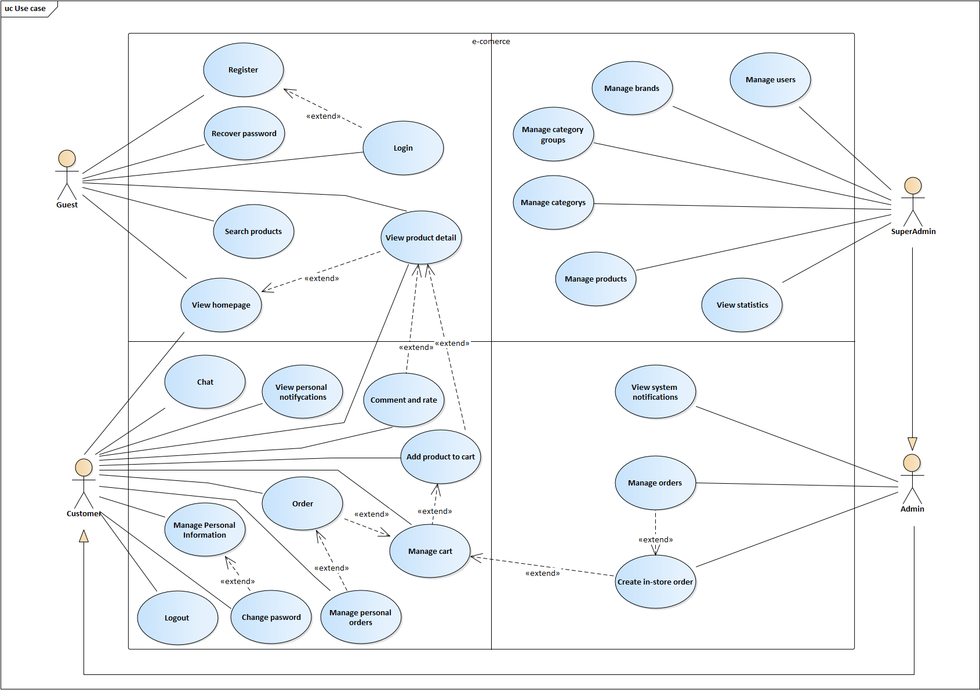

Image .. Use case diagram

## USE CASE SPECIFICATION

### Recover password

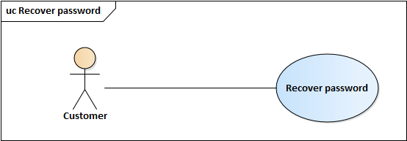

Image .. Use case Recover password

Table .. Specific description Recovery password

|  |  |
| --- | --- |
| Use Case ID | UC_5 |
| Name | Forget password |
| Goal | Allows users to reset their account password |
| Actors | Customer |
| Pre-conditions | Have a website account |
| Main flow | 1. On the login page 2. Click “Quên mật khẩu” 3. Enter your email and click “Tạo mật khẩu mới” on new page appears 4. An email will send to your email within a new password 5. Enter your PIN code into the new page and enter your new account password 6. Click “Đặt lại mật khẩu” |

### Manage personal information

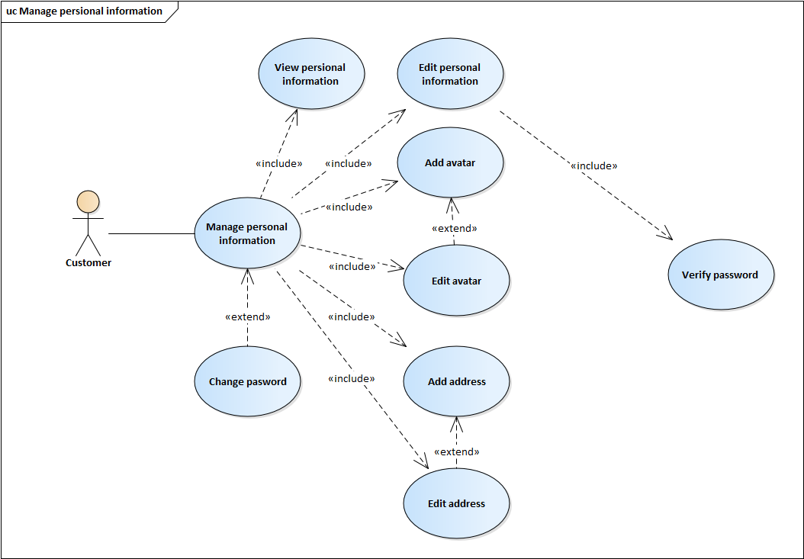

Image .. Use case Manage personal information

#### Add address

Table .. Specific description Add address

|  |  |
| --- | --- |
| Use Case ID | UC_6.5 |
| Name | Add address |
| Goal | Allows users to add their address |
| Actors | Customer |
| Pre-conditions | Signed in to the website |
| Main flow | 1. On any page of website after logged in, click on your name on header bar, you will be moved to Personal information page 2. Click “Địa chỉ” on navigation bar to move to address page 3. Click “Thêm địa chỉ” 4. On the new dialog appears, enter your address and then click “Lưu” |

#### Edit address

Table .. Specific description Edit address

|  |  |
| --- | --- |
| Use Case ID | UC_6.6 |
| Name | Add address |
| Goal | Allows users to edit their addresses |
| Actors | Customer |
| Pre-conditions | Signed in to the website |
| Main flow | 1. On any page of website after logged in, click on your name on header bar, you will be moved to Personal information page 2. Click “Địa chỉ” on navigation bar to move to address page 3. Click on address item which you want to edit 4. On the new dialog appears, edit your address and then click “Lưu” |

### Add product to cart

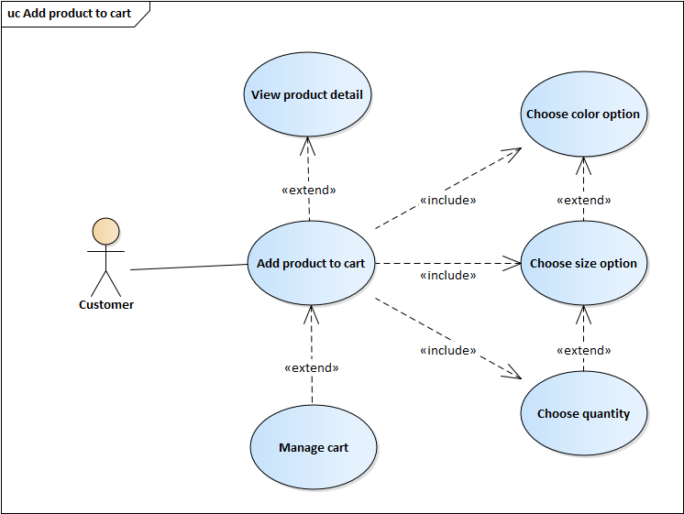

Image .. Use case Add product to cart

Table .. Specific description Add product to cart

|  |  |
| --- | --- |
| Use Case ID | UC_13 |
| Name | Add product to cart |
| Goal | Allows users to add products to cart |
| Actors | Customer |
| Pre-conditions | Signed in to the website and the product is added to the cart has enough quantity in stock and no quantity in the cart is less than 5 |
| Main flow | 1. Access the product detail page 2. Choose product color option 3. Choose product size option 4. Choose product quantity 5. Click “Thêm vào giỏ hàng” to add product to cart or click “Mua hàng” to add product to cart and move to cart page. The product |

### Manage cart

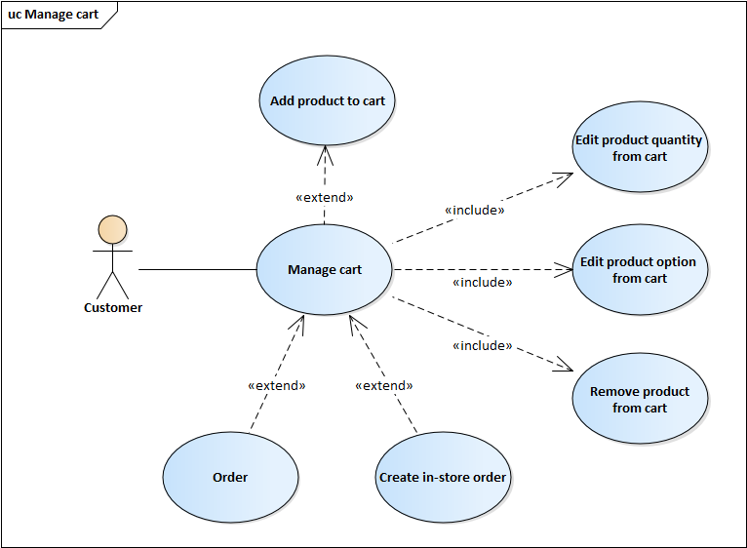

Image .. Use case Manage cart

#### Edit product quantity from cart

Table .. Specific description Edit product quantity from cart

|  |  |
| --- | --- |
| Use Case ID | UC_14.1 |
| Name | Edit product quantity from cart |
| Goal | Allows users to edit product quantity from cart |
| Actors | Customer |
| Pre-conditions | Signed in to the website and the product being manipulated has enough quantity in stock and no quantity in cart is less than 5 |
| Main flow | 1. Access to the cart page 2. On each cart item, click “+”, “-” or change number of quantity field to change product quantity |

#### Edit product option from cart

Table .. Specific description Edit product option from cart

|  |  |
| --- | --- |
| Use Case ID | UC_14.2 |
| Name | Edit product option from cart |
| Goal | Allows users to edit product option from cart |
| Actors | Customer |
| Pre-conditions | Signed in to the website and the product being manipulated has enough quantity in stock and no quantity in cart is less than 5 |
| Main flow | 1. Access to the cart page 2. Click on option field below one cart item which you want to change option 3. Choose your option in new form 4. Click “Thay đổi” to change option of cart item |

#### Remove product from cart

Table .. Specific description Remove product from cart

|  |  |
| --- | --- |
| Use Case ID | UC_14.3 |
| Name | Remove product from cart |
| Goal | Allows users to remove product from cart |
| Actors | Customer |
| Pre-conditions | Signed in to the website |
| Main flow | 1. Access to the cart page 2. Click remove icon in one cart item that you want to remove 3. A confirm dialog appears, click “Xóa” to remove cart item |

### Order

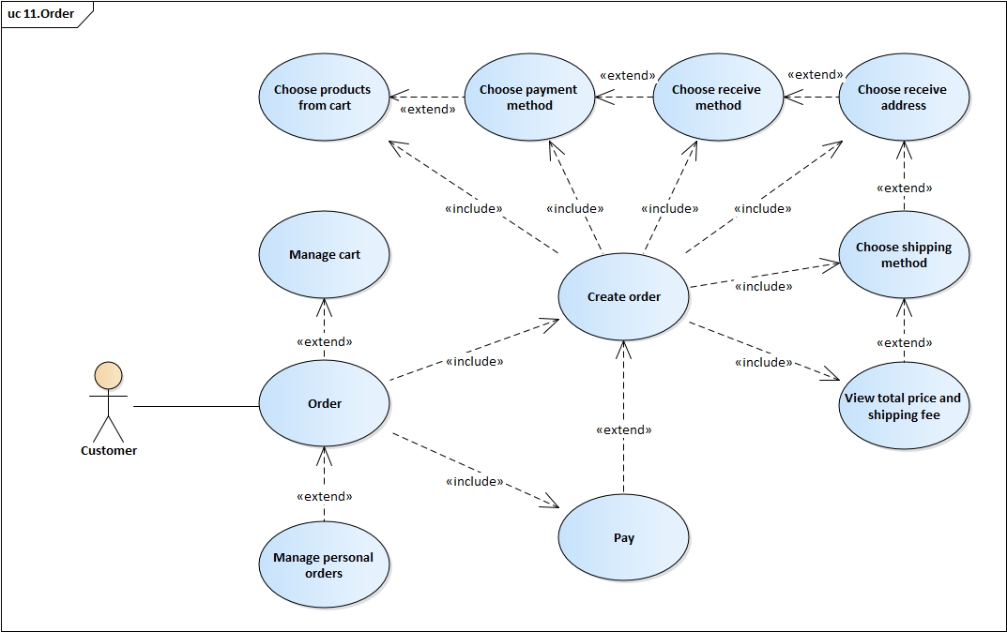

Image .. Use cart order

#### Create order

Table .. Specific description Create order

|  |  |
| --- | --- |
| Use Case ID | UC_15.1 |
| Name | Create order |
| Goal | Allows users to create order |
| Actors | Customer |
| Pre-conditions | Signed in to the website |
| Main flow | 1. Access to the cart page 2. Choose products that you want to order 3. Click “Mua hàng”, you will be moved to Create order page 4. Your order method is “Đặt hàng online” 5. Choose your payment method in “Phương thức thanh toán” field 6. Choose your receive method in “Phương thức nhận hàng” field 7. Choose your receive address in “Chọn địa chỉ” 8. Choose your shipping method in “Giao hàng” field 9. Shipping fee and total price is shown 10. Click “Đặt hàng” to create order |

#### Pay

Table .. Specific description Pay

|  |  |
| --- | --- |
| Use Case ID | UC_15.2 |
| Name | Pay |
| Goal | Allows users to pay the order |
| Actors | Customer |
| Pre-conditions | Signed in to the website, order pending pay |
| Main flow | 1. Click “Thanh toán” in order detail page, you will be moved to pay page 2. In pay page, follow the instructions to pay 3. After finished, you will be returned to order detail page |

### Manage personal orders

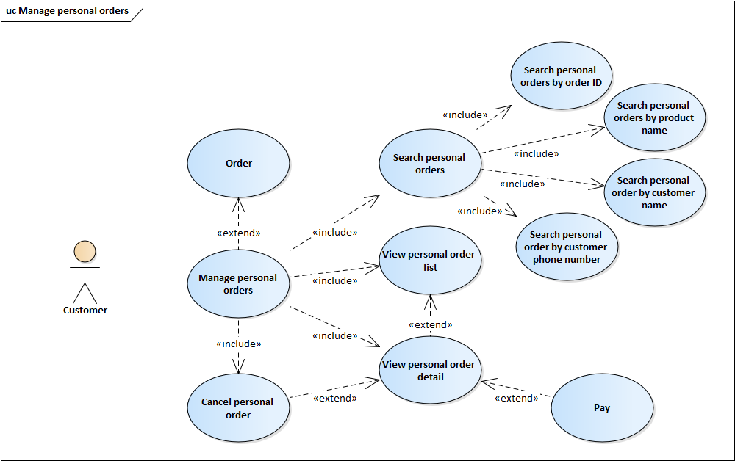

Image .. Use case Manage personal orders

#### View personal order detail

Table .. Specific description View personal order detail

|  |  |
| --- | --- |
| Use Case ID | UC_16.3 |
| Name | View personal order detail |
| Goal | Allows users to search their orders by date |
| Actors | Customer |
| Pre-conditions | Signed in to the website |
| Main flow | 1. Access to Customer’s order management page 2. Choose one order in order list that you want to view detail 3. Order detail will be shown in new page (Personal order detail page) |

#### Cancel personal order

Table .. Specific description Cancel personal order

|  |  |
| --- | --- |
| Use Case ID | UC_16.4 |
| Name | Cancel personal order |
| Goal | Allows users to cancel their orders |
| Actors | Customer |
| Pre-conditions | Signed in to the website, order have “Chờ xử lý” status |
| Main flow | 1. Access to Personal order detail page 2. Choose “Hủy đơn hàng” 3. New confirm dialog appear, choose your reason 4. Click “Hủy đơn hàng” to cancel order |

### View system notifications

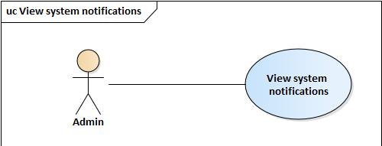

Image .. Use case View system notifications

Table .. Specific description View system notifications

|  |  |
| --- | --- |
| Use Case ID | UC_17 |
| Name | View system notifications |
| Goal | Allows users with Admin role or SuperAdmin role to view systems notifications |
| Actors | Admin, SuperAdmin |
| Pre-conditions | Signed in to the website with Admin role or SuperAdmin role |
| Main flow | 1. Personal notifications are shown in top navigation bar |

### Manage users

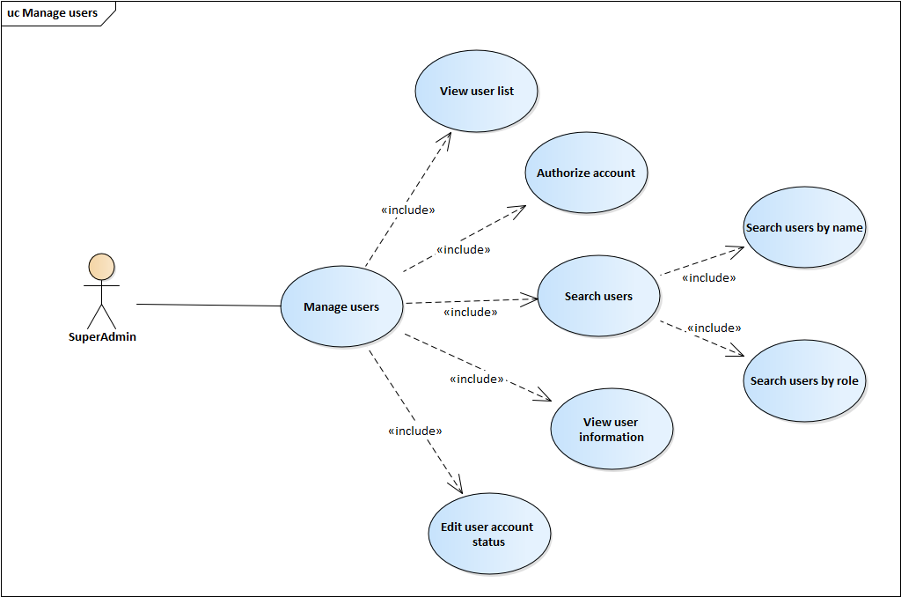

Image .. Use case Manage users

#### View user information

Table .. Specific description View user information

|  |  |
| --- | --- |
| Use Case ID | UC_18.3 |
| Name | View user information |
| Goal | Allows users with SuperAdmin role to view user information |
| Actors | SuperAdmin |
| Pre-conditions | Signed in to the website with SuperAdmin role |
| Main flow | 1. Access to user management page 2. Click on one user of user list that you want to view information 3. Selected user information is shown in new page (User information page) |

#### Authorize account

Table .. Specific description Authorize account

|  |  |
| --- | --- |
| Use Case ID | UC_18.4 |
| Name | View user information |
| Goal | Allows users with SuperAdmin role to authorize account |
| Actors | SuperAdmin |
| Pre-conditions | Signed in to the website with SuperAdmin role |
| Main flow | 1. Access to user information page 2. Choose role in field “Quyền hạn” 3. Click “Xác nhận” to authorize |

#### Edit user account status

Table .. Specific description Edit usser account status

|  |  |
| --- | --- |
| Use Case ID | UC_18.5 |
| Name | Edit user account status |
| Goal | Allows users with SuperAdmin role to edit user account status |
| Actors | SuperAdmin |
| Pre-conditions | Signed in to the website with SuperAdmin role |
| Main flow | 1. Access to user information page 2. Choose status in field “Trạng thái” 3. Click “Xác nhận” to change status |

### Manage products

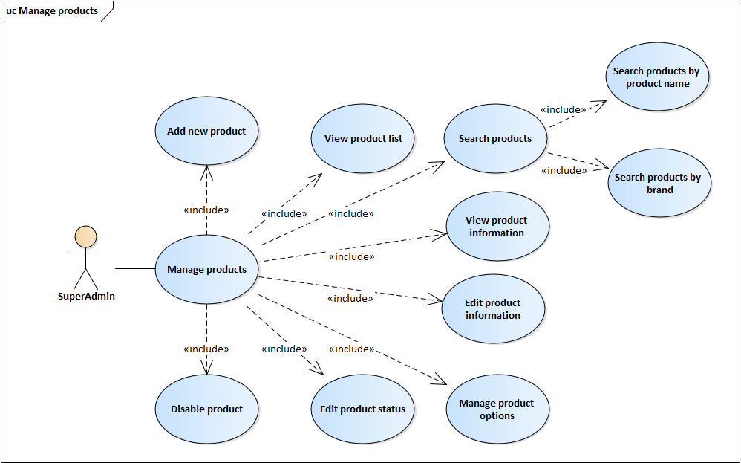

Image .. Use case Manage products

#### Add new product

Table .. Specific description Add new product

|  |  |
| --- | --- |
| Use Case ID | UC_22.1 |
| Name | Add new product |
| Goal | Allows users with SuperAdmin role to add new product |
| Actors | SuperAdmin |
| Pre-conditions | Signed in to the website with SuperAdmin role |
| Main flow | 1. Access to products management page 2. Click “Thêm sản phẩm mới” 3. On the new page appears, enter new product information then click “Tạo” |

#### Edit product information

Table .. Specific description Edit product information

|  |  |
| --- | --- |
| Use Case ID | UC_22.5 |
| Name | Edit product information |
| Goal | Allows users with SuperAdmin role to edit product information |
| Actors | SuperAdmin |
| Pre-conditions | Signed in to the website with SuperAdmin role |
| Main flow | 1. Access to product information page 2. Click “Sửa thông tin” 3. On the new form appears, edit product information 4. Click “Lưu” to save change |

#### Manage product options

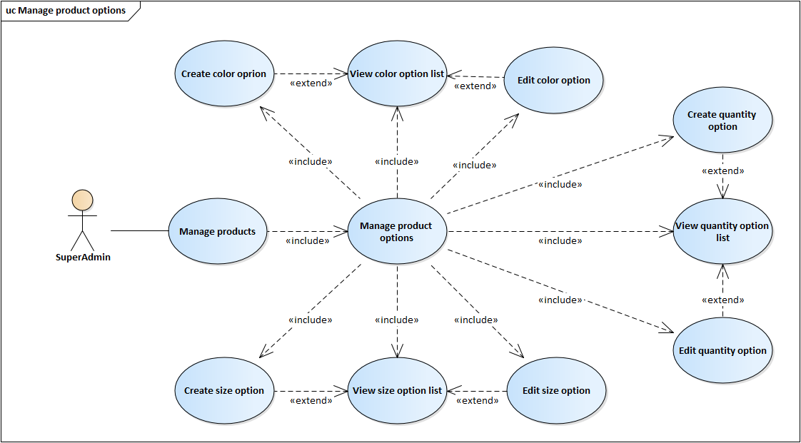

Image .. Use case Manage product options

##### Create color option

Table .. Specific description Add color option

|  |  |
| --- | --- |
| Use Case ID | UC_22.6.1 |
| Name | Create color option |
| Goal | Allows users with SuperAdmin role to add product color option |
| Actors | SuperAdmin |
| Pre-conditions | Signed in to the website with SuperAdmin role |
| Main flow | 1. Access to product options management page 2. Click “Thêm” on “Màu sản phẩm” region 3. On the new form appears, fill color information 4. Click save icon to create color option |

##### Edit color option

Table .. Specific description Edit color option

|  |  |
| --- | --- |
| Use Case ID | UC_22.6.3 |
| Name | Edit color option |
| Goal | Allows users with SuperAdmin role to edit product color option |
| Actors | SuperAdmin |
| Pre-conditions | Signed in to the website with SuperAdmin role |
| Main flow | 1. Access to product options management page 2. The product color option list show on “Màu sản phẩm” region 3. Click edit icon on one of product color option list that you want to edit 4. On the new form appears, edit color option information 5. Click save icon to save change |

##### Create size option

Table .. Specific description Add size option

|  |  |
| --- | --- |
| Use Case ID | UC_22.6.4 |
| Name | Create config option |
| Goal | Allows users with SuperAdmin role to add product config option |
| Actors | SuperAdmin |
| Pre-conditions | Signed in to the website with SuperAdmin role |
| Main flow | 1. Access to product options management page 2. Click add icon on “Kích cỡ sản phẩm” region 3. On the new form appears, fill config infomation 4. Click save to create config option |

##### Edit size option

Table .. Specific description Edit size option

|  |  |
| --- | --- |
| Use Case ID | UC_22.6.6 |
| Name | Edit config option |
| Goal | Allows users with SuperAdmin role to edit product config option |
| Actors | SuperAdmin |
| Pre-conditions | Signed in to the website with SuperAdmin role |
| Main flow | 1. Access to product options management page 2. The product config option list show on “Cấu hình sản phẩm” region 3. Click edit icon on one of product config option list that you want to edit 4. On the new form appears, edit config option information 5. Click save icon to save change |

##### Create quantity option

Table .. Specific description Add quantity option

|  |  |
| --- | --- |
| Use Case ID | UC_22.6.7 |
| Name | Add price option |
| Goal | Allows users with SuperAdmin role to add product price option |
| Actors | SuperAdmin |
| Pre-conditions | Signed in to the website with SuperAdmin role |
| Main flow | 1. Access to product options management page 2. Click add icon on “Giá và số lượng sản phẩm” region 3. On the new form appears, fill price information 4. Click save icon to create price option |

##### Edit quantity option

Table .. Specific description Edit quantity option

|  |  |
| --- | --- |
| Use Case ID | UC_22.6.9 |
| Name | Edit price option |
| Goal | Allows users with SuperAdmin role to edit product price option |
| Actors | SuperAdmin |
| Pre-conditions | Signed in to the website with SuperAdmin role |
| Main flow | 1. Access to product options management page 2. The product price option list show on “Số lượng sản phẩm” region 3. Click edit icon on one of product price option list that you want to edit 4. On the new form appears, edit quantity of product 5. Click save ion to save change |

### Manage orders

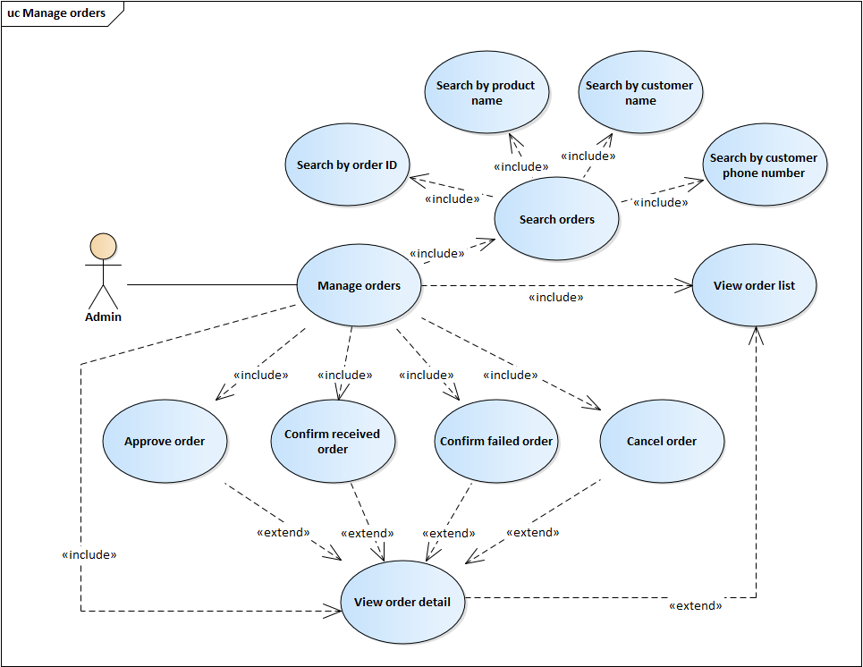

Image .. Use case Manage orders

#### View order detail

Table .. Specific description View order detail

|  |  |
| --- | --- |
| Use Case ID | UC_23.3 |
| Name | View order detail |
| Goal | Allows users with Admin role or SuperAdmin role to view order detail |
| Actors | Admin, SuperAdmin |
| Pre-conditions | Signed in to the website with Admin role or SuperAdmin role |
| Main flow | 1. Access to order management page 2. Choose one order in order list that you want to view detail 3. Details of the selected order will be shown in new page (Order detail page) |

#### Approve order

Table .. Specific description Approve order

|  |  |
| --- | --- |
| Use Case ID | UC_23.4 |
| Name | Approve order |
| Goal | Allows users with Admin role or SuperAdmin role to Approve order |
| Actors | Admin, SuperAdmin |
| Pre-conditions | Signed in to the website with Admin role or SuperAdmin role, order have “Chờ xử lý” status |
| Main flow | 1. Access to Order detail page 2. Choose “Duyệt đơn hàng” to approve order |

#### Confirm received order

Table .. Specific description Confirm received order

|  |  |
| --- | --- |
| Use Case ID | UC_23.5 |
| Name | Approve order |
| Goal | Allows users with Admin role or SuperAdmin role to confirm received order |
| Actors | Admin, SuperAdmin |
| Pre-conditions | Signed in to the website with Admin role or SuperAdmin role, order have “Đang giao hàng” status |
| Main flow | 1. Access to Order detail page 2. Choose “Xác nhận hoàn thành” to confirm received order |

#### Confirm failed order

Table .. Specific description Confirm failed order

|  |  |
| --- | --- |
| Use Case ID | UC_23.6 |
| Name | Approve order |
| Goal | Allows users with Admin role or SuperAdmin role to confirm failed order |
| Actors | Admin, SuperAdmin |
| Pre-conditions | Signed in to the website with Admin role or SuperAdmin role, order have “Đang giao hàng” status |
| Main flow | 1. Access to Order detail page 2. Choose “Xác nhận thất bại” to confirm failed order |

#### Cancel order

Table .. Specific description Cancel order

|  |  |
| --- | --- |
| Use Case ID | UC_23.7 |
| Name | Cancel order |
| Goal | Allows users with Admin role or SuperAdmin role to cancel order |
| Actors | Admin, SuperAdmin |
| Pre-conditions | Signed in to the website with Admin role or SuperAdmin role, order have “Chờ xử lý” status |
| Main flow | 1. Access to Order detail page 2. Choose “Hủy đơn hàng” 3. New confirm dialog appear, choose your reason 4. Click “Hủy đơn hàng” to cancel order |

### Create in-store order

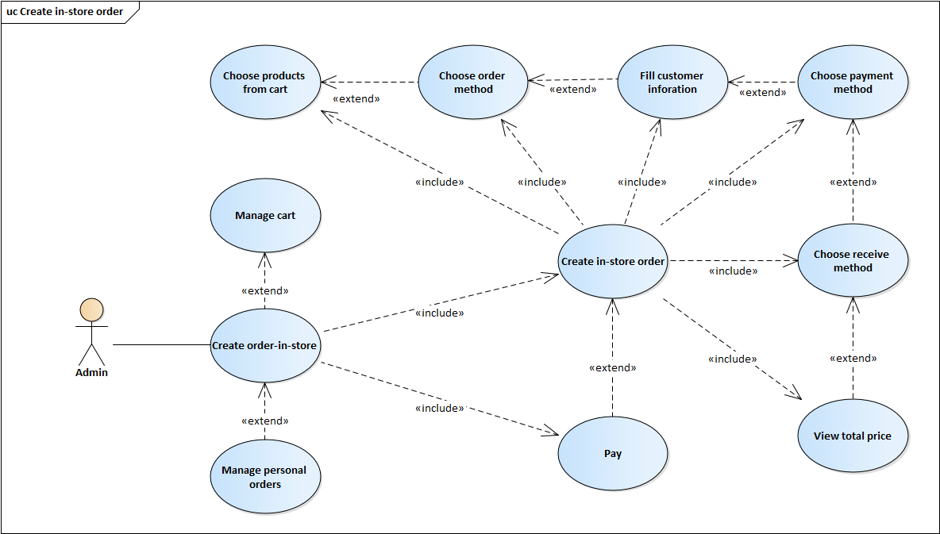

Image .. Use case Create in-store order

#### Create in-store order

Table .. Specific description Create in-store order

|  |  |
| --- | --- |
| Use Case ID | UC_24.1 |
| Name | Create in-store order |
| Goal | Allows users with Admin role or SuperAdmin role to create in-store order |
| Actors | Admin, SuperAdmin |
| Pre-conditions | Signed in to the website with Admin role or SuperAdmin role, order have “Chờ xử lý” status |
| Main flow | 1. Access to the cart page 2. Choose products that you want to order 3. Click “Mua hàng”, you will be moved to Create order page 4. Choose “Đặt hàng tại của hàng” in “Phương thức đặt hàng” field 5. Choose your payment method in “Phương thức thanh toán” field 6. Choose “Nhận hàng tại của hàng” in “Phương thức nhận hàng” field 7. Total price is shown 8. Click “Đặt hàng” to create in-store order |

# SOFTWARE DESIGN



## SYSTEM DESIGN



### Work flow

#### Online ordering

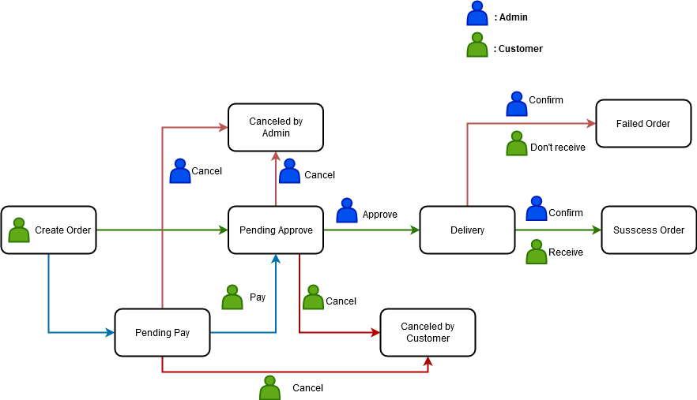

Image .. Work flow about online order



#### Create order in store

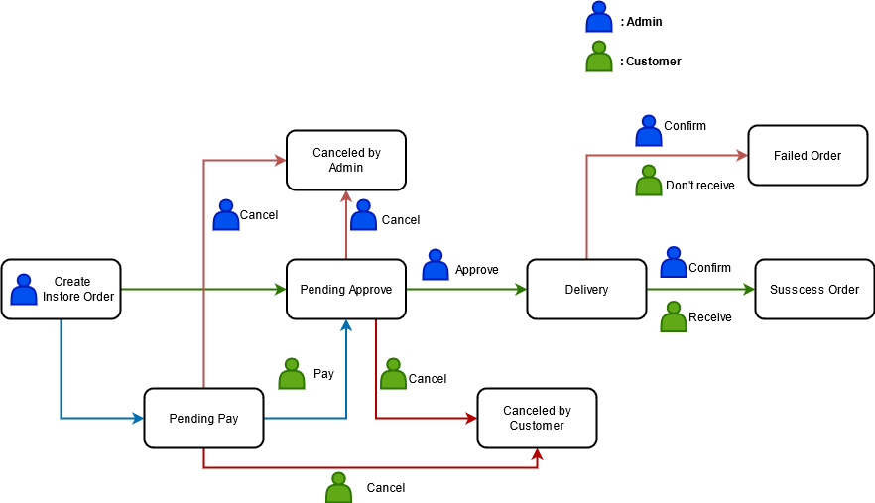

Image .. Work flow about create order in store

### Sequence diagram

#### Login

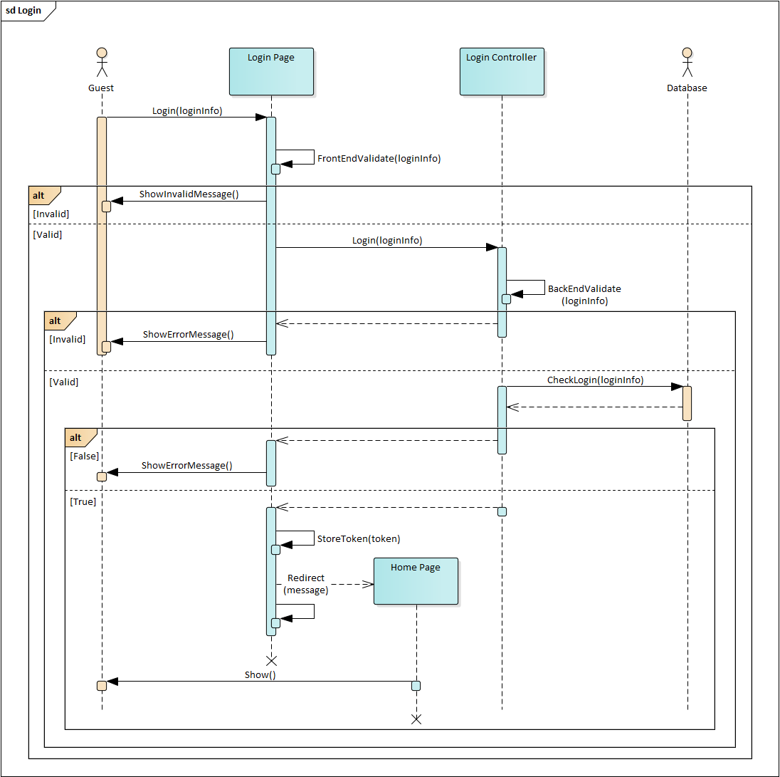

Image .. Sequence diagram for Login

#### Recovery password

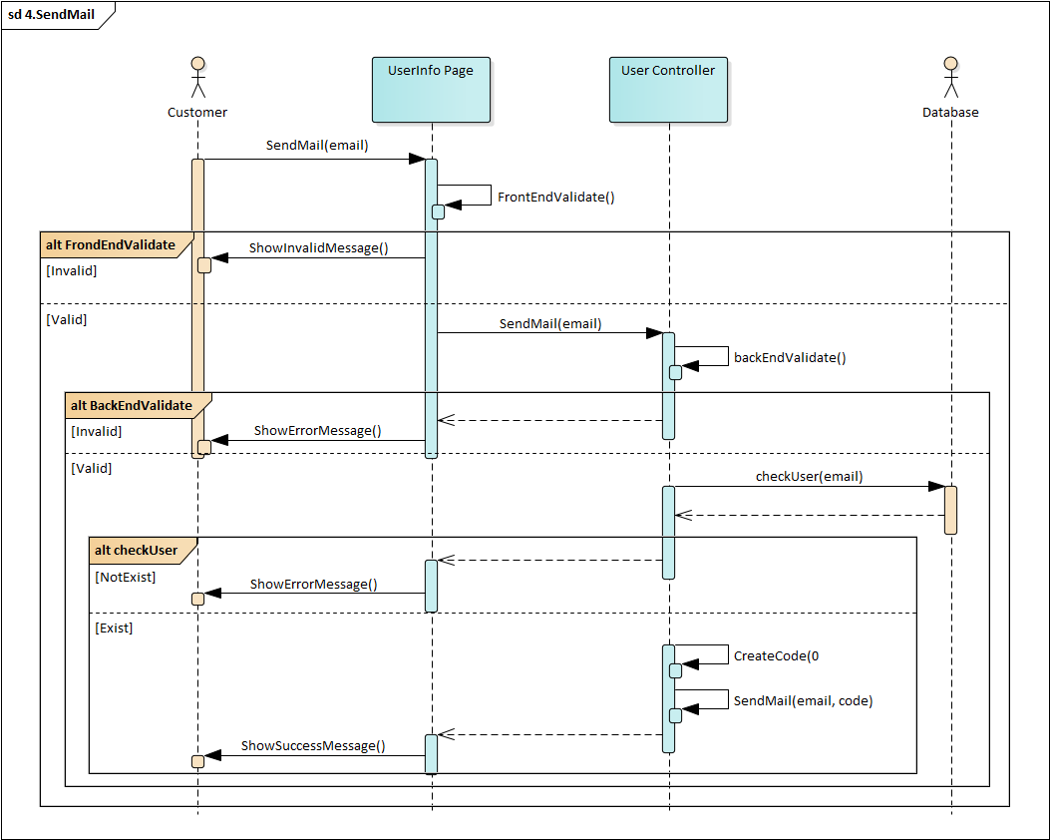

Image .. Send mail

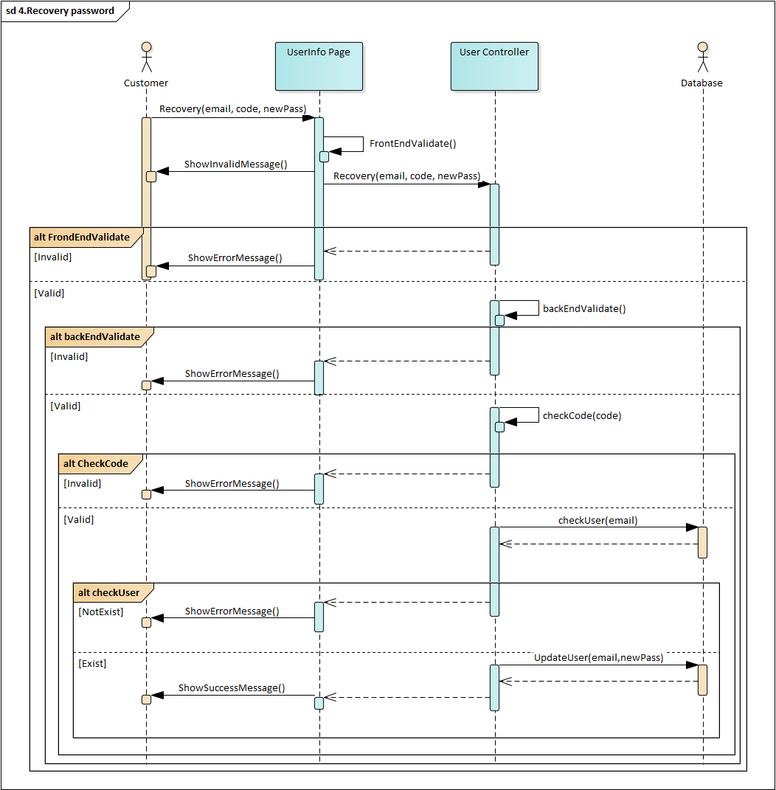

Image .. Recovery password

#### Change password

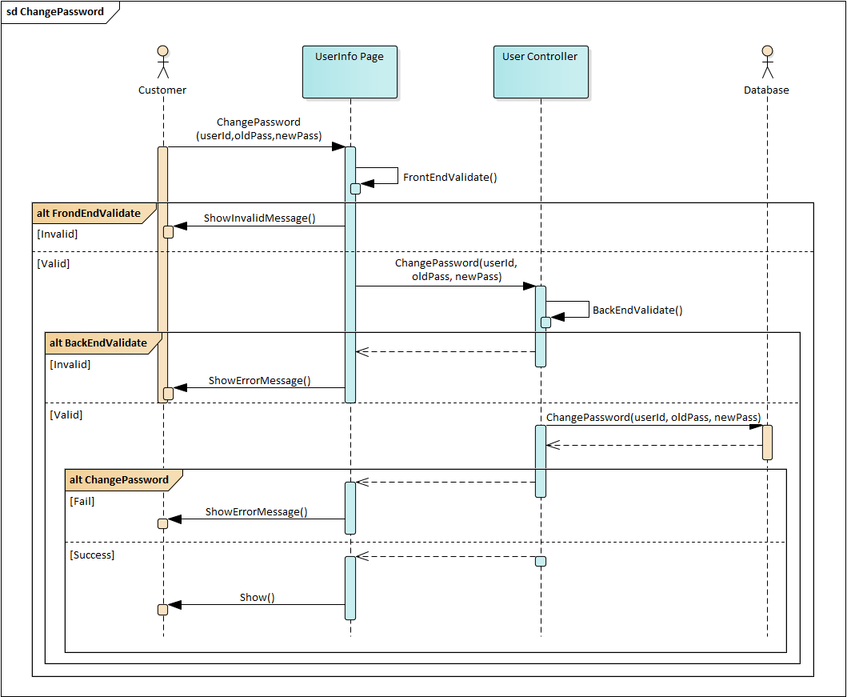

Image .. Sequence diagram for Change password



#### Add product to cart

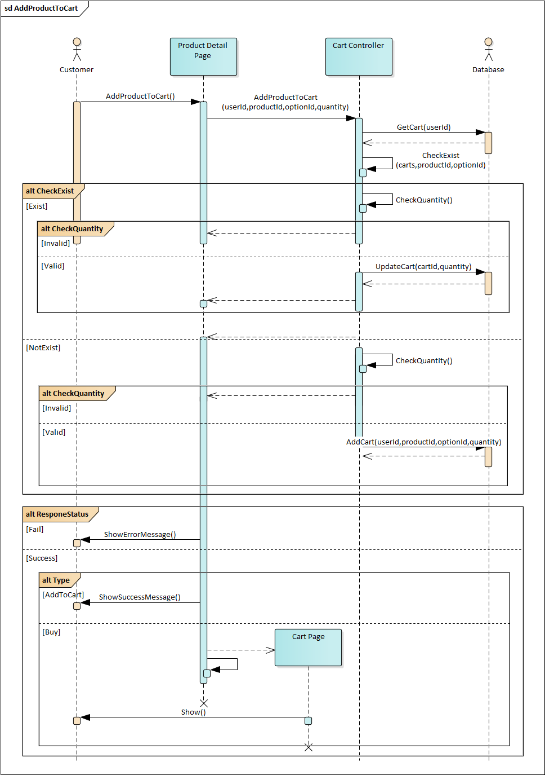

Image .. Sequence diagram for Add product to cart

#### Create Order

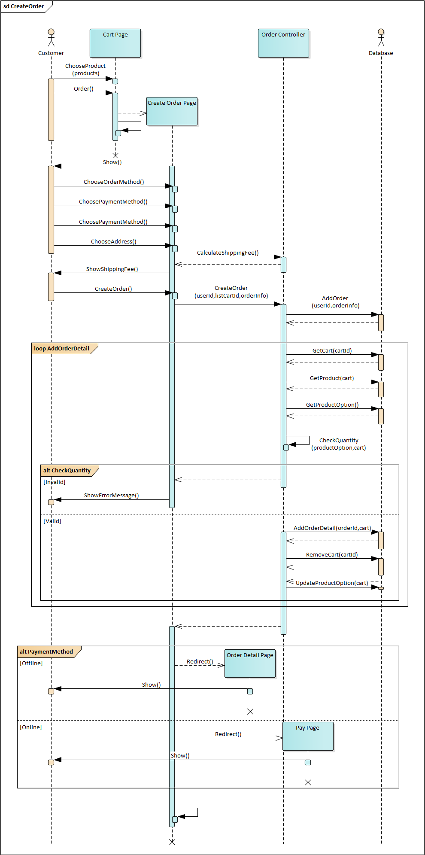

Image .. Sequence diagram for Create order

#### Manage personal order

##### Cancel personal order

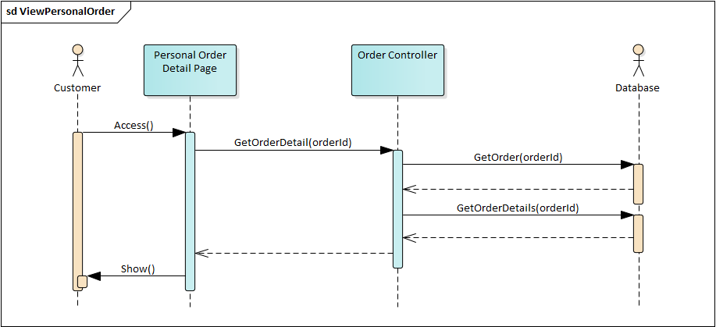

Image .. Sequence diagram for Cancel personal order

#### Manage orders

##### Approve order

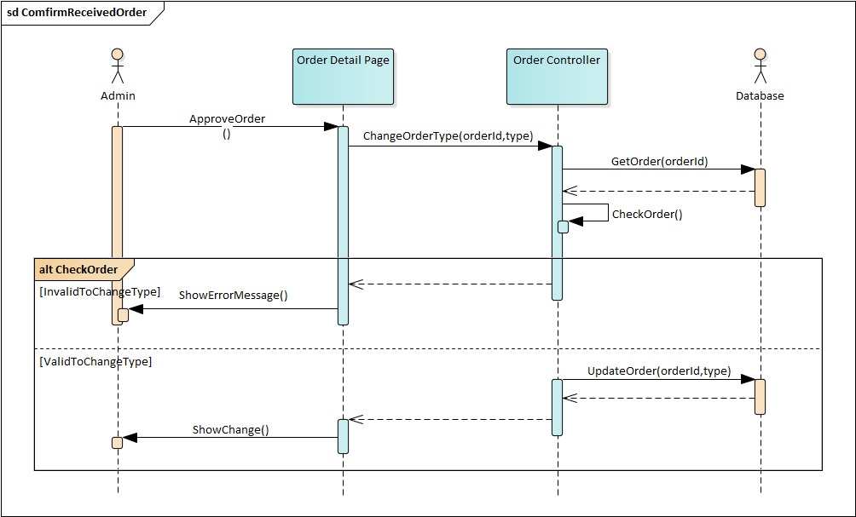

Image .. Sequence diagram for Approve order

##### Confirm received order



Image .. Sequence diagram for Confirm received order

##### Confirm failed order

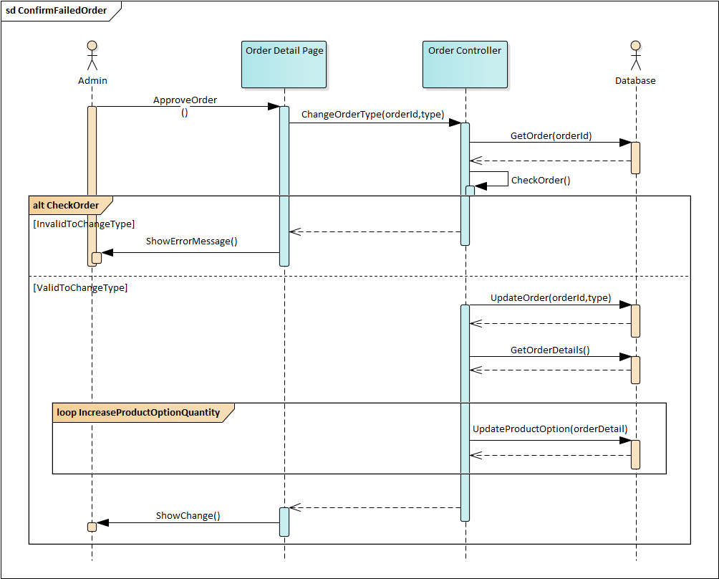

Image .. Sequence diagram for Confirm failed order

#### Create instore order

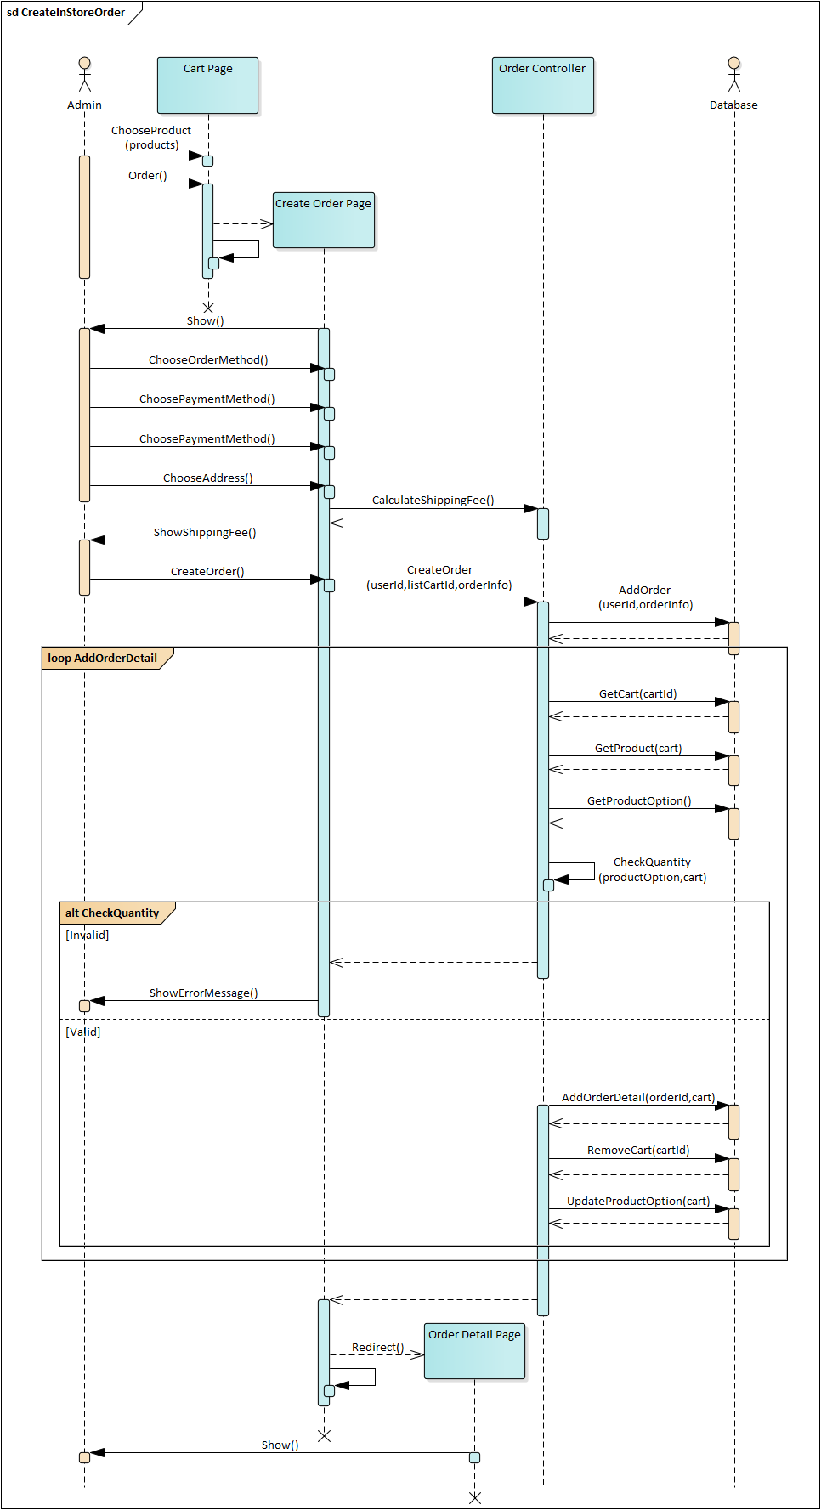

Image .. Sequence diagram for Create in-store order



## DATABASE DESIGN

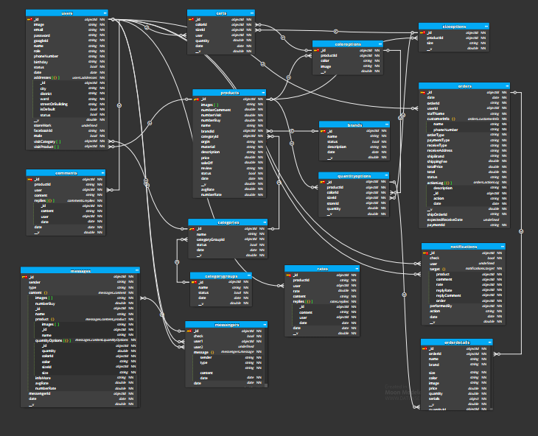

Image .. Database diagram

### users

Table .. users table

|  |  |  |  |  |  |
| --- | --- | --- | --- | --- | --- |
| Purpose: Save user account information | | | | | |
| No | **Column** | **Type** | **Key** | **Allow Null** | **Description** |
| 1 | _id | objectId | PK |  | Unique, auto generate |
| 2 | email | string |  |  | Unique |
| 3 | password | string |  |  |  |
| 4 | googleId | string |  | ✓ | Unique |
| 5 | facebookId | string |  | ✓ | Unique |
| 6 | name | string |  |  |  |
| 7 | role | string |  |  | Has 3 roles: “admin”, “superadmin”, “customer” |
| 8 | phoneNumber | string |  | ✓ |  |
| 9 | birthday | string |  | ✓ |  |
| 10 | image | string |  |  | user avatar |
| 11 | status | bool |  |  |  |
| 12 | date | date |  |  | Date create account |
| 13 | addresses | object |  | ✓ | The list of addresses each has a unique id used to identify |
| 14 | male | bool |  | ✓ | true is man, false is woman |
| 15 | visitCategory | Array objectId |  | ✓ | list of category the user visits |
| 16 | visitProduct | Array objectId |  | ✓ | list of product the user visits |

Table .. addresses table

|  |  |  |  |  |  |
| --- | --- | --- | --- | --- | --- |
| Addresses is a child object in the users table | | | | | |
| Purpose: Save user account information | | | | | |
| No | **Column** | **Type** | **Key** | **Allow Null** | **Description** |
| 1 | id | objectId | PK |  | Unique, auto generate |
| 2 | city | string |  |  |  |
| 3 | district | string |  |  |  |
| 4 | ward | string |  |  |  |
| 5 | streetOrBuilding | string |  |  |  |
| 6 | isDefault | bool |  |  | True: is the default address, each user has a unique default address |
| 7 | status | bool |  |  |  |

### brands

Table .. brands table

|  |  |  |  |  |  |
| --- | --- | --- | --- | --- | --- |
| Purpose: Save the brands and its description | | | | | |
| No | **Column** | **Type** | **Key** | **Allow Null** | **Description** |
| 1 | _id | objectId | PK |  | Unique, auto generate |
| 2 | name | string |  |  |  |
| 3 | status | string |  |  |  |
| 4 | description | string |  | ✓ |  |
| 5 | date | date |  |  | Date create brand |

### categoryGroups

Table .. categoryGroups table

|  |  |  |  |  |  |
| --- | --- | --- | --- | --- | --- |
| Purpose: Save the categoryGroups | | | | | |
| No | **Column** | **Type** | **Key** | **Allow Null** | **Description** |
| 1 | _id | objectId | PK |  | Unique, auto generate |
| 2 | name | string |  |  |  |
| 3 | status | string |  |  |  |
| 4 | date | date |  |  | Date create categoryGroups |

### categories

Table .. categories table

|  |  |  |  |  |  |
| --- | --- | --- | --- | --- | --- |
| Purpose: Save the categories | | | | | |
| No | **Column** | **Type** | **Key** | **Allow Null** | **Description** |
| 1 | _id | objectId | PK |  | Unique, auto generate |
| 2 | name | string |  |  |  |
| 3 | status | string |  |  |  |
| 4 | categoryGroupId | objectId |  |  | Category group code |
| 5 | date | date |  |  | Date create category |

### products

Table .. products table

|  |  |  |  |  |  |
| --- | --- | --- | --- | --- | --- |
| Purpose: Save all product’s information | | | | | |
| No | **Column** | **Type** | **Key** | **Allow Null** | **Description** |
| 1 | _id | objectId | PK |  | Unique, auto generate |
| 2 | name | string |  |  |  |
| 3 | images | string[] |  |  |  |
| 4 | brandId | objectId | FK |  |  |
| 5 | categoryId | objectId |  |  |  |
| 6 | origin | string |  |  |  |
| 7 | material |  |  |  |  |
| 8 | description |  |  | ✓ | Product short description |
| 9 | price | double |  |  | The price of the product |
| 10 | saleOff | double |  |  |  |
| 11 | review | string |  | ✓ |  |
| 12 | status | bool |  |  |  |
| 13 | date | date |  |  | Date add this product |
| 14 | numberVisit | double |  | ✓ | The number of people viewed this product |
| 15 | avgRate | double |  | ✓ | Average score rated |
| 16 | numberRate | double |  | ✓ | The number of people rated this product |
| 17 | numberComment | double |  | ✓ | The number of people commented this product |
| 18 | numberBuy | double |  | ✓ | The number of people bought this product |

### sizeOptions

Table .. sizeOptions table

|  |  |  |  |  |  |
| --- | --- | --- | --- | --- | --- |
| Purpose: Contains 1 product size | | | | | |
| No | **Column** | **Type** | **Key** | **Allow Null** | **Description** |
| 1 | _id | objectId | PK |  |  |
| 2 | productId | objectId | FK |  |  |
| 3 | size | string |  |  | Size of product |

### colorOptions

Table .. colorOptions table

|  |  |  |  |  |  |
| --- | --- | --- | --- | --- | --- |
| Purpose: Contains color information for the product | | | | | |
| No | **Column** | **Type** | **Key** | **Allow Null** | **Description** |
| 1 | _id | objectId | PK |  |  |
| 2 | productId | objectId | FK |  |  |
| 3 | color | string |  |  | Color of product |
| 4 | image | string |  |  | Contain url image of product |

### quantityOption

Table .. quantityOptions table

|  |  |  |  |  |  |
| --- | --- | --- | --- | --- | --- |
| Purpose: Contains quantity of 1 product corresponding to color and size | | | | | |
| No | **Column** | **Type** | **Key** | **Allow Null** | **Description** |
| 1 | _id | objectId | PK |  |  |
| 2 | productId | objectId | FK |  |  |
| 3 | colorId | objectId | FK |  |  |
| 4 | sizeId | objectId | FK |  |  |
| 7 | quantity | double |  |  | Number of product in stock |

### comments

Table .. comments table

|  |  |  |  |  |  |
| --- | --- | --- | --- | --- | --- |
| Purpose: Save all comments | | | | | |
| No | **Column** | **Type** | **Key** | **Allow Null** | **Description** |
| 1 | _id | objectId | PK |  |  |
| 2 | productId | objectId | FK |  | Product code |
| 3 | user | objectId | FK |  | Commenter code |
| 4 | content | string |  |  |  |
| 5 | replies | object |  |  | Contains feedback |
| 6 | date | double |  |  | Date create comment |

Table .. replies table

|  |  |  |  |  |  |
| --- | --- | --- | --- | --- | --- |
| replies is a child object in the comments table | | | | | |
| Purpose: Save Responses | | | | | |
| No | **Column** | **Type** | **Key** | **Allow Null** | **Description** |
| 1 | id | objectId | PK |  | Unique, auto generate |
| 2 | content | string |  |  |  |
| 3 | user | objectId | FK |  | Responder code |
| 4 | date | date |  |  | Date create reply |

### rates

Table .. rates table

|  |  |  |  |  |  |
| --- | --- | --- | --- | --- | --- |
| Purpose: Save all rates | | | | | |
| No | **Column** | **Type** | **Key** | **Allow Null** | **Description** |
| 1 | _id | objectId | PK |  |  |
| 2 | productId | objectId | FK |  | Product code |
| 3 | user | objectId | FK |  | Reviewer code |
| 4 | rate | double |  |  | Score of review (greater than or equal to 1, less than or equal to 5) |
| 5 | content | string |  |  |  |
| 6 | replies | object |  |  | Contains feedback |
| 7 | date | double |  |  | Evaluation date |

Table .. replies table

|  |  |  |  |  |  |
| --- | --- | --- | --- | --- | --- |
| replies is a child object in the rates table | | | | | |
| Purpose: Save Responses | | | | | |
| No | **Column** | **Type** | **Key** | **Allow Null** | **Description** |
| 1 | id | objectId | PK |  | Unique, auto generate |
| 2 | content | string |  |  |  |
| 3 | user | objectId | FK |  | Responder code |
| 4 | date | date |  |  | Date create reply |

### carts

Table .. carts table

|  |  |  |  |  |  |
| --- | --- | --- | --- | --- | --- |
| Purpose: Save the user’s shopping cart information | | | | | |
| No | **Column** | **Type** | **Key** | **Allow Null** | **Description** |
| 1 | _id | objectId | PK |  |  |
| 2 | colorId | objectId | FK |  | colorOption code |
| 3 | sizeId | objectId | FK |  | sizeOption code |
| 4 | user | objectId | FK |  | Cart owner code |
| 5 | quantity | double |  |  |  |
| 6 | date | date |  |  | Date the product was added or updated to the cart |

### orders

Table .. orders table

|  |  |  |  |  |  |
| --- | --- | --- | --- | --- | --- |
| Purpose: Save order information | | | | | |
| No | **Column** | **Type** | **Key** | **Allow Null** | **Description** |
| 1 | _id | objectId | PK |  | Unique, auto generate |
| 2 | orderId | string |  |  | Unique, order shorting code |
| 3 | userId | objectId | FK |  | Customer’s code order |
| 4 | staffName | string |  |  |  |
| 5 | customerInfo | object |  |  | Customer information |
| 6 | orderType | string |  |  |  |
| 7 | paymentType | string |  |  | Payment methods(online, pay on receipt) |
| 8 | reciveType | string |  |  | Recive modethods(at the store, delivery to address) |
| 9 | reciveAddress | string |  |  |  |
| 10 | shippingFee | double |  |  |  |
| 11 | totalPrice | double |  |  |  |
| 12 | total | double |  |  |  |
| 13 | status | string |  |  | Order status |
| 14 | actionLog | object |  |  |  |
| 15 | date | date |  |  | Date create order |
| 16 | shipOrdered | date |  |  | Delivery code |
| 17 | shipBrand |  |  |  | Delivery company code |
| 18 | expectedReceiveDate | date |  |  | Desired delivery date |
| 18 | paymentId | string |  |  | Payment code |

Table .. customerInfo table

|  |  |  |  |  |  |
| --- | --- | --- | --- | --- | --- |
| customerInfo is a child object in the orders table | | | | | |
| Purpose: Save buyer infomation | | | | | |
| No | **Column** | **Type** | **Key** | **Allow Null** | **Description** |
| 1 | name | string |  |  |  |
| 2 | phoneNumber | string |  |  |  |

Table .. actionLog table

|  |  |  |  |  |  |
| --- | --- | --- | --- | --- | --- |
| actionLog is a child object in the orders table | | | | | |
| Purpose: Save buyer information | | | | | |
| No | **Column** | **Type** | **Key** | **Allow Null** | **Description** |
| 1 | _id | objectId | PK |  | Unique, auto generate |
| 2 | action | string |  |  | Type of action |
| 3 | description | string |  |  |  |
| 4 | date | date |  |  | Execution date |

### orderDetail

Table .. orderDetail tables

|  |  |  |  |  |  |
| --- | --- | --- | --- | --- | --- |
| Purpose: Save order detail | | | | | |
| No | **Column** | **Type** | **Key** | **Allow Null** | **Description** |
| 1 | _id | objectId | PK |  | Unique, auto generate |
| 2 | orderId | objectId | FK |  | Order code |
| 3 | name | string |  |  |  |
| 4 | brand | string |  |  |  |
| 5 | size | string |  |  |  |
| 6 | color | string |  |  |  |
| 7 | image | string |  |  |  |
| 8 | price | string |  |  |  |
| 9 | quantity | string |  |  |  |
| 10 | quantityId | object |  |  | quantityOption code |

### notifications

Table .. notifications table

|  |  |  |  |  |  |
| --- | --- | --- | --- | --- | --- |
| Purpose: Save notifications | | | | | |
| No | **Column** | **Type** | **Key** | **Allow Null** | **Description** |
| 1 | _id | objectId | PK |  | Unique, auto generate |
| 2 | check | bool |  |  | Has seen is or not |
| 3 | user | objectId | FK |  | Notification recipients |
| 4 | target | object |  |  | Code of related information |
| 5 | performedBy | objectId |  |  | The person performing |
| 6 | action | string |  |  | Type of notice |
| 7 | date | date |  |  | Date of creation of the notice |

Table .. target table

|  |  |  |  |  |  |
| --- | --- | --- | --- | --- | --- |
| target is a child object in the notifications table | | | | | |
| Purpose: Code of related information | | | | | |
| No | **Column** | **Type** | **Key** | **Allow Null** | **Description** |
| 1 | order | objectId | FK | ✓ | Code orders |
| 2 | product | objectId | FK | ✓ | Code products |
| 3 | rate | objectId | FK | ✓ | Code rates |
| 4 | replyRate | objectId | FK | ✓ | Code reply of rates |
| 5 | comment | objectId | FK | ✓ | Code comments |
| 6 | replyComment | objectId | FK | ✓ | Code reply of comments |

### Messenger

Table .. messenger table

|  |  |  |  |  |  |
| --- | --- | --- | --- | --- | --- |
| Purpose: Used to save a use to save the content message | | | | | |
| No | **Column** | **Type** | **Key** | **Allow Null** | **Description** |
| 1 | _id | objectId | PK |  | Unique, auto generate |
| 2 | user1 | objectId | FK |  | Message sender code or message recipient code |
| 3 | user2 | objectId | FK |  | Message sender code or message recipient code |
| 4 | message | object |  |  | Content of message |
| 5 | check | bool |  |  | Used to check if the message has been viewed or not |
| 7 | date | date |  |  | Message sending time will update every time a new message is sent |

Table .. messenger table

|  |  |  |  |  |  |
| --- | --- | --- | --- | --- | --- |
| message is a child object in the messenger table | | | | | |
| Purpose: Code of related information | | | | | |
| No | **Column** | **Type** | **Key** | **Allow Null** | **Description** |
| 1 | sender | objectId | FK | ✓ | The content of sender is user1 or user2 |
| 2 | type | objectId | FK | ✓ | Type message |
| 3 | content | objectId | FK | ✓ |  |
| 4 | date | objectId | FK | ✓ | Date send |

### Messages

Table .. messenger table

|  |  |  |  |  |  |
| --- | --- | --- | --- | --- | --- |
| Purpose: Use to save the content message | | | | | |
| No | **Column** | **Type** | **Key** | **Allow Null** | **Description** |
| 1 | _id | objectId | PK |  | Unique, auto generate |
| 1 | sender | objectId | FK | ✓ | The content of sender is user1 or user2 |
| 2 | type | objectId | FK | ✓ | Type message |
| 3 | content | objectId | FK | ✓ |  |
| 4 | ‘date | objectId | FK | ✓ | Date send |

## INTERFACE DESIGN

### List of screens and screen flow on website

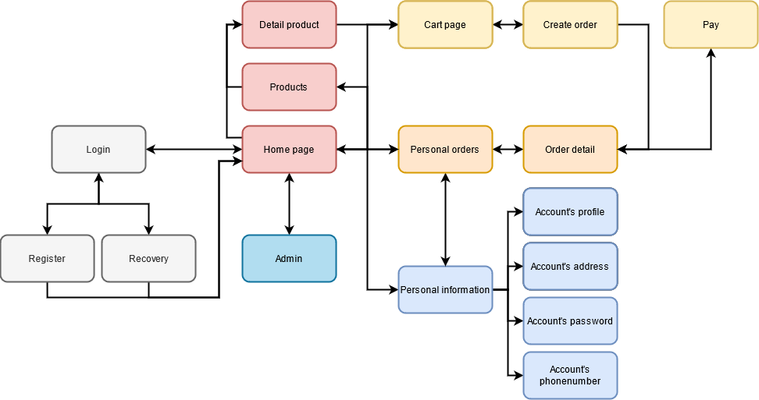

Image .. Screen flow of Customer on website

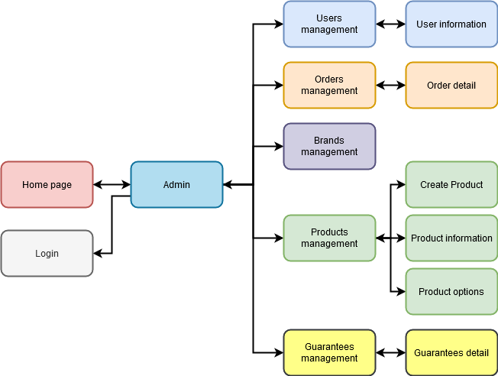

Image .. Screen flow of Admin on website

### Screen details on website

#### Customer pages

##### Home page

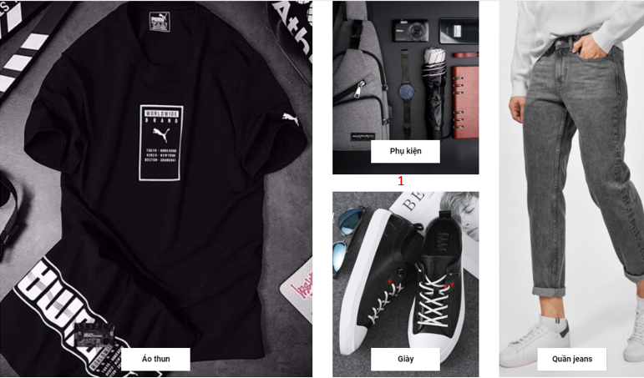

Image . Home screen

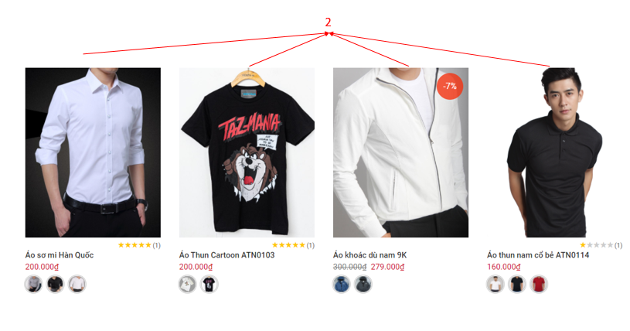

Image .. Home page

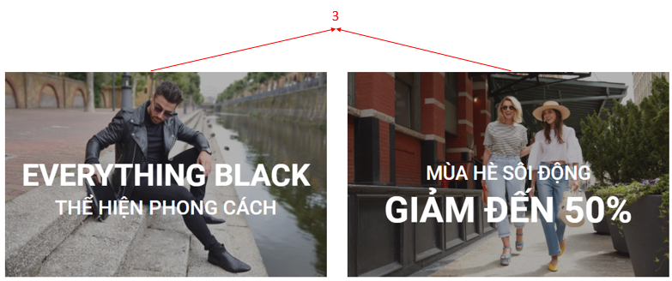

Image .. Home page

Table .. Describe Home page

|  |  |  |
| --- | --- | --- |
| **Index** | **Type** | **Meaning** |
| 1 | Link | Link used to show all category of products can go to product page filtered by that product type. |
| 2 | Link | Link used to show important information of product and can go to detail product page. |
| 3 | Link | Link used to go to product page filtered by condition. |

##### Product page filter by condition

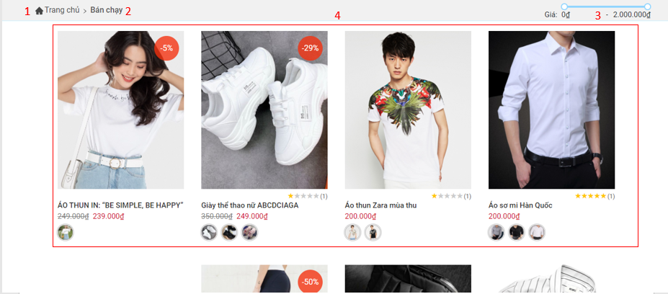

Image .. Home page

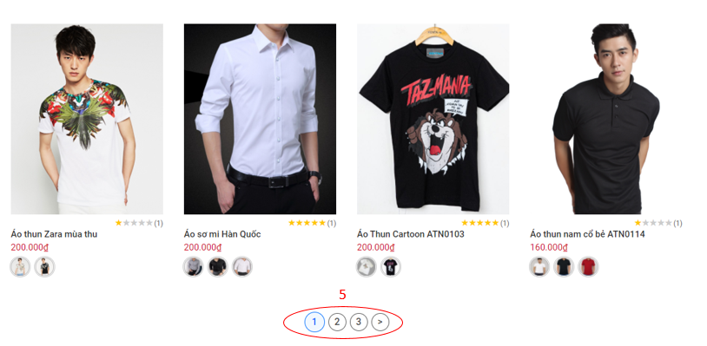

Image .. Product page

Table .. Describe Home page

|  |  |  |
| --- | --- | --- |
| **Index** | **Type** | **Meaning** |
| 1 | Link | Link used to go to home page. |
| 2 | Link | Show current condition. |
| 3 | Link | Filter product by price. |
| 4 | Link | Link used to show important information of product and can go to detail product page. |
| 5 | Link | Paging |

##### Detail product page

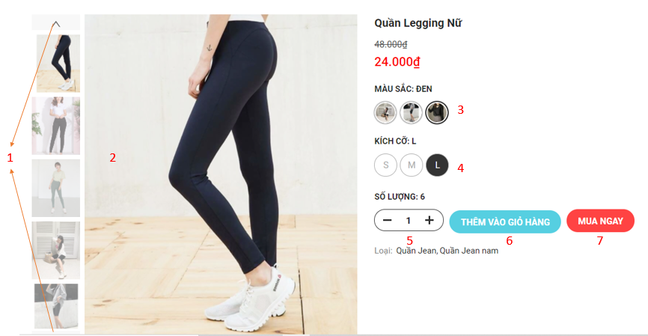

Image .. Detail product page

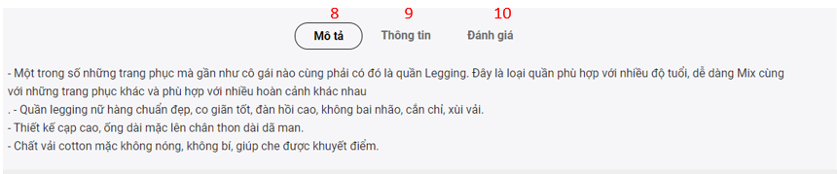

Image .. More information of product detail page

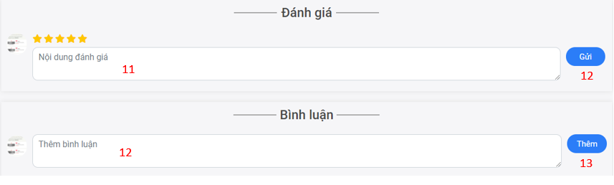

Image .. Comment and race

Table .. Describe Detail product page

|  |  |  |
| --- | --- | --- |
| **Index** | **Type** | **Meaning** |
| 1 | Button | View more image of product |
| 2 | Image | List image of product |
| 3 | Button | Choose color of product |
| 4 | Button | Choose size of product |
| 5 | Button | Change product quantity |
| 6 | Button | Add product to cart |
| 7 | Radio | Buy product |
| 8 | Button | View description of product |
| 9 | Button | View more information of product |
| 10 | Button | Go to comment and review function |
| 11 | Input | Type content rate |
| 12 | Button | Add new rate |
| 13 | Input | Type content comment |
| 14 | Button | Add new comment |

##### The Header of the customer page when not logged in



Image .. Header of customer page when not logged in

Table .. Describe Header of customer page when not logged in

|  |  |  |
| --- | --- | --- |
| **Index** | **Type** | **Meaning** |
| 1 | Drop down button | Menu used to view a list of product categories |
| 2 | Link | Link to home page |
| 3 | Link | View the best selling products |
| 4 | Link | See new product |
| 5 | Link | See featured products |
| 6 | Link | Go to login page |



##### The Header of the customer page when logged in



Image .. Header of customer page when logged in

Table .. Describe Header of customer page when logged in

|  |  |  |
| --- | --- | --- |
| **Index** | **Type** | **Meaning** |
| 1 | Link | Link go to manage page if you admin |
| 2 | Link | Open input to search |
| 3 | Link | Link go to cart page |
| 4 | Link | View messenger |
| 5 | Link | View notification |
| 6 | Link | Link go to profile page |

##### Login Page

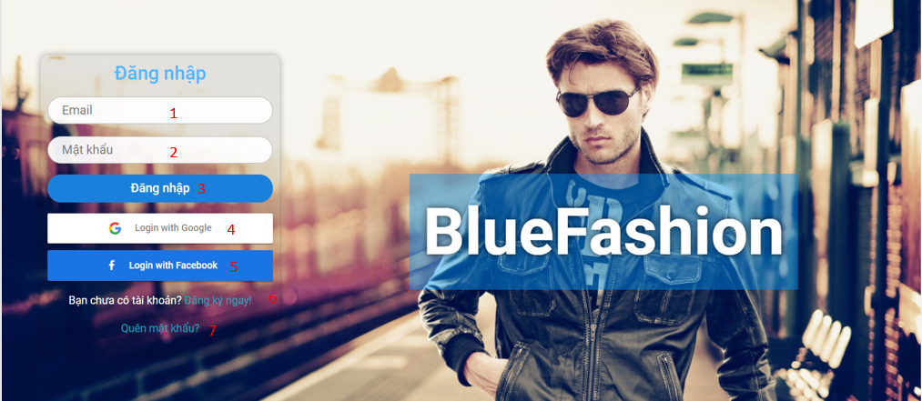

Image .. Login page

Table .. Describe Login page

|  |  |  |
| --- | --- | --- |
| **Index** | **Type** | **Meaning** |
| 1 | Input | Used to enter the Email |
| 2 | Input | Used to enter the Password |
| 3 | Button | Login with account |
| 4 | Button | Login with Google |
| 5 | Button | Login with Facebook |
| 6 | Link | Link to sign up for an account website |
| 7 | Link | Link forgotten password |

##### Forgot password Page



Image .. Forgot password page

Table .. Describe forgot password page

|  |  |  |
| --- | --- | --- |
| **Index** | **Type** | **Meaning** |
| 1 | Input | Used to enter the registered email account |
| 2 | Link | Go to login page |
| 2 | Button | Click to confirm |
| 3 | Link | Go to register page |

##### Registration Page

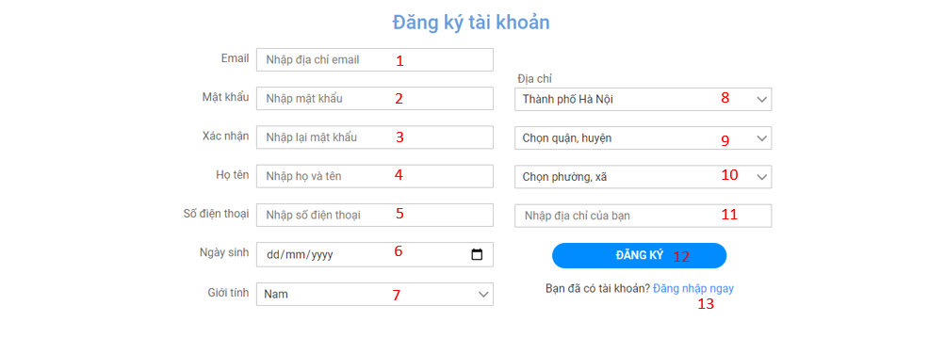

Image .. Registration page

Table .. Describe Registration page

|  |  |  |
| --- | --- | --- |
| **Index** | **Type** | **Meaning** |
| 1 | Input | Used to enter the Email |
| 2 | Input | Used to enter the Password |
| 3 | Input | Re-Used to enter the Password |
| 4 | Input | Used to enter the full name |
| 5 | Input | Used to enter the phone number |
| 6 | Select Options | Select a province or city |
| 7 | Select Options | Select a district |
| 8 | Select Options | Select a ward |
| 9 | Input | Used to enter building, street name |
| 10 | Input | Used to enter birthdate |
| 11 | Select Options | Select Male |
| 12 | Button | Click to sign up for an account |
| 13 | Link | Link go to login page |

##### Account navigation bar in profile page

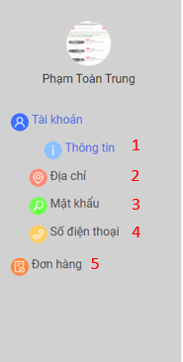

Image .. Account navigation bar

Table .. Describe Account navigation bar

|  |  |  |
| --- | --- | --- |
| **Index** | **Type** | **Meaning** |
| 1 | Link | Link go to account’s profile page |
| 2 | Link | Link go to account’s address page |
| 3 | Link | Link go to account’s password page |
| 4 | Link | Link go to account’s phonenumber page |
| 5 | Link | Link go to order page |

##### Account’s profile page

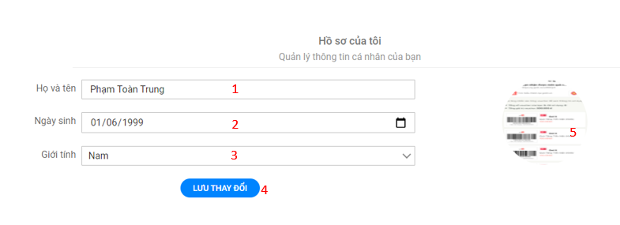

Image .. Account’s profile page

Table .. Describe Account’s profile page

|  |  |  |
| --- | --- | --- |
| **Index** | **Type** | **Meaning** |
| 1 | Input | Used to change full name |
| 2 | Input | Used to change birthdate |
| 3 | Input | Used to change male |
| 4 | Button | Save profile |
| 5 | Button | Button to update avatar |

##### Account’s address page

###### List addresses

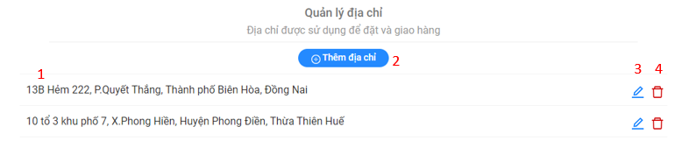

Image .. List addresses

Table .. Describe List addresses

|  |  |  |
| --- | --- | --- |
| **Index** | **Type** | **Meaning** |
| 1 | Table | Display list address |
| 2 | Button | Button add new address |
| 3 | Button | Button edit address |
| 4 | Button | Button delete address |

###### Add new address dialog

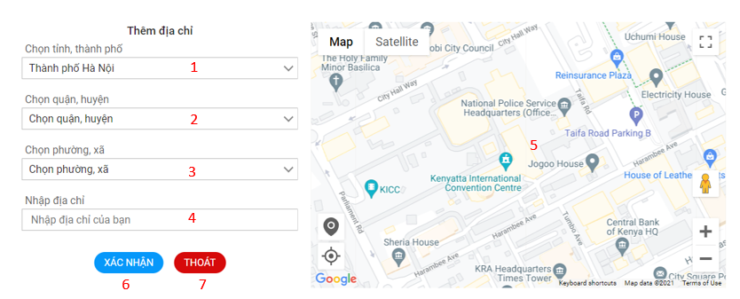

Image .. Add new address dialog

Table .. Describe Add new address dialog

|  |  |  |
| --- | --- | --- |
| **Index** | **Type** | **Meaning** |
| 1 | Select Options | Select a province or city |
| 2 | Select Options | Select a district |
| 3 | Select Options | Select a ward |
| 4 | Input | Used to enter building, street name |
| 5 | Map | Used to select the address manually |
| 6 | Button | Button to confirm |
| 7 | Button | Button to cancel and close dialog |

###### Edit address

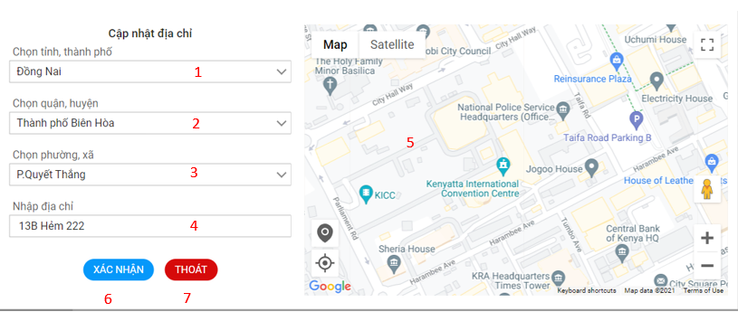

Image .. Edit address dialog

Table .. Describe Edit address dialog

|  |  |  |
| --- | --- | --- |
| **Index** | **Type** | **Meaning** |
| 1 | Select Options | Select a province or city |
| 2 | Select Options | Select a district |
| 3 | Select Options | Select a ward |
| 4 | Input | Used to enter building, street name |
| 5 | Map | Used to select the address manually |
| 6 | Button | Button to confirm update address |
| 7 | Button | Button to cancel and close dialog edit address |

###### Delete address dialog

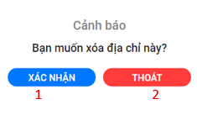

Image .. Delete address dialog

Table .. Describe Delete address dialog

|  |  |  |
| --- | --- | --- |
| **Index** | **Type** | **Meaning** |
| 1 | Button | Button to confirm delete address |
| 2 | Button | Button to cancel and close dialog delete address |

##### Account’s update password page

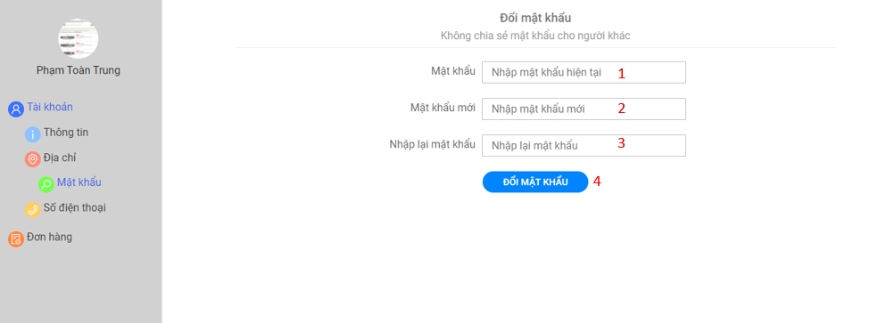

Image .. Account’s update password page

Table .. Describe Account’s update password page

|  |  |  |
| --- | --- | --- |
| **Index** | **Type** | **Meaning** |
| 1 | Input | Used to enter the password |
| 2 | Input | Used to enter the new password |
| 3 | Input | Re-Used to enter the password |
| 5 | Button | Confirm update password |

##### Account’s update phone number page

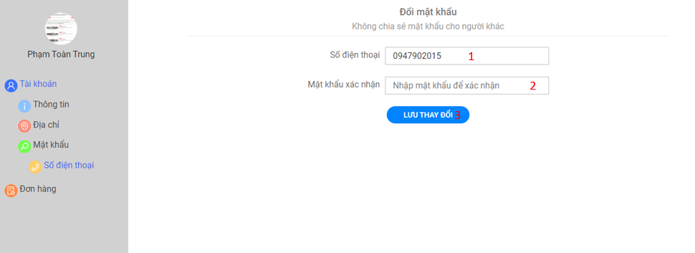

Image .. Account’s update phone number page

Table .. Describe Account’s update phone number page

|  |  |  |
| --- | --- | --- |
| **Index** | **Type** | **Meaning** |
| 1 | Input | Display current phone number and allows editing of phone numbers |
| 2 | Input | Used to enter the password |
| 3 | Button | Confirm update phone number |

##### Personal order page

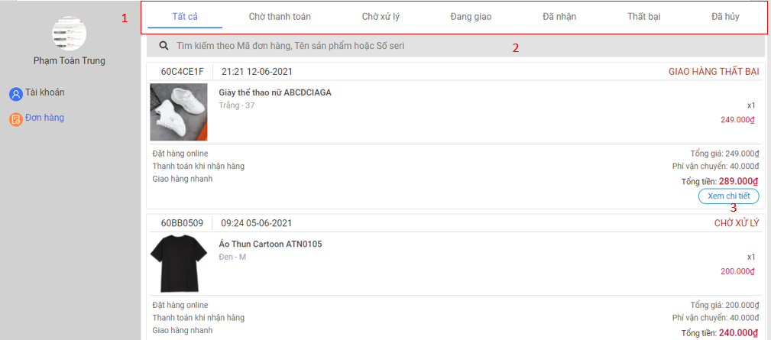

Image .. Personal order page

Table .. Describe Personal order page

|  |  |  |
| --- | --- | --- |
| **Index** | **Type** | **Meaning** |
| 1 | Navigation bar | Filter orders by status of order |
| 2 | Input | Used to enter the keyword need find orders |
| 3 | Button | View detail order |

##### Personal order detail page

###### Online payment method

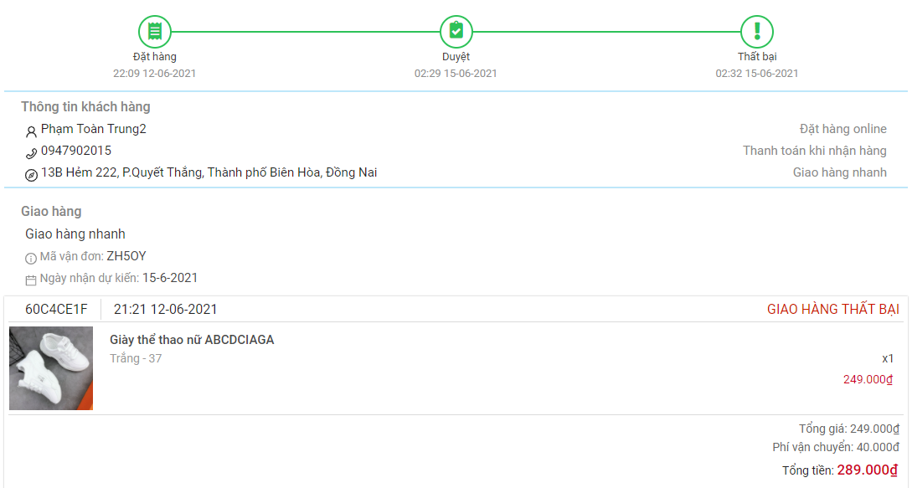

Image .. Personal order detail page with online payment method of order

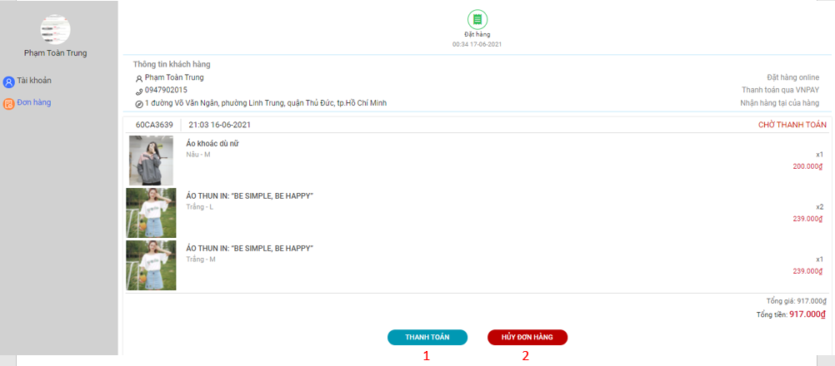

Image .. Personal order detail page with online payment method of order

Table .. Describe Personal order page with online payment method of order

|  |  |  |
| --- | --- | --- |
| **Index** | **Type** | **Meaning** |
| 1 | Button | Click to pay |
| 2 | Button | Click to cancel |

###### Pending approve

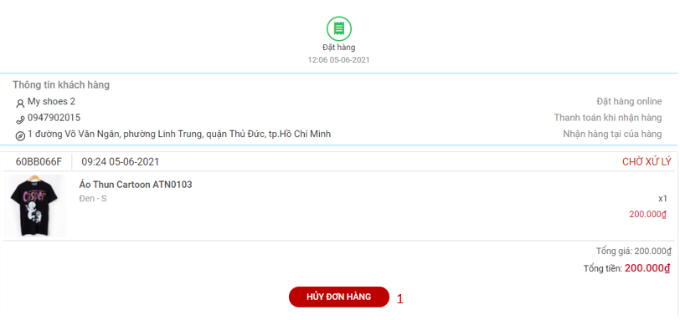

Image .. Personal order detail page with pending approve status of order

Table .. Describe Personal order detail page with pending approve status of order

|  |  |  |
| --- | --- | --- |
| **Index** | **Type** | **Meaning** |
| 1 | Button | Click to cancel |

##### Cart page

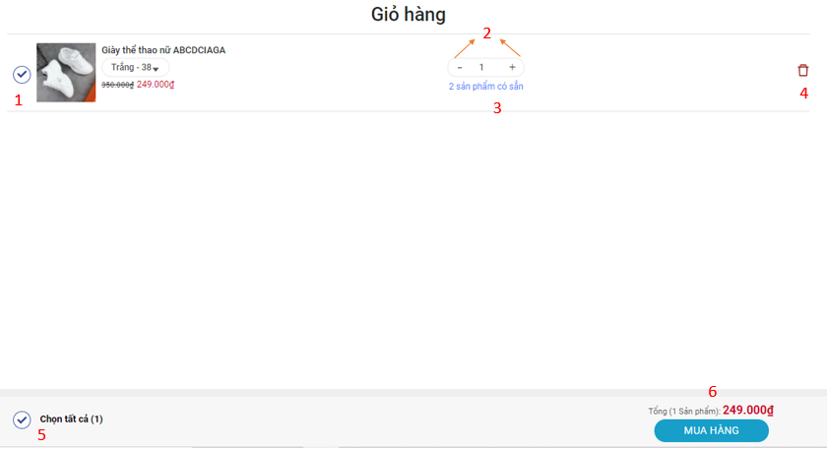

Image .. Cart page

Table .. Describe Cart page

|  |  |  |
| --- | --- | --- |
| **Index** | **Type** | **Meaning** |
| 1 | Check Box | Check to choose product |
| 2 | Button | Edit quantity |
| 3 | Link | Click to edit type product |
| 4 | Button | Click to delete product |
| 5 | Check Box | Check to choose all products |
| 6 | Button | Click to order |

##### View notice

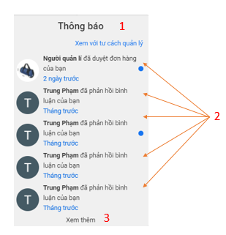

Image .. Notification dialog

Table .. Describe Notification dialog

|  |  |  |
| --- | --- | --- |
| **Index** | **Type** | **Meaning** |
| 1 | Link | View notice administrator(if you are an administrator) |
| 2 | Link | Link go to page have notice |
| 3 | Link | View more notice |

##### Messenger

###### View messenger

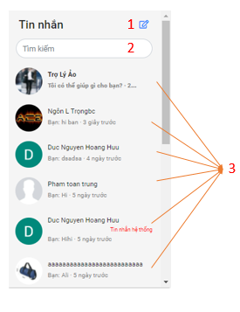

Image .. Messenger dialog

Table .. Describe messenger dialog

|  |  |  |
| --- | --- | --- |
| **Index** | **Type** | **Meaning** |
| 1 | Link | Open dialog to create new message |
| 2 | Input | Search message |
| 3 | Link | Open dialog to see and send message |

###### Create new message

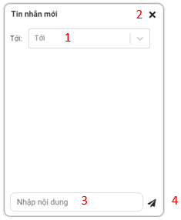

Image .. Create new message dialog

Table .. Describe create message dialog

|  |  |  |
| --- | --- | --- |
| **Index** | **Type** | **Meaning** |
| 1 | Select | Choose who will receive message |
| 2 | Button | Close dialog |
| 3 | Input | Used to enter the content of the message |
| 4 | Button | Used to send message |

###### Detail messages

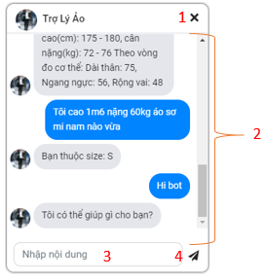

Image .. Detail messages dialog

Table .. Detail messages dialog

|  |  |  |
| --- | --- | --- |
| **Index** | **Type** | **Meaning** |
| 1 | Button | Close dialog |
| 2 | Text | Used to view message content |
| 3 | Input | Used to enter the content of the message |
| 4 | Button | Used to send message |

#### Admin Pages

##### Admin navigation bar

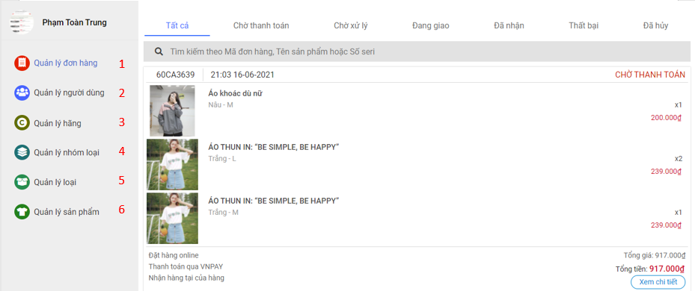

Image .. Admin navigation bar

Table .. Describe Admin navigation bar

|  |  |  |
| --- | --- | --- |
| **Index** | **Type** | **Meaning** |
| 1 | Link | Link go to page manage orders |
| 2 | Link | Link go to page manage users |
| 3 | Link | Link go to page manage brands |
| 4 | Link | Link go to page manage category group |
| 5 | Link | Link go to page manage category |
| 6 | Link | Link go to page manage product |

##### Orders management page

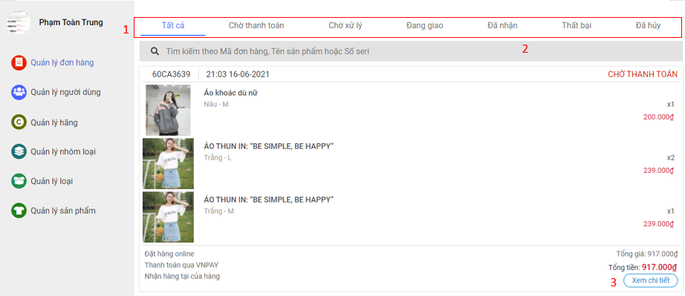

Image .. Manage order page

##### Admin order detail page

Table .. Describe Manage order page

|  |  |  |
| --- | --- | --- |
| **Index** | **Type** | **Meaning** |
| 1 | Navigation bar | Filter orders by status of order |
| 2 | Input | Used to enter the keyword need find orders |
| 3 | Button | View detail order |

###### Pending pay status

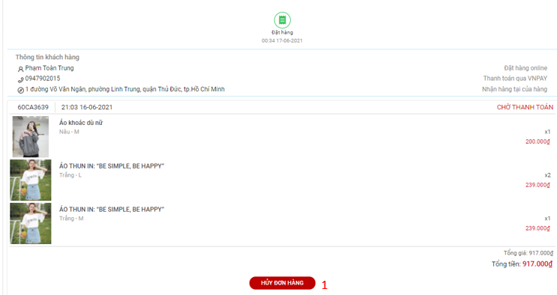

Image .. Order page with pending pay status or order

Table .. Describe Order page with pending pay status or order

|  |  |  |
| --- | --- | --- |
| **Index** | **Type** | **Meaning** |
| 1 | Button | Used to cancel an order |

###### Complete status

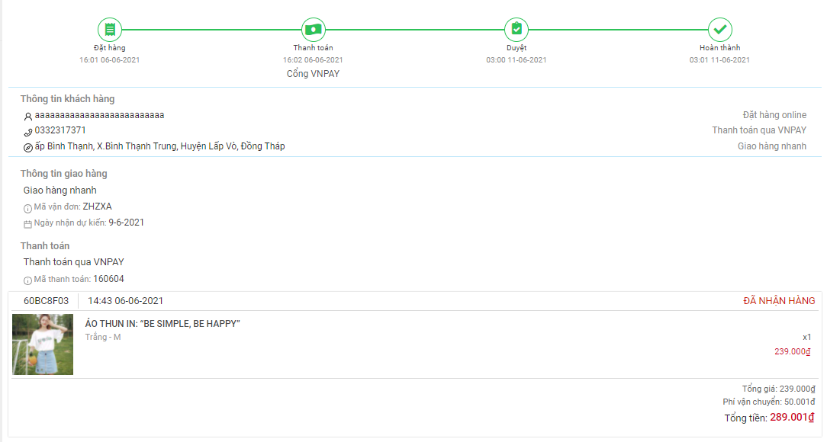

Image .. Order page with complete status of order

###### Pending approve status

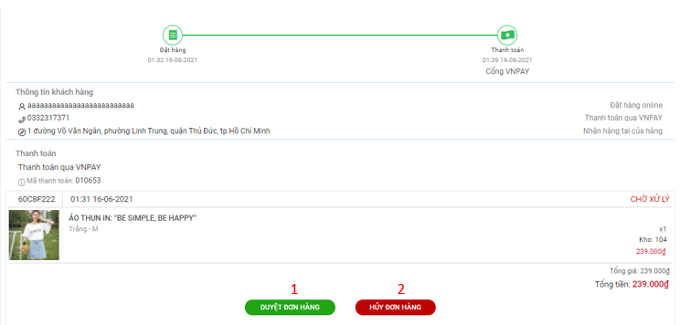

Image .. Order page with pending approve status of order

Table .. Describe Order page with pending approve status of order

|  |  |  |
| --- | --- | --- |
| **Index** | **Type** | **Meaning** |
| 1 | Button | Used to approve order |
| 2 | Button | Used to cancel order |

###### Delivering status

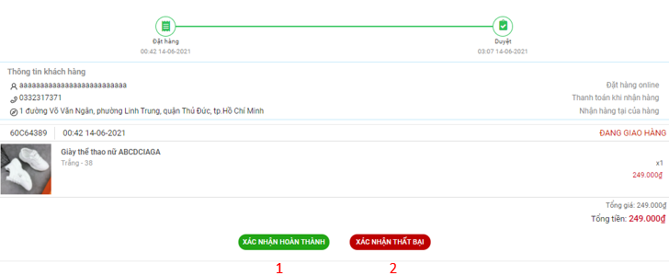

Image .. Order page with delivering status of order

Table .. Describe Order page with delivering status of order

|  |  |  |
| --- | --- | --- |
| **Index** | **Type** | **Meaning** |
| 1 | Button | Used to confirm completion |
| 2 | Button | Used to confirm failure |

##### Users management page

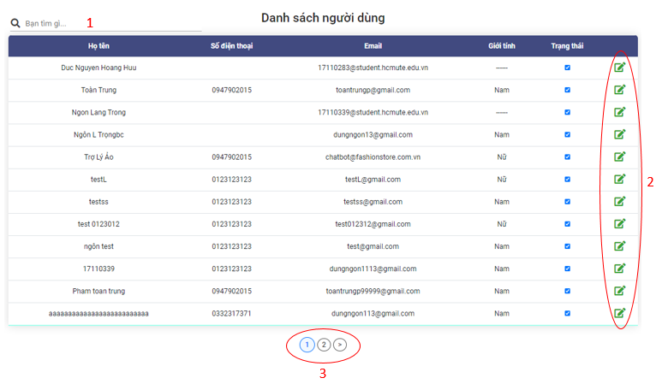

Image .. User management page

Table .. Describe User management page

|  |  |  |
| --- | --- | --- |
| **Index** | **Type** | **Meaning** |
| 1 | Input | Used to enter the key words to search |
| 2 | Link | Used to go to the user details management page |
| 3 | Link | Used to go to another page of the user management page |

##### User details page

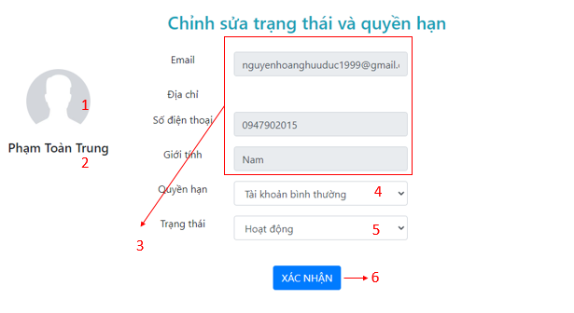

Image .. User detail page

Table .. Describe User detail page

|  |  |  |
| --- | --- | --- |
| **Index** | **Type** | **Meaning** |
| 1 | Image | Display the user’s avatar |
| 2 | Label | Display the user’s name |
| 3 | Input | Display the user’s email, phone number and male |
| 4 | Select option | Use to show or choose another role |
| 5 | Select option | Use to show or choose another status |
| 6 | Button | Used to confirm update the user’s role and status |

##### Brands management page

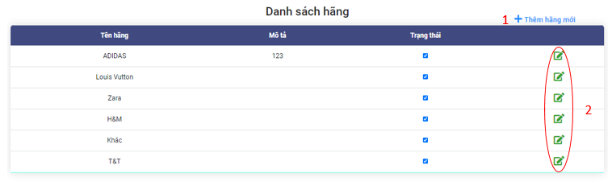

Image .. Brand management page

Table .. Describe Brand management page

|  |  |  |
| --- | --- | --- |
| **Index** | **Type** | **Meaning** |
| 1 | Link | Used to add new row allowing user to enter new brands. |
| 2 | Link | Used to enable row allowing user edit it. |

###### Brand management page on add status

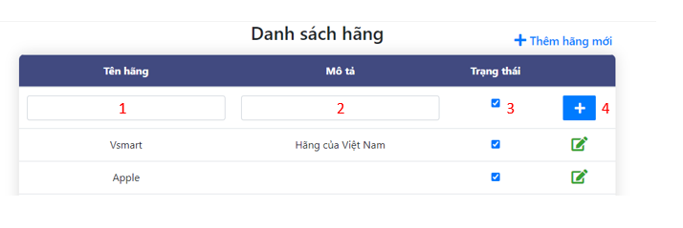

Image ..Brand management page on add status

Table .. Describe Brand management page on edit status

|  |  |  |
| --- | --- | --- |
| **Index** | **Type** | **Meaning** |
| 1 | Input | Used to enter the brand name |
| 2 | Input | Used to enter the brand description |
| 3 | Input | Used to choose status the brand status |
| 4 | Button | Used to add new brand |

###### Brand management page on edit status



Image .. Brand management page on edit status

Table .. Describe Brand management page on edit status

|  |  |  |
| --- | --- | --- |
| **Index** | **Type** | **Meaning** |
| 1 | Input | Used to edit the brand name |
| 2 | Input | Used to edit the brand description |
| 3 | Input | Used to edit status the brand status |
| 4 | Button | Used to update brand |
| 5 | Button | Used to cancel edit |

##### Products management page

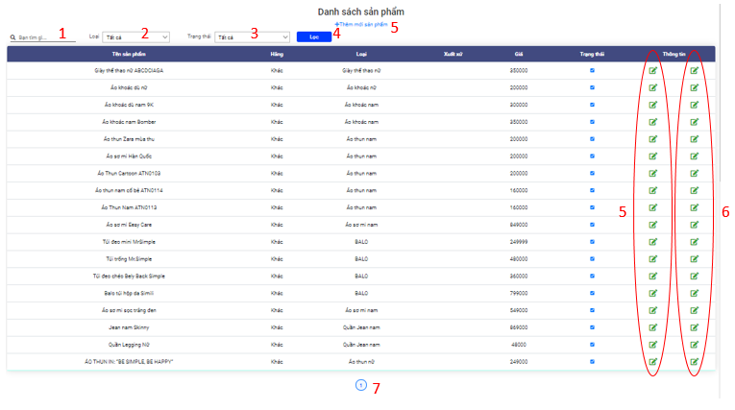

Image .. Product management page

Table .. Describe Product management page

|  |  |  |
| --- | --- | --- |
| **Index** | **Type** | **Meaning** |
| 1 | Input | Used to enter the key words to search |
| 2 | Select | Used to select the brand |
| 3 | Select | Used to select the status |
| 4 | Button | Used to filter results after selecting |
| 2 | Link | Used to go to the new product page |
| 3 | Link | Used to go to the product options management page |
| 4 | Link | Used to go to the product details management page |
| 5 | Link | Used to go to another page of the products management page |

##### Product options management page

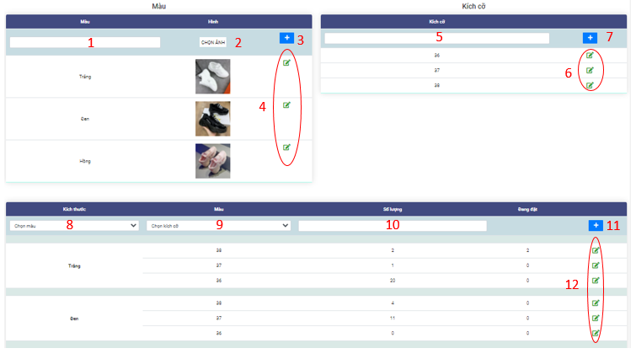

Image .. Product option page

Table .. Describe Product option page

|  |  |  |
| --- | --- | --- |
| **Index** | **Type** | **Meaning** |
| 1 | Input | Used to enter color |
| 2 | Button | Used to choose image of color |
| 3 | Input | Used to add new color |
| 4 | Button | Used to enable row and allowing edit color |
| 5 | Input | Used to enter the size |
| 6 | Button | Used to add new size of product |
| 7 | Button | Used to enable row and allowing edit size |
| 8 | Select | Used to select color |
| 9 | Select | Used to choose size |
| 10 | Input | User to enter quantity |
| 11 | Button | Used to add new option of product |
| 12 | Button | Used to enable row and allowing edit option of product |

##### Add product page

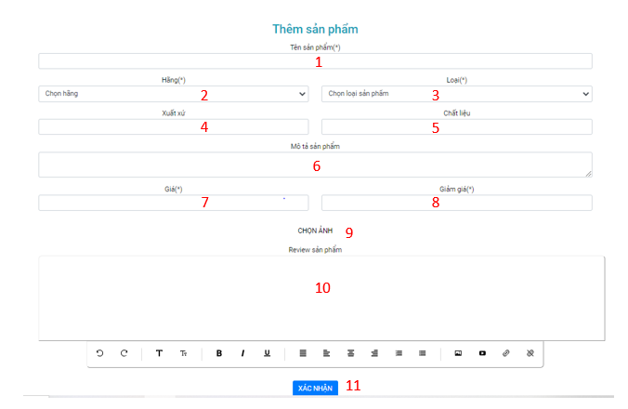

Image .. Add product page

Table .. Describe Add product page

|  |  |  |
| --- | --- | --- |
| **Index** | **Type** | **Meaning** |
| 1 | Input | Used to enter the product’s name |
| 2 | Input | Used to select the product’s branch |
| 3 | Input | Used to select the product’s category |
| 4 | Input | Used to enter the product’s material |
| 5 | Input | Used to enter the product’s description |
| 6 | Input | Used to enter the product’s price |
| 7 | Input | Used to enter the product’s sale off |
| 10 | Button | Used to choose the product’s image |
| 11 | Text area | Used to enter the product’s review |
| 12 | Button | Used to add new product |

### List of screens and screen flow on mobile application

Because of the specificity of the mobile app, the list of screens and the screen flow will be slightly different. But details the screens and functions similar to the website interface

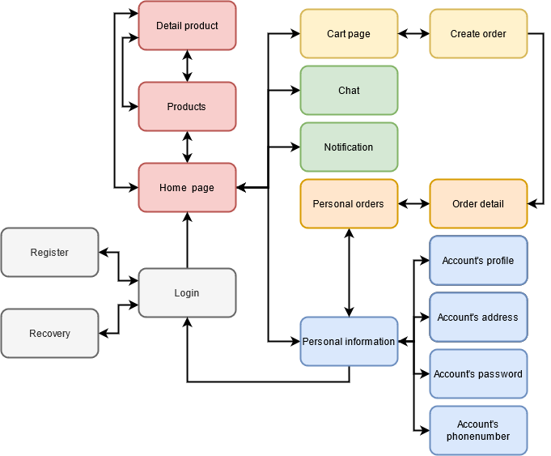

Image .. Screen flow on mobile application

# INSTALLATION AND TESTING



## INSTALL APPLICATION

* Machine must have installed npm
* Machine with NodeJS installed

**Installation steps :**

In this tutorial, the group using IDE is Visual Studio Code:

Step 1:

Clone or download the project from the github link:

<https://github.com/toantrungp999/TLCN_PhamToanTrung_LangTrongNgon>

Step 2: A folder named “TLCN_PhamToanTrung_LangTrongNgon” will appear after cloning the project from github or extracting the report attachment. Proceed to the directory TLCN_PhamToanTrung_LangTrongNgon"

Step 3: After entering the folder "TLCN_PhamToanTrung_LangTrongNgon", we right click and select "Open with Code" backend directory to run the API.

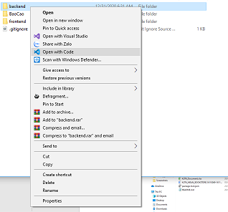

Image .. Open the project backend with visual code

Step 4: After opening the project with Visual Studio Code, select "Terminal" on the taskbar, select "New Terminal" (Or simply press Ctrl + `)

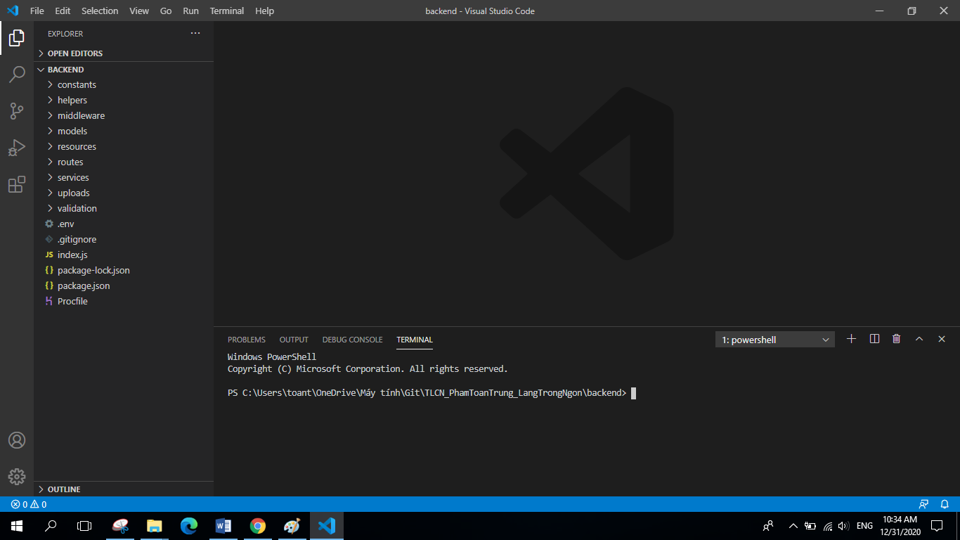

Image .. Visual studio code interface

Step 5: After the integrated Command Line window appears, run the command “npm install” to update the missing libraries and packages on the computer that Project needs.

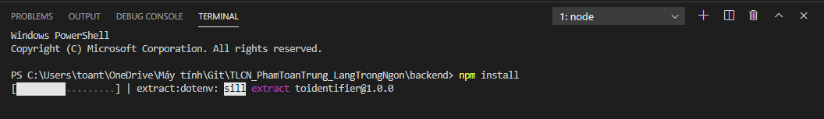

Image .. Terminal window

Step 6: After the command “npm install” finishes, type the command “npm start” to run the project .

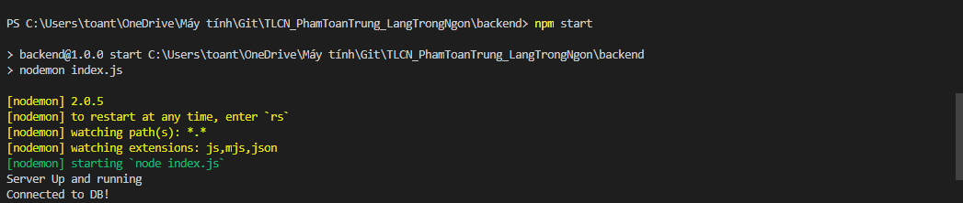

Image .. The Terminal window informs that the project has been run successfully

Step 7: In the folder "TLCN_PhamToanTrung_LangTrongNgon", we right click and select "Open with Code" in the frontend folder to open the project containing the website interface code.

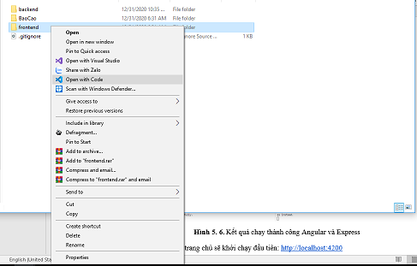

Image .. Open project frontend with visual code

Step 8: Similar to steps 4, 5, 6 we open a terminal window and type the command "npm install", "npm start"

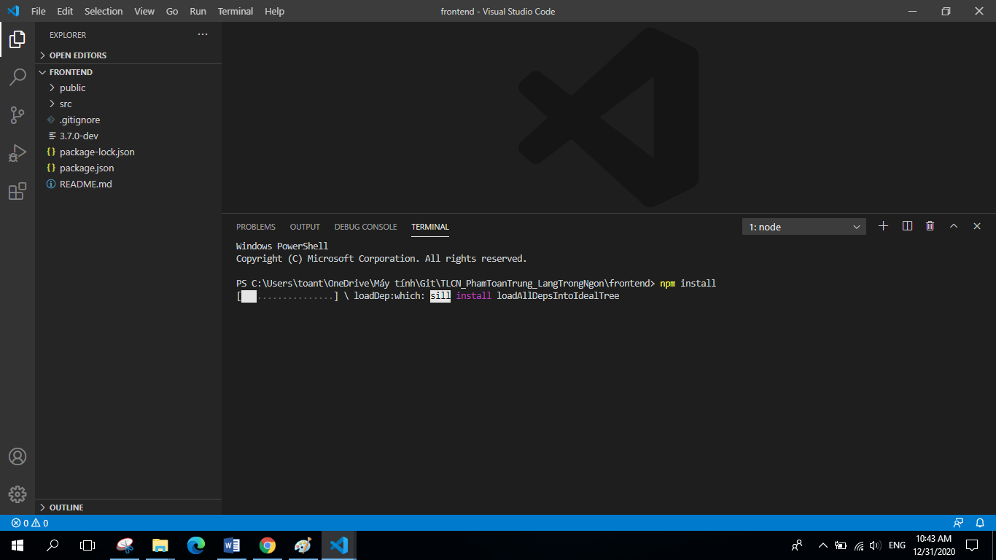

Image .. The terminal is in the process of installing the missing package

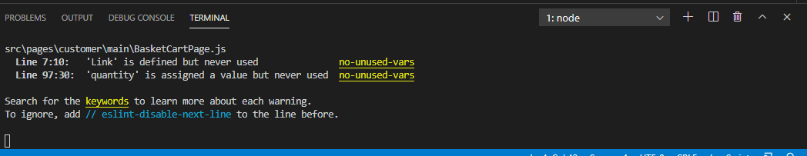

Image .. Terminal window informs that the project has been run successfully

Step 9: After completing the steps on the web browser will automatically run the web page. Or you can run it manually by opening a web browser and entering url: http: // localhost: 3000

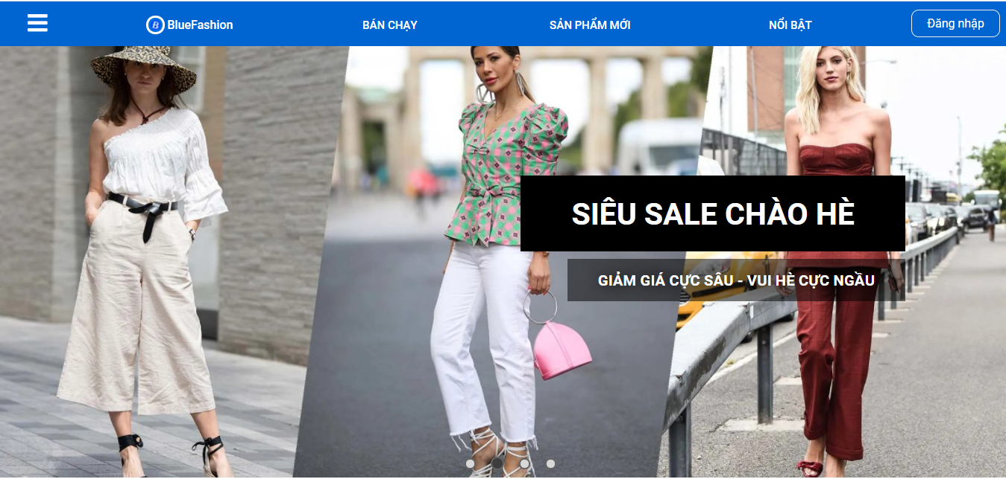

Image .. The results run successfully

The home page interface will launch first: <http://localhost:3000>

## SOFTWARE TESTING

After completing the testing, the group would like to present some typical test cases.

### Registration function

Table .. Software testing registry functions

|  |  |  |  |  |
| --- | --- | --- | --- | --- |
| **ID** | **Test Case Description** | **Test steps** | **Expected Output** | **Result** |
| Registration function | Sign up for an account | 1. Enter the required information on the screen: “Email”, "Mật khẩu”, “Nhập lại mật khẩu”, "Họ và tên", "Số điện thoại", "Thành phố", "Quận-huyện", "Phường-xã", "Ngày sinh", và "Giới tính"  2. Press the button “Đăng ký” | Successful registration will move to the login screen | Pass |
| SignUp_002 | Check to leave any information blank | 1. Check to leave any information blank and press the button “Đăng ký” | Please re-enter the complete information for each field | Pass |
| SignUp_003 | Check that email already exists in the system | 1. Enter the required information above and enter an email that already exists in the system  2. Press the button “Đăng ký” | The system does not allow to create an account because the email already exists and the message requires re-entering | Pass |
| SignUp_004 | Check if the Password and Confirm password are the same | 1. Enter all the information, enter “Mật khẩu” and “Nhập lại mật khẩu” khác nhau  2. Press the button “Đăng ký” | The system does not allow creating accounts because “Mật khẩu” and “Nhập lại mật khẩu” are not the same and require re-entry | Pass |

### Login function

Table .. Software testing login functionality

|  |  |  |  |  |
| --- | --- | --- | --- | --- |
| **ID** | **Test Case Description** | **Test steps** | **Expected Output** | **Result** |
| SignIn _001 | Check the login without an account | 1. Enter “Email” and “Mật khẩu” were not register in the system  2. Press the button “Đăng nhập” | Displayed the notice “Email hoặc mật khẩu không chính xác!” | Pass |
| SignIn _002 | Log in with an account already in the system | 1. Enter “Email” and “Mật khẩu” registered in the system  2. Press the button “Đăng nhập” | Successful login, the system switches to the homepage | Pass |
| SignIn _003 | Login with an account already in the system but locked | 1. Enter “Email” and “Mật khẩu” registered in the system  2. Press the button “Đăng nhập” | Displayed the notice “Tài khoản đang bị khóa!” | Pass |
| SignIn _004 | Sign in but the email is not in the correct format | 1. Enter “Email” with incorrect format and “Mật khẩu”  2. Press the button “Đăng nhập” | An email message with an incorrect format appears | Pass |
| SignIn _005 | Do not enter anything | 1. Press the button “Đăng nhập” | The message asking you to enter information in the missing box appears | Pass |

### Password change function

Table .. Test the password change functionality

|  |  |  |  |  |
| --- | --- | --- | --- | --- |
| **ID** | **Test Case Description** | **Test steps** | **Expected Output** | **Result** |
| ChangePass _001 | Check password change with incorrect password input | 1. Enter “Mật khẩu mới” và “Mật khẩu”  2. Press the button “Đổi mật khẩu” | Displayed the notice “Mật khẩu bạn nhập không chính xác” | Pass |
| ChangePass _002 | Check the password change with entering the correct password | 1. Enter “Mật khẩu mới” và “Mật khẩu”  2. Press the button “Đổi mật khẩu” | Displayed the notice “Đổi mật khẩu thành công” | Pass |

### Product search function

Table .. Test product search functionality

|  |  |  |  |  |
| --- | --- | --- | --- | --- |
| **ID** | **Test Case Description** | **Test steps** | **Expected Output** | **Result** |
| SearchProduct _001 | Search for products already in the system | 1. Visit the home page  2. Enter product related information (name, price, brand) that exists in the search box | A list of corresponding products appears just below the search box | Pass |
| SearchProduct _002 | Search for products not already in the system | 1. Visit the home page  2. Enter non-existing product related information (name, price, brand) in the search box | Do not appear a list of corresponding products below the search box | Pass |

### Ordering functions

Table .. Test order functionality

|  |  |  |  |  |
| --- | --- | --- | --- | --- |
| **ID** | **Test Case Description** | **Test steps** | **Expected Output** | **Result** |
| Order_001 | Check your order when there are no items in the shopping cart | 1. Nhấn vào giỏ hàng  2. Nhấn vào “MUA HÀNG” | Show notifications “Chưa chọn sản phẩm” | Pass |
| Order_002 | Check your order when not selected “Phương thức thanh toán” or “Phương thức nhận hàng” or “Chọn địa chỉ” | 1. Click cart  2. Press the button “MUA HÀNG”  3. Leave any request blank or all  4. Press the button “ĐẶT HÀNG” | When you click “MUA HÀNG”, there will be no response, and below the unselected request will display a message. | Pass |
| Order_003 | Check ordering when the product in stock is insufficient | 1. Click cart  2. Press the button “MUA HÀNG”  3. Enter full information of the order  4. Press the button “ĐẶT HÀNG” | Show notifications “Sản phẩm trong kho không đủ” | Pass |

### Product list filter by condition function

Table .. Test product filter by condition function

|  |  |  |  |  |
| --- | --- | --- | --- | --- |
| **ID** | **Test Case Description** | **Test steps** | **Expected Output** | **Result** |
| Filter_001 | Verify that the product list filter by best sell. | 1. Visit the application website address  2. Click condition “BÁN CHẠY” in header of website | Products will are show best selling products. | Pass |
| Filter_002 | Verify that the product list filter by new product. | 1. Visit the application website address  2. Click condition “BÁN CHẠY” in header of website 3. Click sort by “SẢN PHẨM MỚI” | Products will are show new products.. | Pass |
| Filter_003 | Verify that the product list filter by featured products. | 1. Visit the application website address  2. Click condition “BÁN CHẠY” in header of website 3. Click sort by “NỔI BẬT” | Products will are show featured products. | Pass |

### Image change function when changing product colors

Table .. Test image change function

|  |  |  |  |  |
| --- | --- | --- | --- | --- |
| **ID** | **Test Case Description** | **Test steps** | **Expected Output** | **Result** |
| ChangeImage_001 | Confirm the image change function when product color change works as desired | 1. Visit the application website address  2. Click to select a product from the product list  3. Click to select change product color | The product image changes to the product with the selected color | Pass |

### **Product rating function**

Table .. Test product rating function

|  |  |  |  |  |
| --- | --- | --- | --- | --- |
| **ID** | **Test Case Description** | **Test steps** | **Expected Output** | **Result** |
| Rating_001 | Verify that the product review function is working as expected | 1. Visit the application website address  2. Click to select a product from the product list  3. Scroll to the Reviews section, select the stars and enter a rating  4. Click "Gửi đánh giá" | Reviews are submitted and displayed | Pass |

### **Product comment function**

Table .. Test product comment function

|  |  |  |  |  |
| --- | --- | --- | --- | --- |
| **ID** | **Test Case Description** | **Test steps** | **Expected Output** | **Result** |
| CMT_001 | Confirm that the product comment function works as expected | 1. Visit the application website address  2. Click to select a product from the product list  3. Go to Comments section, enter your comment  4. Click "Thêm" | Comments are posted and displayed in the comments box | Pass |

# CONCLUSIONS AND DEVELOPMENT STRATEGY

## RESULT

### Knowledge and skills

Firstly, we worked, researched, practiced, understand and grasped the advantages and disadvantages of some popular technologies, including ReactJS, NodeJS, Mongodb.

Thereby we have a knowledge about the processes of communication, authentication and authorization, the scale and complexity of a large system as well as the security, development and expansion between services, the client and the server via RESTful APIs and JWT for a commercial project.

We have a knowledge to building the user application interface from the core knowledge researched and applied is the ReactJS, one of the quite popular library now for building applications in the form of SPA - Single Page Application under the client-side rendering, help UI don’t need to reload the interface. Beside that, search, calculate and validate data from the user side to improve time, increase user interaction and reduce the load on the server. In addition, Angular helps increase software development performance through build by dividing the website into separate components and individual services, increasing the reuse and helping the interface of a website is unified and has its own characteristics. We also found any disadvantages of the framework such as the browser will load slower for the first request, and if the client uses the device has low specification then the website will be slow.

Besides, we exposed and learn about the operations, management and production processes in the field of e-commerce, grasp the main operations required and urgent requirements in the developing field which most population and most attractive now, thereby building a basic e-commerce system, addressing the basic and urgent requirements in field, including: trading, product evaluation and management, manage customers for the system as well as manage, capture revenue and profit from branches and stores in its system in real time.

### Product

Completing an e-commerce website specializing in clothing. There are enough basic components to meet the needs of searching, ordering products, paying and looking up orders, and managing customers' personal information. There are also functions for administration such as product management, user management, order monitoring. Along with that is a user-friendly interface. Besides, there is a mobile application that provides similar functions to customers.

## ADVANTAGES

* Using NodeJS and Mongodb is highly customizable. The application can be easily extended and modified.
* ReactJS are open sources which is currently a strong and popular library now, bringing a good experience for users.
* Applying the APIs of Facebook, Google as well as JWT technology to authenticate and decentralize to ensure security and convenience for users.
* Use React-native to develop mobile apps that share an API server with website.

## DISADVANTAGES

* Due to time constraints, epidemics, restrictions of third parties on the development environment and other factors, the product is still incomplete:
* Some functions have not been completed.
* Functions related to third-party APIs have not been implemented or are not working properly.

**Table. Check list of Customer function**

|  |  |
| --- | --- |
| **Function, task** | **Done** |
| Register | x |
| Login with account | x |
| Use JWT | x |
| Login with Google | x |
| Login with Facebook | x |
| 2-factor authentication | x |
| Recovery password | x |
| Edit personal information | x |
| Change password | x |
| Manage addresses | x |
| Notifications | x |
| Chat | x |
| Virtual assistant | x |
| Get location with Google Map API | x |
| View Homepage | x |
| Search product by category group | x |
| Search product by category | x |
| Search product by key word | x |
| Search product by other criteria | x |
| Sort product by price | x |
| Sort product by create date | x |
| Filter product by price range | x |
| View hot product | x |
| Recommend product | x |
| View product detail | x |
| Rate | x |
| Comment | x |
| Manage cart | x |
| Order | x |
| Third-party shipping method | x |
| Online Payment | x |
| View personal order list | x |
| View personal order detail | x |
| Cancel order | x |
| Send mail when order status change | x |
| Optimized the interface | x |

**Table. Check list of Admin function**

|  |  |
| --- | --- |
| **Function, task** | **Done** |
| View user list | x |
| View user information | x |
| Enable/Disable, authorize account | x |
| CRUD brands | x |
| CRUD category groups | x |
| CRUD categories | x |
| CRUD products | x |
| CRUD product options | x |
| System notification | x |
| View order list | x |
| View order detail | x |
| Search order by customer name, customer phone number, orderID, product name | x |
| Approve, cancel, confirm success, confirm failed order | x |
| View payment history |  |
| Rollback and refund payment |  |
| Statistics | x |

* Unfinished mobile application: Only suitable for android operating system, not fully functional, not optimized interface, not optimized for different devices.
* Due to the lack of practical experience, the web configuration, database structure and business process are still not really good.

## DEVELOPMENT STRATEGY

The team plans to continue completing the project with the following jobs:

* Develop missing functions. Complete third-party functions.
* Complete mobile applications for both Android and IOS, meet many different devices. Develop application for POS devices.
* Control system errors, backup data periodically and improve website performance.
* Expanding the business line is not only the clothing industry.
* Develop a business model for a chain of stores or a customer-to-customer model.

# REFERENCES

1. [1] TopDev, JSON Web Token (JWT) là gì?

Link: <https://topdev.vn/blog/jwt-la-gi/>

2. [2] Documentation about ReactJS.

Link: <https://reactjs.org/docs/getting-started.html>

3. Jason Parks, 12 Steps to Building a Successful Ecommerce Site in 12 Months.

Link: <https://www.entrepreneur.com/article/284175>

4. [3] Documentation about Redux.

Link: <https://redux.js.org/introduction/getting-started>

5. [4] Documentation about Mongoose.

Link: <https://mongoosejs.com/docs/guide.html>

6. [5] TopDev, Node.js thực sự là gì?

Link: <https://topdev.vn/blog/node-js-la-gi/>

7. [6] MERN Stack.

Link: <https://www.geeksforgeeks.org/mern-stack/>

8. Julie Luong, 3 Mô hình thương mại điện tử điển hình ở Việt Nam.

Link: <https://magenest.com/vi/3-mo-hinh-thuong-mai-dien-tu/>

9. Tìm hiểu về ReactJS Router với một ví dụ cơ bản (NodeJS).

Link: <https://openplanning.net/12139/tim-hieu-ve-react-router-voi-mot-vi-du-co-ban>

10. Giải thích React Component Lifecycle.

Link: <https://vuilaptrinh.com/2017-10-20-react-lifecycle-la-gi/>

11. Stack Abuse, How To Write Asynchronous Code in Node.js.

Link: <https://www.digitalocean.com/community/tutorials/how-to-write-asynchronous-code-in-node-js>

12. [7] Documentation about Axios.

Link: <https://www.npmjs.com/package/axios>

13. Documentation about Bootstrap 4.0.

Link: <https://getbootstrap.com/docs/4.0/getting-started/introduction/>

14. [8] Lê Đức Mạnh, RESTful API là gì?

Link: <https://viblo.asia/p/restful-api-la-gi-1Je5EDJ4lnL>

15. Đặng Thanh Long, Hướng Dẫn Cách Deploy Project NodeJS Lên Heroku Và Sử Dụng Database MongoDB Atlas.

Link: <https://www.thanhlongdev.com/huong-dan-cach-deploy-project-nodejs-len-heroku/>

16. Documentation about React Native.

Link: <https://reactnative.dev/docs/getting-started>

17. Documentation about React Navigation.

Link: <https://reactnavigation.org/docs/getting-started/>

18. Documentation about React Paper.

Link: <https://callstack.github.io/react-native-paper/index.html>

19. Instructions for integrating VNPay payment gateway.

Link: <https://sandbox.vnpayment.vn/apis/docs/gioi-thieu/>